QuickBooks Online 2013 Student Guide

Course 1:  
Product Overview – How to Choose

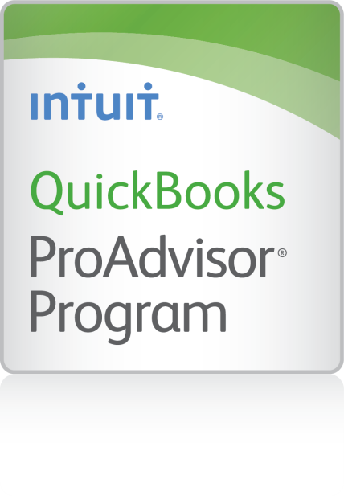

**Copyright**

© 2013 Intuit Inc. All rights reserved.

**Trademarks**

©2013 Intuit Inc. All rights reserved. Intuit, the Intuit logo, and QuickBooks, among others, are registered trademarks of Intuit Inc. Other parties’ marks are the property of their respective owners.

**Notice to Readers**

The publications distributed by Intuit Inc. are intended to assist accounting professionals in their practices by providing current and accurate information. However, no assurance is given that the information is comprehensive in its coverage or that it is suitable in dealing with a client’s particular situation. Accordingly, the information provided should not be relied upon as a substitute for independent research. Intuit Inc. does not render any accounting, legal, or other professional advice nor does it have any responsibility for updating or revising any information presented herein. Intuit Inc. cannot warrant that the material contained herein will continue to be accurate or that it is completely free of errors when published. Readers should verify statements before relying on them.

Table of Contents

About the Authors 3

Introduction – About this Course 5

Course Overview 5

Course Objectives 5

Introduction to QuickBooks Online 6

Why You Should Care 6

The Office of the Future is Here Now 6

Current Trends Signal that the Future Is Here, Right Now 6

What Intuit is Hearing from Accounting Professionals 7

What Intuit is Hearing from Small Businesses 7

What Intuit is Doing and Experiencing in Response 8

QuickBooks Online Benefits to You– General Cloud Benefits 9

Businesses Using QuickBooks Online 10

QuickBooks Online Advantages over QuickBooks Desktop 11

Features You Will Love 12

Income List (Simple Start, Essentials, and Plus) 12

Money Progress Bar (Simple Start, Essentials, and Plus) 12

Downloaded Transactions (Simple Start, Essentials, and Plus) 13

View, Print, and E-mail Customizable Reports (Simple Start, Essentials, and Plus) 14

One-Click Business Reports (Simple Start, Essentials, and Plus) 14

Choose the Right QuickBooks Online Plan 15

QuickBooks Online Simple Start 16

QuickBooks Online Essentials 17

QuickBooks Online Plus 18

Expand QuickBooks Online with Apps 19

Get Connected 19

Access Apps from QuickBooks Online 20

QuickBooks Online-Supported Browsers 21

Recap the Benefits of QuickBooks Online 22

Course Conclusion 23

# About the Authors



#### Course originally written by:

#### Stacy Kildal, CPB

#### **Kildal Services LLC**

Stacy Kildal is owner/operator of Kildal Services LLC, located in Waterford Michigan—an accounting and technology consulting company that specializes in all things QuickBooks. As an Advanced QuickBooks ProAdvisor, she also supports QuickBooks clients all over the country, offering payroll, bookkeeping and training. In 2012, Stacy had the distinct honor of being selected as one of CPA Practice Advisor’s Most Powerful Women In Accounting.

She regularly teaches QuickBooks workshops through the local county planning and economic development department, along with community college and continuing education classes for various school districts. Stacy is one of the three hosts for the Radio Free QuickBooks weekly online radio show, and writes regular blogs for the [Sleeter Group’s QuickBooks and Beyond](http://www.sleeter.com/blog/category/expertscorner/onlinesolutions/) as well as [AccountingWEB.com](http://www.accountingweb.com/blog/pajama-work-quickbooks-technology-cloud)

As a member of the esteemed Intuit Trainer/Writer Network, Stacy has presented many live seminars and webinars. Her attendees enjoy the passion she exhibits for her work and can easily relate to the many real life examples she uses during these presentations. She has also been frequently featured on Intuit’s [Accountant Blog](http://blog.accountants.intuit.com/author/stacyikildal/), Community "Ask the Expert" forums, at various Intuit Academy To Go podcasts, and has hosted a number of Intuit Small Business Online Town Hall sessions. She is a big fan of working mobile and has been recognized by Intuit as being an expert on QuickBooks Online, having written Intuit’s original courses for the US, Singapore and Canadian versions.

Kildal Services LLC provides consulting, speaking and writing services to clients (including other accounting professionals) nationwide.



#### Course updated by:

#### Esther Friedberg Karp, MBA

#### ****President, EFK CompuBooks Inc. Toronto****

Esther is founder and president of EFK CompuBooks Inc., based in Toronto, Canada. She is a Certified ProAdvisor for QuickBooks in Canada, and has developed an international following as a speaker, course and webinar developer and contributor for Intuit world-wide as well as other companies and associations, and accounting firms. In the US, she is an Advanced Certified QuickBooks ProAdvisor, as well as a Certified QuickBooks Enterprise Solutions ProAdvisor.

Esther is also a member of the esteemed Intuit Trainer/Writer Network and has been featured on Intuit’s Community “Ask the Expert” forum. She has spoken at the conferences hosted by Intuit and the Sleeter Group, and she has been a guest on Radio Free QuickBooks.

CompuBooks clients are located all over the world, and Esther supports them remotely using the power of the cloud, never having met some of them face-to-face.

EFK CompuBooks Inc. provides consulting, speaking and writing to clients world-wide. Esther can be reached at esther@e-compubooks.com.

# Introduction – About this Course

## Course Overview

We’ll cover the benefits of QuickBooks Online, starting with the general advantages of cloud computing and then going on to specific advantages QuickBooks Online offers when compared to the desktop versions of QuickBooks. Then, we’ll go into more features of QuickBooks Online that you will love, and the subscription plans available. Finally, we’ll address how to go about expanding the power of QuickBooks Online using third-party add-on software to offer a rich, cloud-based accounting system to businesses that require more flexible access than the desktop editions offer.

You will learn about:

* The advantages that QuickBooks Online presents over QuickBooks desktop editions – Explore key advantages that QuickBooks Online has when compared to the desktop editions of QuickBooks, along with other features you will adore
* The available QuickBooks Online subscription options – We’ll teach you when to consider QuickBooks Online, whether you are new to QuickBooks altogether or are a current desktop user
* Additional software and services – See how to access third-party applications to enrich the QuickBooks Online experience

## Course Objectives

By attending this course, participants will be able to do the following:

* Determine if QuickBooks Online is right for your business
* Identify the advantages of QuickBooks Online vs. QuickBooks desktop editions
* List the important QuickBooks Online features and benefits
* Determine when to consider QuickBooks Online:
* List important features and benefits you will love
* Identify the differences among QuickBooks Online Simple Start, Essentials and Plus subscription plans and the types of companies each supports
* Identify the best subscription plan for you
* Identify third-party software that integrates with QuickBooks Online to solve important business needs

# Introduction to QuickBooks Online

## Why You Should Care

### The Office of the Future is Here Now

Today’s workplace is vastly different from the typical office of just a decade ago.

The office of the future has you working with customers remotely, and in many cases you’ve never met them face-to-face. There is no IT specialist in your office keeping all the computers running smoothly and putting out technology “fires.” There’s no requirement to create data backup schedules, ensure that the backups are made, or to take the backups off-site for security in case the office blows up.

There’s no need to install new versions of software or upgrade data to be read in those new versions.

Furthermore, the office of the future has no paper clutter!

That office of the future is coming at us very quickly. In many ways, in fact, it’s already here. If you’re not experiencing the “office of the future” yet, you will very soon. You will experience this new “office of the future” because of the huge advantages in time and cost savings it presents, but also because you’ll need it to keep up with your competitors

### Current Trends Signal that the Future Is Here, Right Now

The future is here and now...and there are three ubiquitous technology trends that are bringing the future to us more quickly than we thought possible. What are these trends that we see everywhere?

### What Intuit is Hearing from Accounting Professionals

* Technology Trend #1 – So many people are already using smart phones, tablets, notebooks and other mobile computing devices as the main tools for managing the complex choreography of work and life. These technologies are reinventing work as well as the workplace, allowing greater flexibility around when, where and how work is done. While customer service will remain of paramount importance, being onsite will become much less important, and these mobile tools will enable, and often require, “anytime, anyplace” work.
* Technology Trend #2 – So many businesses are adopting the virtual office. This trend persists for two main reasons: firstly, it promises huge cost efficiencies in terms of computer systems, virtual server space and even employee resources. There is no longer the same cachet there used to be in having a pricey office address with sky-high rents. Secondly, it gives rise to exciting new enterprises that provide physical real estate anyplace, offering flexibility to other businesses wishing to take advantage of these spaces. Savvy entrepreneurs have adopted this flexible approach to traditional office requirements, saving both time and money.
* Technology Trend #3 – As we continue to head towards mobile and cloud adoption, eventually, small businesses will never have to enter any data at all. Online downloads of virtually all data will mean that data can be downloaded automatically in minutes (or even seconds). Data is becoming accessible from multiple platforms, with data flows to and from more places and flowing in and out of more applications. That means that you will no longer be focusing on data entry, but more on interpreting what the numbers and data mean for you and your business. You will no longer be working in the business, but on the business. The grunt work will no longer exist.

### What Intuit is Hearing from Small Businesses

It seems that small businesses are right at the forefront of those tech trends, along with the accounting professionals who serve them.

That same Intuit survey from the fall of 2011 showed 58% of small and medium-sized businesses (SMB’s) found it appealing to access financial and accounting records on-the-go. This figure represented a 12-point jump from just a year before.

That survey resulted in some other fascinating numbers. 63% of SMB’s use at least one Software-as-a-Service (SaaS) application for their business. Those SMB’s expect to increase the number of cloud business applications they use this year from an average of two apps to an average of seven apps.

43% of SMB’s reported that all of their employees use wireless devices or technologies to work away from the office.

Intuit has conducted the survey and read the results. And Intuit is responding quickly…

### What Intuit is Doing and Experiencing in Response

Intuit is leading with QuickBooks Online for new users in their marketing channels, and has 10 times the number of engineers working on QuickBooks Online products relative to the number of engineers five years ago. As a result, QuickBooks Online has experienced annual growth of 30 – 40% for several years running. Part of the reason for this growth has been the global release of QuickBooks Online (see below).

### QuickBooks Online Benefits to You– General Cloud Benefits

Historically, businesses were required to buy, build, and maintain their IT infrastructures despite exorbitant and exponentially-rising costs. This presented a definite disadvantage to small businesses or startups with limited financial resources. The cloud gives companies of all sizes a revolutionary alternative. With the cloud, users can plug in and subscribe to services built on shared infrastructure via the Internet. The benefits are plentiful, and all you need to access QuickBooks Online is one of the supported browsers (a list of these browsers is available at the end of this course):

* Time Savings – With cloud computing, your business will save time with everything as the technology and data are always available and reliable. From not having to manage your software infrastructure to not having to travel back and forth to the office to access important customer and financial information, to far less data entry, QuickBooks Online offers a huge time savings for you and your business.
* Anytime, Anywhere Access – No matter where you are - Iowa, Illinois or Istanbul, and no matter what time it is, the functionality of the cloud allows you to have access and work anywhere with an always-on connection to your data. There are no location or time-zone restrictions for filing that tax return.

With easy and mobile access using any of the supported browsers (see the list at the end of this course), users can do the following from anywhere, at any time:

* Add and edit customers, vendors, and employees
* Create and email invoices
* View Balance Sheet and Profit & Loss reports
* Access vendor, customer, and employee lists
* View Bank account and credit card balances
* Understand who owes you money and to whom you owe money
* QuickBooks Online contact information works with your phone to make calls, create emails, and even look up addresses using Google Maps TM
* Easy Collaboration – Cloud software is making collaboration with your accounting professional a reality for many small businesses around the world, without it costing a fortune. Businesses of all types are able to benefit from cloud collaboration. QuickBooks Online lets the you and your accountant or bookkeeper see what work is being done at every single stage of the process. The possibilities for your business are endless.
* Secure Sharing – Many of the data centers in which SaaS environments are housed have security infrastructures that are much stronger and more secure than those infrastructures most individual firms are able to provide or afford. QuickBooks Online uses the same data-encryption technology as leading banks. QuickBooks Online’s servers are protected by firewall software, intrusion detection software and hardware, and security systems and personnel. QuickBooks Online is also a VeriSign Secured™ product.
* Speed and Productivity – No lengthy planning and implementation guide is necessary. The setup is so easy, that it’s virtually non-existent. This means a shorter deployment time, which means more time to work *on* your business, rather than *in* your business.
* Automatic Backup and Upgrades – You will save enormous amounts of time not worrying about backing up data, taking it off-site, or upgrading the data and software to the latest version or release. It’s all done for you with QuickBooks Online.
* It’s Affordable – You’ll experience cost efficiencies. Since SaaS applications are subscription-based, there are no license fees, meaning lower initial costs. QuickBooks Online’s support is free, included in the cost of the subscription. In addition, having a SaaS provider manage all your IT infrastructure means lower IT costs for hardware, software, and the people needed to manage it all.

### Businesses Using QuickBooks Online

As a result of the advantages listed above, companies and entities of almost every type can use QuickBooks Online, as there are three subscription plans to cover a wide range of user types.

Furthermore, QuickBooks Online can be expanded upon by adding payroll, payments, and third-party applications. We’ll cover accessing the vast and growing list of apps later in this course.

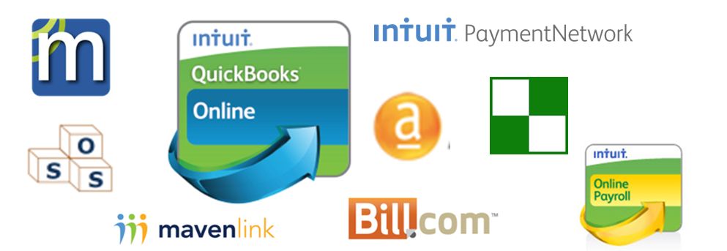

### QuickBooks Online Advantages over QuickBooks Desktop

In addition to the general advantage of having cloud-based accounting with QuickBooks Online, here are some specific ways in which the features in QuickBooks Online present significant advantages over the features available in QuickBooks desktop versions:

* Invoice/Sales Receipt Automation – In QuickBooks desktop versions, you can memorize these transactions, but QuickBooks Online will go further and send them out automatically.
* Delayed customer charges/billing – QuickBooks desktop versions won’t automatically create invoices for unbilled time and costs, but QuickBooks Online will do it.
* Activity Log – QuickBooks desktop offers the Audit Trail, which tracks a transaction being created, modified, and/or deleted. The Audit Trail does not track logins, third party activity, or list changes. The Activity Log in QuickBooks Online tracks all those activities.
* No need for an Accountant’s Copy – There is no need to transfer data back and forth via an Accountant’s Copy when working with your accountant in QuickBooks Online data. (In fact, there is no such thing as an Accountant’s Copy in QuickBooks Online.) He or she can just log right in and do the work.
* Automatic e-mail reporting – In QuickBooks Online, you can set up memorized reports and memorized report groups to run automatically on schedules you set, and the reports are sent automatically to specified recipients. QuickBooks desktop versions don’t do this.
* Bank transactions are automatically downloaded nightly – In QuickBooks desktop, you have to enter a password each time and initiate a bank download manually. QuickBooks Online does it all for you, nightly, and automatically.
* Unlimited report reader and time tracker users – QuickBooks Online allows the setup of unlimited users to view reports only or enter time tracking, depending on the subscription level chosen. This is not so in QuickBooks desktop.
* Both Class *and* Location tracking – While QuickBooks desktop allows for reporting on the company “pie” by class, QuickBooks Online Plus offers specifying either a class or a location or both on transactions, and can report on whatever is being tracked. This is a management tool that QuickBooks desktop just does not have.
* For Accountants – Multiple Accounts Receivable and Accounts Payable lines in journal entries: QuickBooks desktop allows for just one A/R or A/P account per journal entry. As a result, recording year-end and reversing journal entries with multiple A/R and A/P accounts is time-consuming in QuickBooks desktop, but very easy in QuickBooks Online.

Note: QuickBooks Online is a very viable solution for cash-strapped startups requiring five-user remote access with Enterprise-type user roles and some Advanced Inventory features. If you are set up with QuickBooks Online Plus with the SOSinventory.com add-on (covered in a separate course) you can save a lot of money over using QuickBooks Enterprise with Advanced inventory and still enjoy robust functionality.

## Features You Will Love

In addition to the general benefits of using cloud-based QuickBooks Online, and in addition to the advantages it has compared to QuickBooks desktop, you will love the following QuickBooks Online features:

### Income List (Simple Start, Essentials, and Plus)

Like so many other features and benefits of QuickBooks Online, the Income List saves time.

The Income List is not just a list of Sales Receipts or Invoices. It’s a tool or “Command Center” to track customer transactions: Estimates, Invoices, etc., and take action on those transactions.

Just filter the Income List for any or all of the following: transaction type, payment status (paid, open, accepted, etc.), delivery status (all, to be printed, to be sent), date, and customer. Then check the box next to each transaction that interests you once the filtering is done, or click on Batch Actions to choose all of them. Then select the action (print transaction, print packing slip, send) you want and apply that action to the chosen transactions on the filtered list.

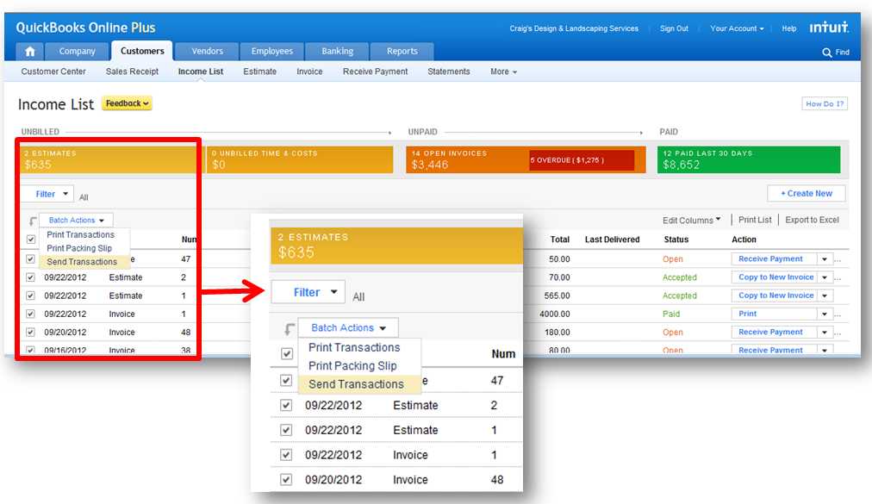

### Money Progress Bar (Simple Start, Essentials, and Plus)

The Money Progress Bar is part of the Income List screen. It shows the following in pictorial format:

* Estimates
* Unbilled time & costs
* Unpaid invoices (including overdue in red)
* Recently paid invoices

The user can click on any section of the Money Progress Bar in order to get to a transaction report, on which they can QuickZoom or drill down to get to the original transaction(s).



### Downloaded Transactions (Simple Start, Essentials, and Plus)

Downloaded Transactions replaces the old Online Banking Feature in QuickBooks Online.

Here is why you’ll love Downloaded Transactions (in comparison with the old Online Banking Feature or on its own merit: Downloaded Transactions is easy and saves considerable time:

* Downloaded Transactions has a very clean interface (much cleaner than the old Online Banking)
* Automatically downloads transactions every night
* With the old Online Banking feature, it took a very long time to download transactions, and users would see only four to five transactions at a time, after which they would have to refresh the page after dealing with each transaction. The new Downloaded Transactions feature, by comparison, gives you the choice to show 25, 50 or 100 transactions at a time.
* The old Online Banking feature presented problems to end users and accountants with the Full Automation option, because everything was automatically posted to Uncategorized Income or Uncategorized Expense, and many transactions ended up being duplicated. Downloaded Transactions has eliminated this problem

### View, Print, and E-mail Customizable Reports (Simple Start, Essentials, and Plus)

QuickBooks Online reports give you valuable insight into a company's finances so you can make better business decisions, from basic financial reports to reports for specialized business activities:

* Customize Reports in Minutes – It's easy to customize QuickBooks Online reports, so you can develop report formats tailored to your unique business, and you can do it quickly. Once you customize a report, you can have QuickBooks Online memorize it so that you can run it any time you wish. (Remember the automatic emailing feature!)
* Get the Bigger Picture – The QuickZoom® feature shows the detail behind the reports and lets you drill down to the transaction level. You can display original transactions and analyze the transactions behind the numbers. It is easy to see summary reports on a cash or accrual-basis at any time.

### One-Click Business Reports (Simple Start, Essentials, and Plus)

In addition to the ability to view, customize, QuickZoom, memorize, print, and e-mail report, QuickBooks Online offers one-click business reports to save time.

QuickBooks Online Simple Start features over 20 one-click business reports; Online Essentials offers over 40, and Online Plus offers over 65.

QuickBooks Online Reports are covered more thoroughly in a later course.

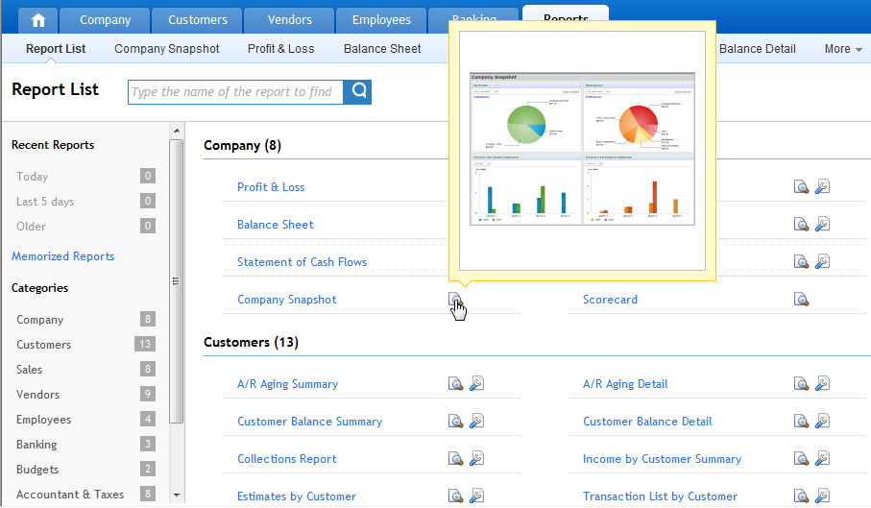

## Choose the Right QuickBooks Online Plan

QuickBooks Online gives you the freedom to manage your business anytime, anywhere. For businesses who want on-line access to their QuickBooks data. There are three subscription plans available to meet these needs:

**Online Simple Start**

***Starting Your Business***

**Online Essentials**

***Growing Your Business***

**Online Plus**

***Includes Everything***

### QuickBooks Online Simple Start

For those who are just getting started or have basic accounting needs, it includes these features:

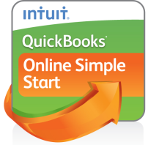

* Import customer data from Excel
* Create and manage invoices
* Track sales and expenses
* 20+ one-click business reports
* Connect 1 bank or credit card account to Downloaded Transactions
* Print checks
* Allows for 1 user

There are some limitations of QuickBooks Online Simple Start that should be noted here:

* No accounts payable – Expenses are managed by checks, cash and credit card expense transactions
* Limit of one Downloaded Transactions account – Connect to only one bank or credit card account for downloaded transactions
* No import from QuickBooks desktop
* No Estimates
* No Automated Invoicing
* No permission controls – As Online Simple Start is for one user only, there are no permission controls
* No payroll available – Online Simple Start is not available with payroll

### QuickBooks Online Essentials

For those who are up and running, QuickBooks Online Essentials includes all the features of QuickBooks Online Simple Start plus these additional features:

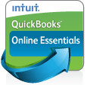

* Automated Invoicing
* Estimates
* Accounts Payable
* Can add payroll
* 40+ one-click business reports
* Unlimited accounts for Downloaded Transactions
* Allows for 3 users
* Permission controls

There is a limitation of QuickBooks Online Essentials that should be noted here:

* Although you add payroll to QuickBooks Online Essentials, it does not offer time-tracking functionality. You need QuickBooks Online Plus in order to get time-tracking functionality.

### QuickBooks Online Plus

QuickBooks Online Plus is for those who are established and expanding their businesses. QuickBooks Online Plus includes all the features of QuickBooks Online Essentials plus these additional features:

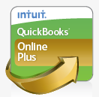

* Time-tracking
* Purchase Orders
* FIFO-based Inventory tracking
* 1099s
* Sales tax tracking
* Class & Location Tracking
* Budgeting and planning
* 65+ one-click business reports
* Allows for 5 users

## Expand QuickBooks Online with Apps

### Get Connected

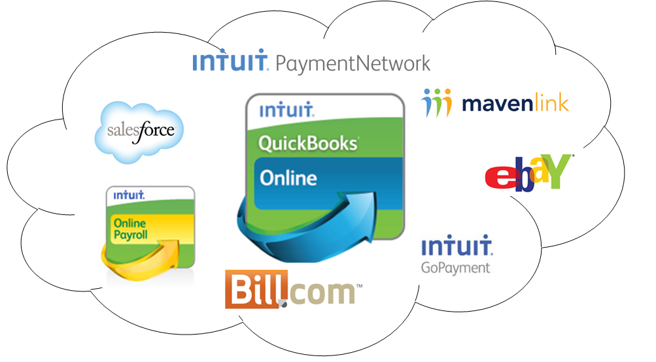

While QuickBooks Online focuses on tackling all the core accounting tasks, there are many other related business management tasks addressed for small businesses by other apps that integrate with QuickBooks Online.

The cloud offers an unparalleled opportunity to connect to these applications so that data is shared.

Once you do this, you’ll have a single source of truth across these applications for accounting as well as business management.

So instead of re-entering data, which creates unnecessary workload and the potential for errors, your data flows seamlessly across applications.

QuickBooks Online has deep integrations with other Intuit products like Payroll and credit card processing. These deep, rich integrations provide tremendous value because they save time. If QuickBooks Online users employ two or more of Intuit’s integrated products, their satisfaction vastly increases.

Intuit has launched the Intuit Payment Network, which allows QuickBooks Online invoices that are e-mailed to be paid online by check or credit card. The Intuit Payment Network automatically reconciles that payment back to the QuickBooks Online transaction and closes the loop for you.

Payments, Payroll, and Apps are covered in a later course: Expanding QuickBooks Online.

### Access Apps from QuickBooks Online

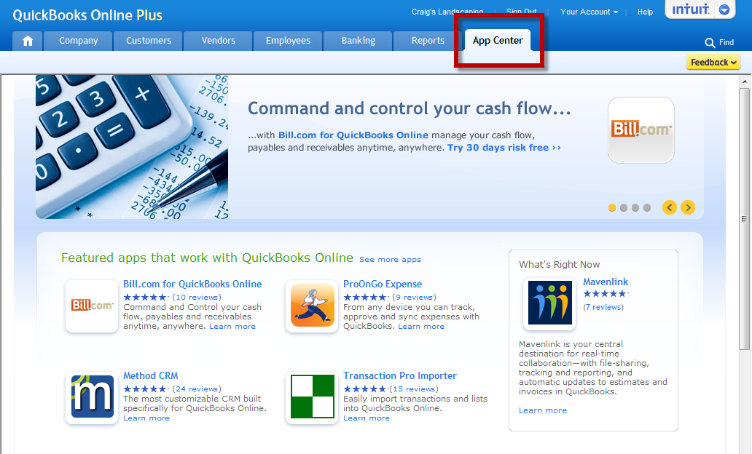

QuickBooks Online can be connected to non-Intuit cloud products through the Intuit Partner Platform.

QuickBooks Online is an open platform, so that any third-party developer can access the QuickBooks Online services and build integrations. To access these apps from within QuickBooks Online, click on the App Center tab, where you can learn all about its third-party integrations.

If you’re not logged into QuickBooks Online, you can also access the App Center by visiting [appcenter.intuit.com](http://appcenter.intuit.com).

# QuickBooks Online-Supported Browsers

As promised, here is the list of QuickBooks Online-supported browsers, along with information on mobile access:

* Supported browsers (Windows)
* Internet Explorer for Windows, version 9 or higher
* Firefox for Windows, version 4 or higher
* Google Chrome
* Safari for Windows 5.0.1 or higher
* Supported browsers (Mac)
* Safari for Mac, version 4.1.1 or higher
* Firefox for Mac, version 3.6 or higher
* Google Chrome
* Mobile support for Blackberry, iPhone and Android, iPad*
* There is a mobile version of QuickBooks Online for the iPad using Safari to login, but the features are limited.

Take a Test Drive

Lessons in the Activities Handbooks frequently include hands-on exercises in a QuickBooks Online Plus “test drive”. The test drive uses a sample company file called Craig’s Design & Landscaping Services. It can be accessed through the following link:

<https://qbo.intuit.com/redir/testdrive>

You don’t have to create an account or sign in; just complete the security validation and click Continue. This test drive is designed for you to explore and try out new things without worrying that you will break something or make a mistake. It is not designed to retain any changes you make. Once you close the test drive, it is completely refreshed, so please remember to allow sufficient time to complete each activity. But don’t worry if you have to close the test drive before you are finished! You can always begin again.

Note: The test drive uses the QuickBooks Online Plus plan. It contains some features that are not available in QuickBooks Online Simple Start or Essentials. In addition, some features, such as the Apps Center tab and in-product Help are not enabled at this time. However, this is subject to change.

# Recap the Benefits of QuickBooks Online

Let’s take the opportunity to review the benefits of QuickBooks Online for you and you:

* No IT Guy
* Wider Geography Served
* No Data Backups
* Secure
* “Always On” Access
* Affordable
* Easy Collaboration
* Stress-Free Data Sharing
* Work Anywhere!
* Reporting at Your Fingertips
* Reduce Data Entry
* Save Time
* Focus on Planning & Analysis (!!)
* Integrated Solutions
* Specific Tools Built to Help Support
* Add-ons to Help Enrich & Grow

# Course Conclusion

By embracing QuickBooks Online as a viable part your back office, you have the opportunity of growing your business, by not spending as much time working on the books. With anytime, anywhere access, you’ll be able to provide an estimate, or bill a client without the old: “I’ll send you that when I get back to the office”. You’ll be able to focus more on planning and analysis when working with your accountant or bookkeeper, and collaboration is much easier.

With the additions of payroll and payments, you have a unique, integrated ecosystem. By looking to the Intuit Appcenter, this ecosystem can grow and evolve as your company expands. QuickBooks Online gives you the power to liberate the data, to make it flow seamless between you, your customer and your accounting professional.