QuickBooks Online 2013 Student Guide

Lesson 2:  
Navigating QuickBooks Online

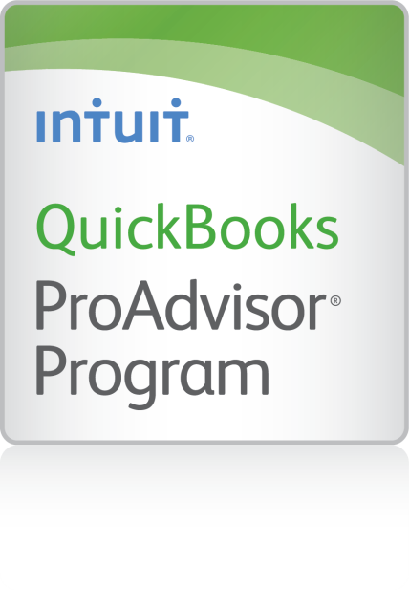

**Copyright**

© 2013 Intuit Inc. All rights reserved.

**Trademarks**

©2013 Intuit Inc. All rights reserved. Intuit, the Intuit logo, and QuickBooks, among others, are registered trademarks of Intuit Inc. Other parties’ marks are the property of their respective owners.

**Notice to Readers**

The publications distributed by Intuit Inc. are intended to assist accounting professionals in their practices by providing current and accurate information. However, no assurance is given that the information is comprehensive in its coverage or that it is suitable in dealing with a client’s particular situation. Accordingly, the information provided should not be relied upon as a substitute for independent research. Intuit Inc. does not render any accounting, legal, or other professional advice nor does it have any responsibility for updating or revising any information presented herein. Intuit Inc. cannot warrant that the material contained herein will continue to be accurate or that it is completely free of errors when published. Readers should verify statements before relying on them.

Table of Contents

About the Author 3

Course Overview 4

Course Opening 4

Objectives 4

Training at a Glance 5

Getting Started 5

QBO Plus Test Drive 5

Google Chrome 6

Lesson 1: Web Based 7

Supported Web Browsers 7

Navigating Online 8

Lesson 2: Tips and Tricks 9

Open Multiple Windows 9

Open Multiple Companies 12

Installing the Chrome QuickBooks Online App 15

Lesson 3: Tour of QuickBooks Online 17

Company Name/Your Account 19

Lesson 4: Home Tab 20

Home Page Features 20

Getting Started Resources 22

Menu Tabs 24

Lesson 5: Helpful Tools for Getting Started 26

Find 26

Feedback 27

How Do I? 27

Intuit Community and QuickBooks Online Blog 28

QuickBooks Online Blog 28

Course Conclusion 30

About the Author



#### Stacy Kildal, CPB

Kildal Services LLC

Stacy Kildal is owner/operator of Kildal Services LLC, located in Waterford Michigan—an accounting and technology consulting company that specializes in all things QuickBooks. As an Advanced QuickBooks ProAdvisor, she also supports QuickBooks clients all over the country, offering payroll, bookkeeping and training. In 2012, Stacy had the distinct honor of being selected as one of CPA Practice Advisor’s Most Powerful Women In Accounting.

She regularly teaches QuickBooks workshops through the local county planning and economic development department, along with community college and continuing education classes for various school districts. Stacy is one of the three hosts for the Radio Free QuickBooks weekly online radio show, and writes regular blogs for the [Sleeter Group’s QuickBooks and Beyond](http://www.sleeter.com/blog/category/expertscorner/onlinesolutions/) as well as [AccountingWEB.com](http://www.accountingweb.com/blog/pajama-work-quickbooks-technology-cloud)

As a member of the esteemed Intuit Trainer/Writer Network, Stacy has presented many live seminars and webinars. Her attendees enjoy the passion she exhibits for her work and can easily relate to the many real life examples she uses during these presentations. She has also been frequently featured on Intuit’s [Accountant Blog](http://blog.accountants.intuit.com/author/stacyikildal/), Community "Ask the Expert" forums, at various Intuit Academy To Go podcasts, and has hosted a number of Intuit Small Business Online Town Hall sessions. She is a big fan of working mobile and has been recognized by Intuit as being an expert on QuickBooks Online, having written Intuit’s original courses for the US, Singapore and Canadian versions.

Kildal Services LLC provides consulting, speaking and writing services to clients (including other accounting professionals) nationwide.

# Course Overview

## Course Opening

“If people can't navigate your site, they will leave it.” To meet customer’s needs, QuickBooks Online engineers have designed the website with the user in the driver’s seat. QuickBooks Online is a clean and simple navigating experience. Designed with plenty of room for buttons, links and dropdown menus, QuickBooks Online is very functional and easy to get around.

## Objectives

In this course, you will work through several hands-on activities to:

* Identify the functions of Internet browsers that work with QuickBooks Online
* Describe the features of the QuickBooks Online interface
* Explore the usage of the QuickBooks Online Home Page navigational features

## Training at a Glance

Use this as a guide for selecting specific training you want to cover.

|  |  |  |
| --- | --- | --- |
| Lessons | Topics | Description |
| 1. Web Based | * Common Web Browsers * Navigating Online | This lesson will guide you through the basic features and functions of typical web browsers that work with QuickBooks Online. |
| 1. Tips & Tricks | * Open Multiple Windows * Open Multiple Companies * QuickBooks Online Chrome App | This part of the lesson will explore helpful tips to using QuickBooks Online more efficiently. |
| 1. Tour of QuickBooks Online | * QBO Plus Test Drive * Company/Name/Your Account * Menu Tab Location | Here you will explore the QuickBooks Online interface. You will locate the various links located under the QuickBooks Online navigation tabs. |
| 1. Home Tab | * Home Page Features * Getting Started Resources * Getting Around * Menu Tab Locations | This lesson identifies the quick link features to the most important workflow topics of your business. |
| 1. Tools | * Find * Feedback * How Do I? * Intuit Community | This lesson will explore helpful tools for locating help with QuickBooks Online. |

## Getting Started

### QBO Plus Test Drive

Lessons in the Activities Handbooks include hands-on exercises in a QuickBooks Online Plus “test drive”. The test drive uses a sample company file called Craig’s Design & Landscaping Services. It can be accessed through the following link:

<https://qbo.intuit.com/redir/testdrive>

You don’t have to create an account or sign in; just complete the security validation and click Continue. This test drive is designed for you to explore and try out new things without worrying that you will break something or make a mistake. It is not designed to retain any changes you make. Once you close the QBO Plus test drive, it is completely refreshed, so please remember to allow sufficient time to complete each activity. But don’t worry if you have to close the test drive before you are finished! You can always begin again.

Note: *The test drive uses the QuickBooks Online Plus plan. It contains some features that are not available in QuickBooks Online Simple Start or Essentials. In addition, some features, such as the App Center tab and in-product Help are not enabled at this time*.

### Google Chrome

Most screenshots and instructions are based on the Google Chrome browser. There are fun activities in the Tips & Tricks section that require Chrome. Please download Chrome and create an account if you haven’t already got one. https://www.google.com/intl/en/chrome/browser/

# Lesson 1: Web Based

## Supported Web Browsers

One of the greatest features of QuickBooks Online is its ability to work with Mac and PC platforms. Both platforms support browsers that are supported by QuickBooks Online. It’s as easy as visiting a website.

You may be a pro at working inside a web browser. If not, use this part of the lesson to learn more or review to brush up on those web browser skills.

Even though Chrome and Internet Explorer are the most popular web browsers on the web, Firefox and Safari also work with QuickBooks Online. They all have a different look and feel, but the basic features are all the same. From a common experience, many users feel that Chrome works best for QuickBooks Online.

Currently, the minimum operating requirements for QuickBooks Online will work with the following supported web browser versions:

* Chrome
* Internet Explorer 8 or 9 (Note: IE8 will soon stop being supported)
* Firefox 12
* Safari 5

## Navigating Online

Working in online software is a little different from working on desktop software. QuickBooks Online opens in a browser, just like LinkedIn and Facebook. If you use online banking, you are also working in a browser. Using software on mobile devices allows you to also use Touch Screens. Let’s briefly explore working online in browsers on both computers and mobile devices.

On all browsers have buttons or links that move you from the page you are on to other pages you may have visited in that particular web session. Below is an example of typical page navigation buttons that move you from page to page. All the browsers that work with QuickBooks Online have these features.

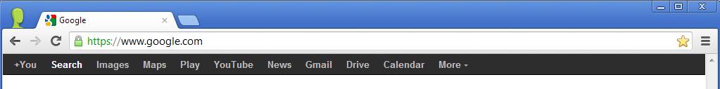

Notice the row of menu buttons. These represent new browser windows and links that help you navigate to new content. They are web browser favorites that you can change or add additional links specific for navigation through the internet. From your browser of choice, take a minute to explore your browsers Favorites feature.



Touch screens are used on mobile devices like tablets and phones. The web pages are arranged specific to the device you will be using. Navigation buttons are similar; however, you use your fingers or a stylus to move about the web page.

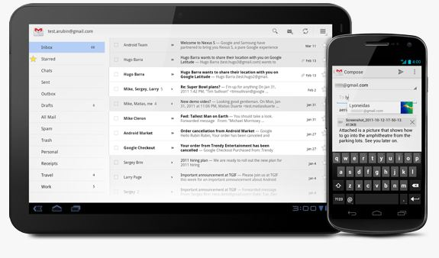

## 

# Lesson 2: Tips and Tricks

## Open Multiple Windows

Having access to multiple windows adds an additional level of effective process to your workflow. By using   
CTRL + N (or, on a Mac, CMD + N), you are able to open a new window. There are different results, depending on the browser that you are using.

If you’re using Internet Explorer, you’ll already be logged into a QuickBooks Online screen. With Firefox and Chrome, you’ll have to type the QuickBooks Online URL into the address bar, but you won’t need to enter your username and password. Another option is to open a new tab in the current browser window. From Chrome, right click the tab you’re in, and then click Duplicate.

[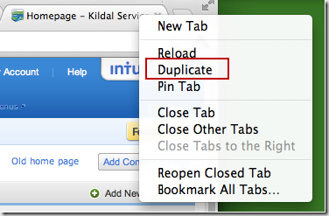](http://www.sleeter.com/blog/wp-content/uploads/2012/03/image25.png)

What if you want to see the windows side by side? Just pull the tab out into its own window. When completed, drag it back. Chrome handles this function best.

View Reports Side by Side

1. If you haven’t already done so, open the QBO Plus Test Drive in the Chrome browser: <https://qbo.intuit.com/redir/testdrive>
2. Click the Reports tab, and then select Profit & Loss.
3. Right click the Chrome tab, and select Duplicate. Two identical tabs now appear. Each show the Reports tab with the Profit & Loss report.
4. On the new tab, select Balance Sheet.
5. Drag the Balance Sheet from the browser window.

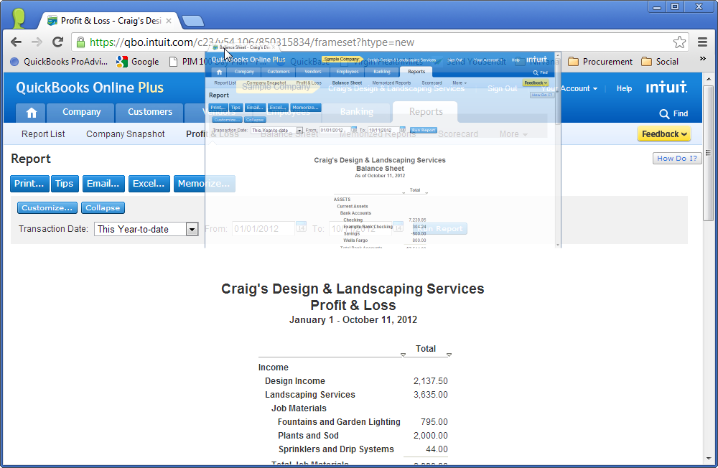

1. The Balance Sheet tab now appears in its own browser window.

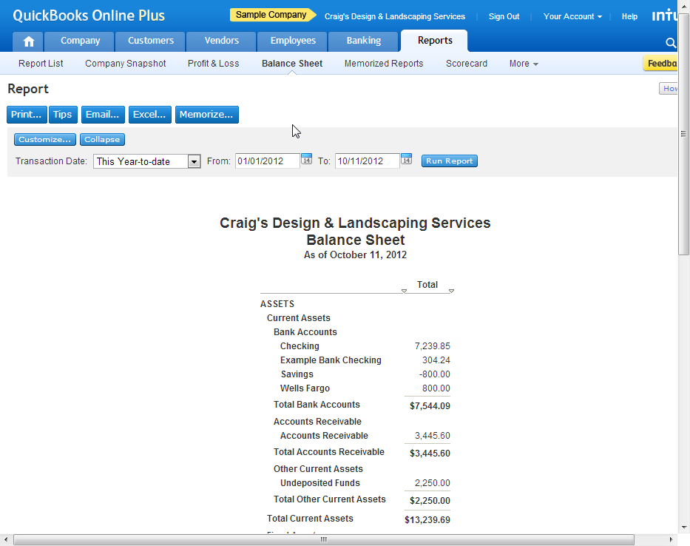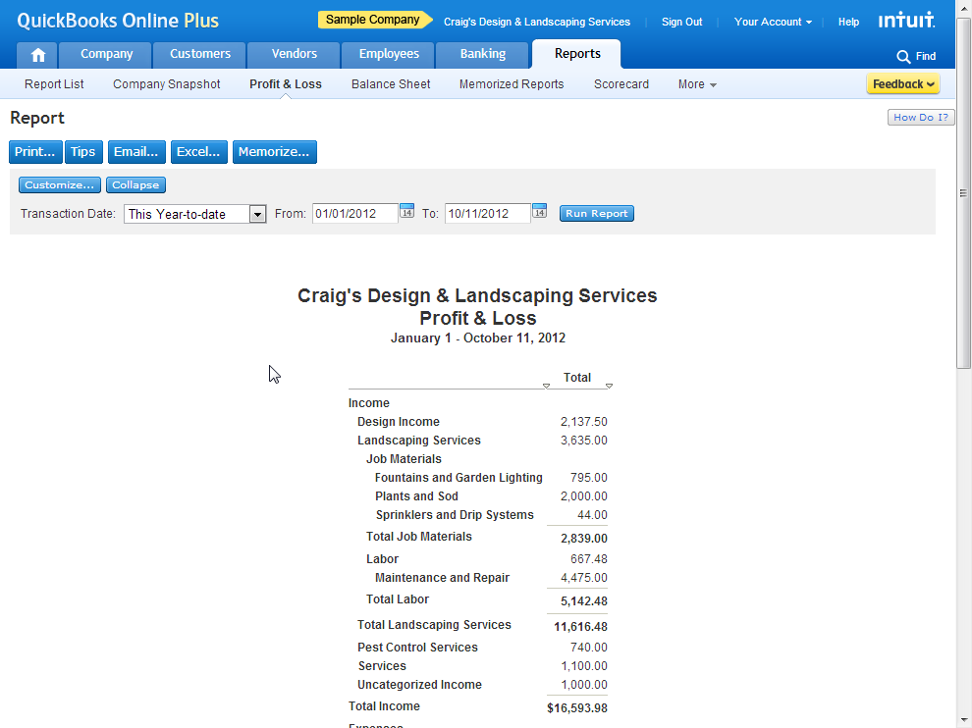

1. Once you have finished comparing the reports side by side, return the Balance Sheet tab by dragging it by the tab over the original browser window. The Balance Sheet tab is returned to the original browser window.
2. Close the Balance Sheet by pointing to its tab and clicking the X that appears.

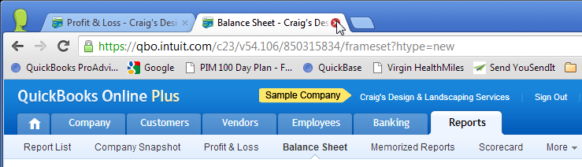

1. Click the Home tab to close the Profit & Loss report.

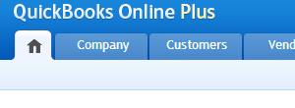

## Open Multiple Companies

Chrome offers a very useful feature of creating multiple users. This enables you to have two different QuickBooks Online companies open at the same time. Here is the process of creating a second user in Chrome.

1. Open Chrome if it isn’t already open.
2. Click the Chrome Customize and control Chrome button, and then click Settings.

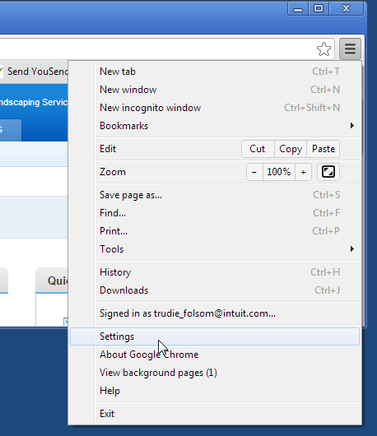

1. Click Add new user.

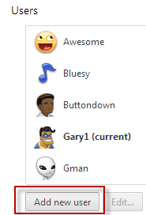

1. Create a Buddy Icon and name for your new user.

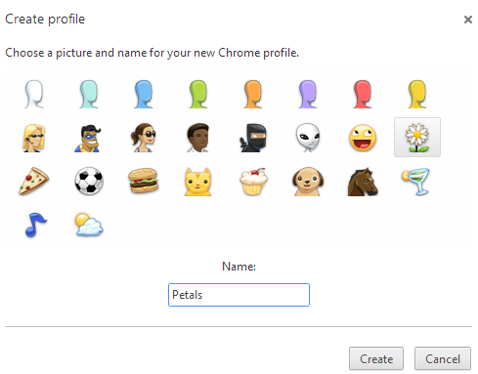

1. Once you add an additional user, you can open up a Chrome browser window for each user and log in to QuickBooks Online separately.

[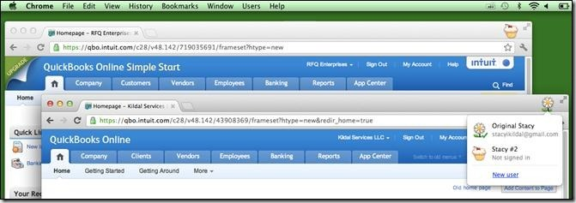](http://www.sleeter.com/blog/wp-content/uploads/2012/03/clip_image0051.jpg)

See How to Open Multiple Companies

Watch a demo about how to open multiple companies on the Radio Free QuickBooks YouTube Channel: <http://youtu.be/L2iOEui78LA>.

## Installing the Chrome QuickBooks Online App

You can type in qbo.intuit.com into the browser address bar, and you are off and running. But maybe you are thinking, “Wouldn’t clicking an icon be easier than typing in the URL?” There’s an app for that!

1. Log into your Chrome account or set one up at Chrome.Google.com.
2. Click the Chrome Web Store icon if it appears on the Chrome home page or go to  
   <https://chrome.google.com/webstore/category/home>



1. Search for the QuickBooks Online App and install the QuickBooks Online Icon app. It will appear next to the other icons on your Chrome home page.

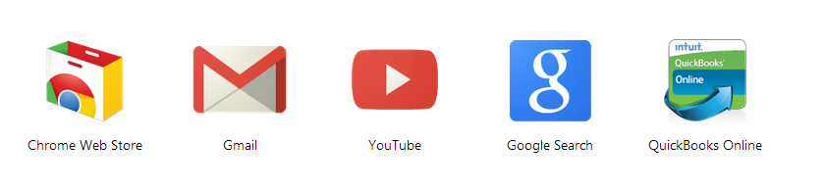

1. Right click the QuickBooks Online icon from the Chrome home page. There are additional dropdown options you may want to consider, such as creating a shortcut.

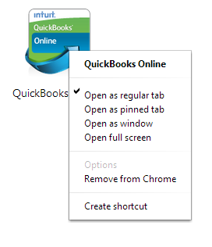 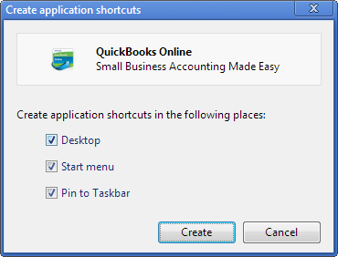

1. Clicking the icon takes you to the QuickBooks Online Sign In page.

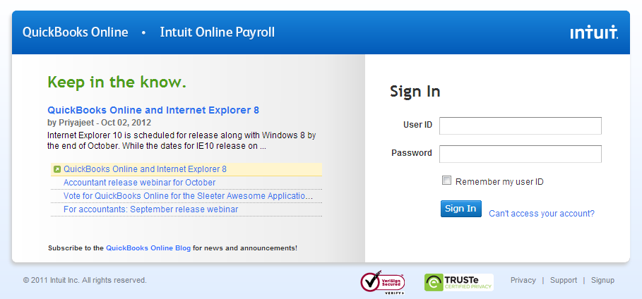

# Lesson 3: Tour of QuickBooks Online

Let’s check out how to get around in QuickBooks Online.



Sign In to the QBO Plus Test Drive

1. If you haven’t already done so, open the QBO Plus Test Drive in the Chrome browser: <https://qbo.intuit.com/redir/testdrive>
2. Enter the word that appears in the Security Verification window, and then click Continue.

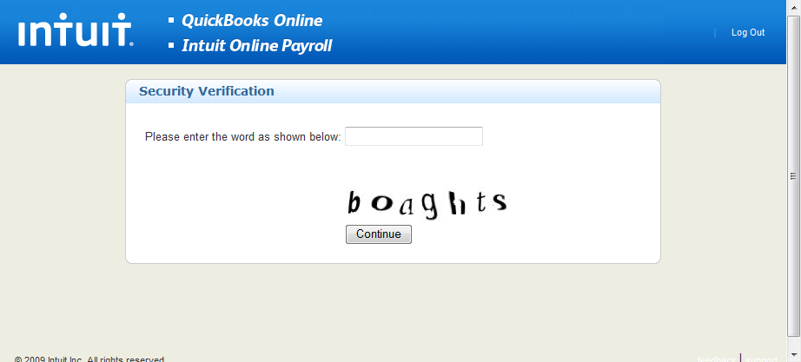

1. Close this window if it appears.

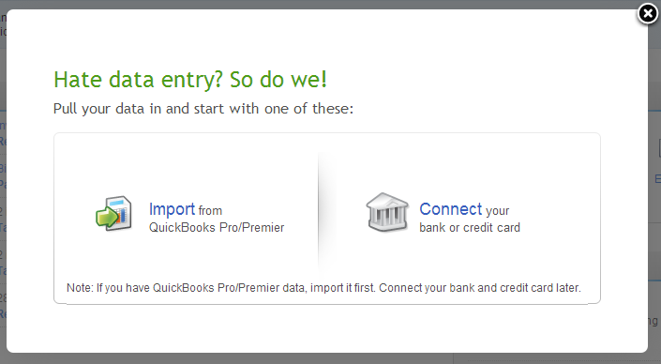

To sign in to a real QuickBooks Online company:

1. From your browser address bar, type in [qbo.intuit.com](http://www.google.com/url?q=http%3A%2F%2Fqbo.intuit.com&sa=D&sntz=1&usg=AFQjCNG2P2AirBwSWbRYw5T71zndLCCjtg).
2. The Sign In window opens.

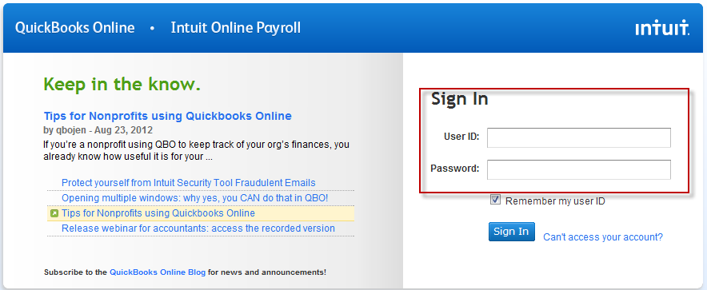

Note: You must enable pop-ups for QuickBooks Online. See this article to learn how to turn off your browser’s pop-up blocker: <https://qboe.custhelp.com/app/answers/detail/a_id/2701>

## Company Name/Your Account

Let’s start from the top of the QuickBooks Online window.

Company Name and Sign Out.png

* Company Name: You may eventually have multiple companies in QuickBooks Online. The easiest way to confirm you are viewing the correct company is to locate the company name in the top center of the QuickBooks Online window. The dropdown window (triangle) will list multiple companies’ you may have created with your login information.
* Sign Out will log you out of the QuickBooks Online company and close it
* Your Account gives you access to basic account information
* Help guides you to help menus and Knowledge Base articles

Note: The Your Account and Help features are not currently enabled in the QBO Plus Test Drive.

# Lesson 4: Home Tab

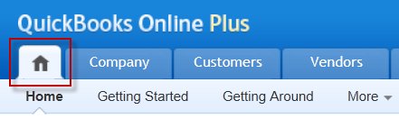

## Home Page Features

The Home Page is the first screen you see when first launching QuickBooks Online. Notice the layout:

* To do list
* Quick Links
* Messages
* Recent Activities
* Financial Snapshot
* Do more with QuickBooks Online

Important Note: The Home page in the Test Drive may have a different look and feel from what is seen by people who have had QuickBooks Online accounts for a year or more.

Let’s explore the To Do list. After completing, please look at other Home Page Features on your own.

Complete a Task on Your To Do List

1. You have received $35.00 from Shara and need to post the payment against her invoice.
2. From the To Do List, click Record Payment for the first Past Due item for Shara Barnett. The Receive Payment window opens. Notice most of the needed information to post this payment is automatically  
   filled in.
3. She sent you a $35.00 check with check number 123. Enter this information in the Pmt Method dropdown and Ref# box.
4. In the Invoices and outstanding transactions section, check the invoice for the $35.00 if it is not already selected.
5. You want to deposit this money to checking. This is what your completed transaction should look like:

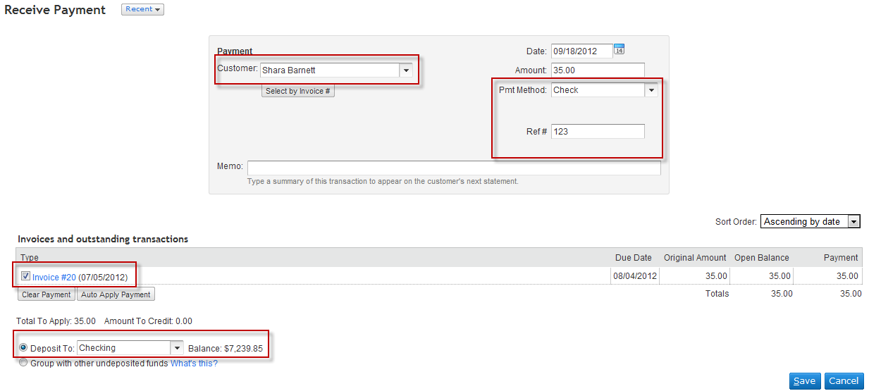

1. Click Save.
2. Notice your payment was received and confirmed.

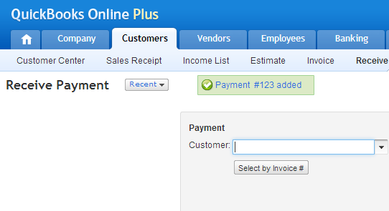

## Getting Started Resources

Unlike the Test Drive, the Home tab in a real QuickBooks Online company has helpful features for new users, including the Getting Started window, which contains links to tutorials and a getting started guide.

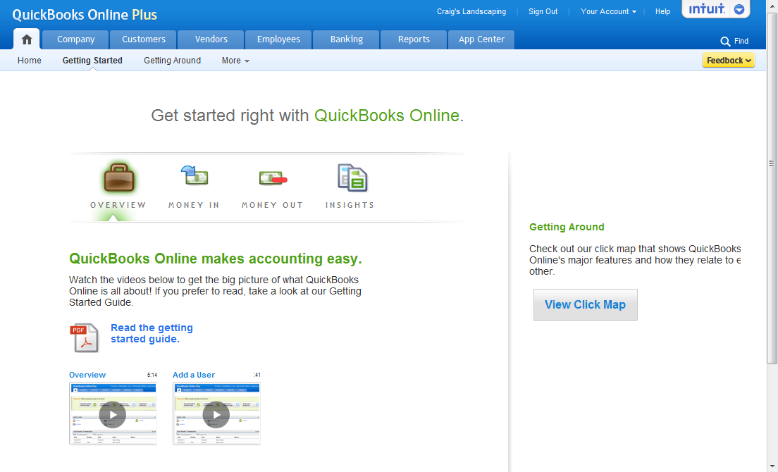

In addition, there is a Getting Around page that shows a map for navigating the workflow of Money-in and Money-out transactions. Click on an icon to navigate to the feature. There is a pop-up Learn More link available to know more about the transactions related to that workflow.

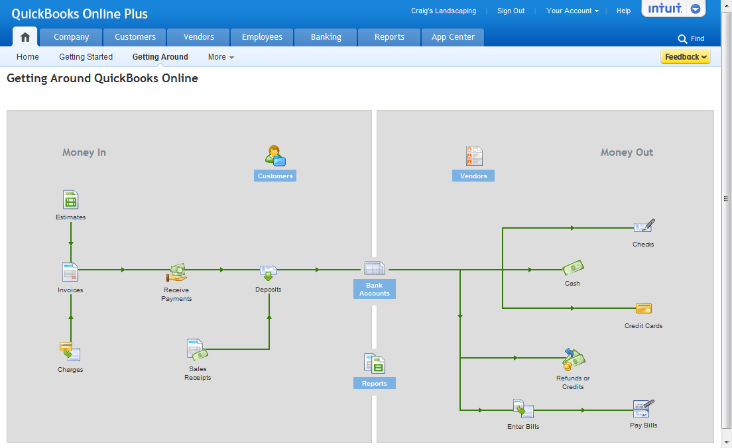

## Menu Tabs

We covered the Home tab. Now let’s take a high level look at the other tabs. We cover these tabs in greater detail in other courses.



* Company
* The Company tab offers links to many types of lists, important to organizing data and making transactions
* The Chart of Accounts is accessed from this tab
* Lists is the central spot for accessing all lists



* Customers
* The Customer tab contains the Customer List, Sales Receipt, Income List, Invoice, Receive Payment, Accept Credit Cards, Statements and More
* The Income List is a great place to complete many transactions all in one place



* Vendors
* The Vendors tab contains the Vendors List, Purchase Orders, Enter Bill, Pay Bills, Pay One Vendor, Vendor Credit and More



* Employees
* From the Employees tab you can Set up payroll, and access the Single Activity Time Sheet, Weekly Time Sheet and More

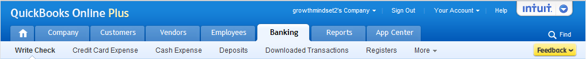

* Banking
* The Banking links are Write Check, Credit Card Expense, Cash Expense, Deposits, Downloaded Transactions, Registers and More



* Reports
* The Reports tab contains links to the Reports List, Company Snapshot, Profit & Loss, Balance Sheet, Memorized Reports, Scorecard, Customer Balance Detail and More



* App Center
* The App Center contains links to important to working solutions that work with QuickBooks Online

## 

# Lesson 5: Helpful Tools for Getting Started

In the upper right corner is a set of links to assist you in locating help and information.

## Find

* Use Find to search for specific transactions in QuickBooks Online

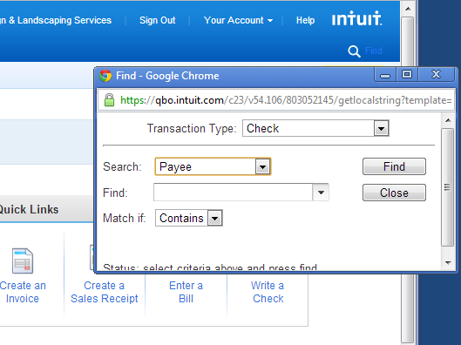

## Feedback

* Feedback is your opportunity to let Intuit know what you think about QuickBooks Online. QuickBooks Online product managers read the feedback frequently. Be sure to be very specific about your feedback so that it’s easy to understand what action should be taken to improve QuickBooks Online. If you click that it’s OK to contact you, don’t be surprised if they take you up on it!

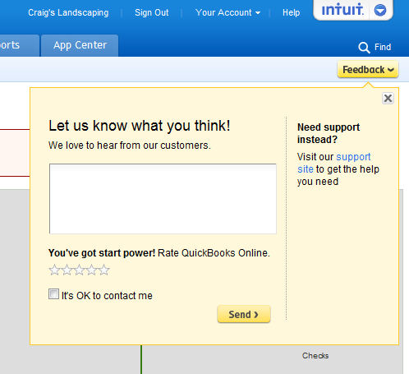

## How Do I?

* The How Do I? link corresponds directly to the page you are currently on. Clicking the How Do I? will give you links to helpful step-by-step instructions on how to perform tasks. Take a few minutes and explore the How Do I? links.

## Intuit Community and QuickBooks Online Blog

The Intuit Community is a great place to gather additional information, and it’s super easy to access.

* The bottom right of the Home tab has several links to Privacy/Security/Terms of Service/Mobile/Forum and Blog sites. Click Forum to access the Intuit Community for QuickBooks Online.

community.png

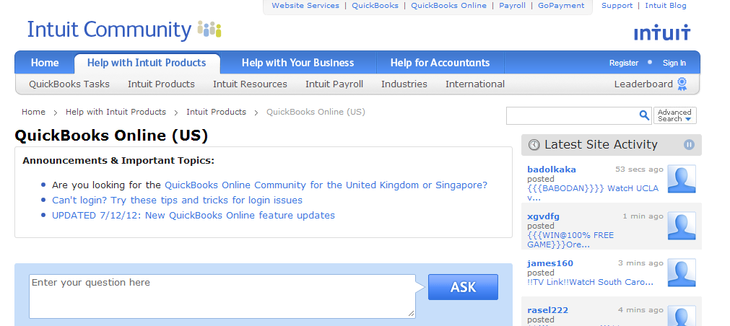

## QuickBooks Online Blog

The QuickBooks Online Blog is a great way to learn tips and tricks, and keep up with the improvements to QuickBooks Online. Click **Blog** to access it.



Subscribe to the QuickBooks Online blog

1. Click Blog or go to [blog.qbo.intuit.com](http://blog.qbo.intuit.com).
2. On the right under Email Subscription, enter your email address and then click Sign me up!

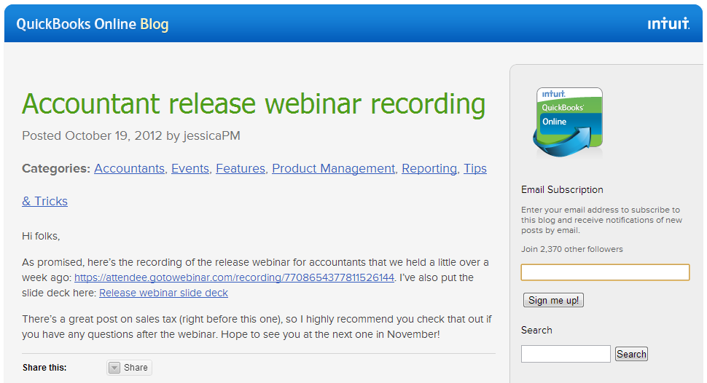

1. You will receive a confirmation email. Click Confirm Follow.

# 

# Course Conclusion

This course covered the basics of working in a supported web browser and the basics of navigating in QuickBooks Online. You explored the browsers ability to bring up web pages and move from one page to another. You identified a browser’s basic buttons and links. You learned about the menu tabs and features of QuickBooks Online.