QuickBooks Online 2013 Student Guide

Course 5:  
Reporting in QuickBooks Online

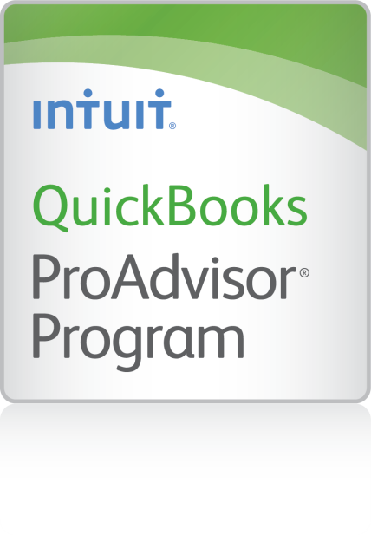

**Copyright**

© 2013 Intuit Inc. All rights reserved.

**Trademarks**

©2013 Intuit Inc. All rights reserved. Intuit, the Intuit logo, and QuickBooks, among others, are registered trademarks of Intuit Inc. Other parties’ marks are the property of their respective owners.

**Notice to Readers**

The publications distributed by Intuit Inc. are intended to assist accounting professionals in their practices by providing current and accurate information. However, no assurance is given that the information is comprehensive in its coverage or that it is suitable in dealing with a client’s particular situation. Accordingly, the information provided should not be relied upon as a substitute for independent research. Intuit Inc. does not render any accounting, legal, or other professional advice nor does it have any responsibility for updating or revising any information presented herein. Intuit Inc. cannot warrant that the material contained herein will continue to be accurate or that it is completely free of errors when published. Readers should verify statements before relying on them.

Table of Contents

About the Author 3

Course Overview 4

Course Opening 4

Objectives 4

Training at a Glance 5

QBO Plus Test Drive 6

Preferences Pre-work 6

Lesson 1: Reports Overview 8

Reports Available 8

QuickBooks Online Simple Start: 20+ Reports 8

QuickBooks Online Essentials: 40+ Reports 9

QuickBooks Online Plus: 65+ Reports 10

Viewing Reports 13

Changing How A Report Looks When Printed 14

Turn on the Text Wrapping Preference for Reports 14

Change Browser Printing Options 14

Change the Way Column Titles Print 15

Printing Wide Reports 15

Email Reports 16

Customizing the Content of a Report 16

Lesson 2: Company Reports 18

What is a Company Report? 18

Balance Sheet 19

Profit & Loss 19

Quick Company Health Reports 20

Company Snapshot 20

Scorecard 21

Lesson 3: Customer Reports 22

Customer Balance Detail Report 22

Collections Report 23

Unbilled Charges Report 24

Memorized Reports 25

Customizing Fields, Columns and Filtering 28

Sorting and Filtering (Matching) 31

Lesson 4: Vendor and Sales Reports 32

A/P Aging Summary Report 32

Sales by Customer Detail Report 33

Sales by Product/Service Detail Report 34

Course Conclusion 35

# About the Author



#### **Megan Bronson, CPA**

Squire & Company, PC

Megan is an Advisory Supervisor Accountant at Squire & Company, PC, located in Orem, Utah – a full-fledged CPA firm specializing in Audit, Tax, and Business Advisory. Megan is a Certified Public Accountant and Advanced QuickBooks ProAdvisor, and has provided consulting and training services for many of the Intuit suite of products, including QuickBooks Enterprise Solutions, QuickBooks Point of Sale, and QuickBooks Online.

She teaches many QuickBooks seminars through in-class sessions, one on one consulting sessions, and online webinars. She is most recently participating in developing QuickBooks training materials through the Intuit Trainer/Writer Network. She works hard to empower her clients to know their accounting system enough to either do it themselves or have confidence that it is providing valuable information as they make business decisions.

She is involved in the community through Kiwanis, a global organization dedicated to serving children, as well as spending significant time providing service through her local church. She loves spending time with her young family and playing sports whenever she gets a chance.

Squire & Company, PC provides numerous accounting services, including individual and business tax return preparation and planning; audit, review, and compilation services; technology consulting; and business advisory services including outsource CFO, processes and policy documentation, financial planning, and much more. Squire is one of the original Intuit Solution Provider firms and has Premier status in the Intuit Reseller Program. Megan can be reached at [meganb@squire.com](mailto:meganb@squire.com)

# Course Overview

## Course Opening

Working from the QuickBooks Online Plus Test Drive, you will explore the power of reporting in QuickBooks Online. You will find the company reporting features help measure the health of your company. You will see a company’s use of sales reports to track income and vendor reports that track spending.

## Objectives

In this module, you will work through hands-on activities to:

* Identify features and utility of Company reports
* Recognize the elements of the Sales and Vendor reports
* Identify features of AP Aging and Vendor Balance Detail reports

## Training at a Glance

|  |  |  |
| --- | --- | --- |
| Lessons | Topics | Description |
| 1. Reports Overview | * View, print, and e-mail customizable reports * QuickBooks Online Simple Start: 20+ reports * QuickBooks Online Essentials: 40+ reports * QuickBooks Online Plus: 65+ Reports | Explore the types of reports and various changes that you can modify report data using all the versions of QuickBooks Online. |
| 1. Company Reports | * Balance Sheet Report * Profit and Loss Report * Company Snapshot * Scorecard | Uncover the use of basic company reports to show profit, expenses, liabilities and income. |
| 1. Customer Reports | * Customer Balance Detail Report * Collections Report * Unbilled Charges Report * Memorized Reports | Identify customer reports. Showing the amounts of money still on the books but net yet collected is important to the bottom line of any business. |
| 1. Vendor and Sales Reports | * A/P Aging Summary Report * Sales by Customer Detail Report * Sales by Product/Service Detail Report | How much you sell and how much you spend is critical to profits. Vendor billing can be looked at and evaluated using vendor reports. |

## QBO Plus Test Drive

Lessons in the Activities Handbooks include hands-on exercises in a QuickBooks Online Plus “test drive”. The test drive uses a sample company file called Craig’s Design & Landscaping Services. It can be accessed through the following link:

<https://qbo.intuit.com/redir/testdrive>

You don’t have to create an account or sign in; just complete the security validation and click Continue. This test drive is designed for you to explore and try out new things without worrying that you will break something or make a mistake. It is not designed to retain any changes you make. Once you close the QBO Plus test drive, it is completely refreshed, so please remember to allow sufficient time to complete each activity. But don’t worry if you have to close the test drive before you are finished! You can always begin again.

Note: The test drive uses the QuickBooks Online Plus plan. It contains some features that are not available in QuickBooks Online Simple Start or Essentials. In addition, some features, such as the Apps Center tab and in-product Help are not enabled at this time. However, this is subject to change.

## Preferences Pre-work

1. Open the QBO Test Drive <https://qbo.intuit.com/redir/testdrive>.
2. On the Company tab, click Preferences.
3. In the Preference list, under Sales Form Entry, click Delayed Charges to go to that section of the Preferences screen. Click the box next to Delayed charges.

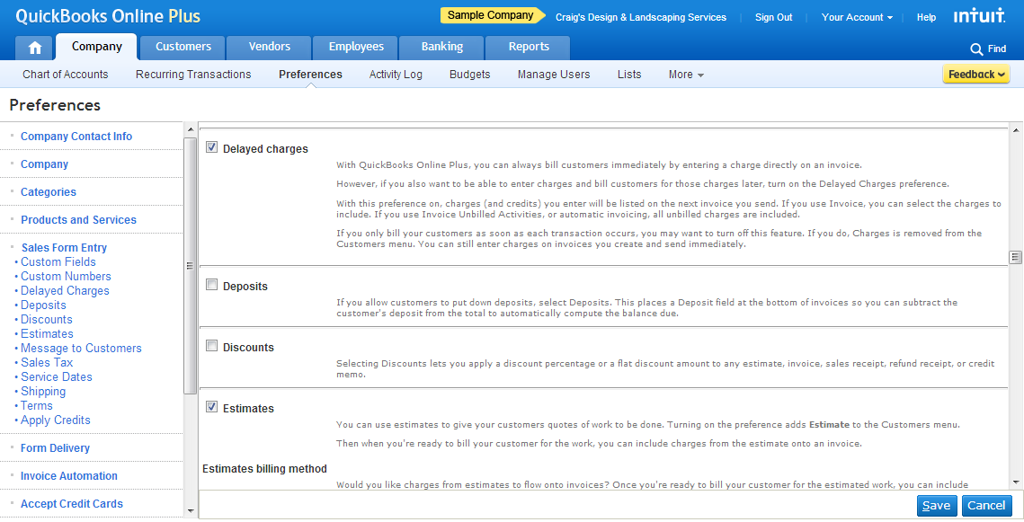

1. In the Preferences list, scroll down to Reports, and click Cash/Accrual. In the Preferences screen, in the Default accounting method for summary section, select Accrual.
2. In the Default display and print settings section, select Turn on text wrapping in report columns.
3. Scroll down to the bottom of the Preferences screen. In the Numbers Format section, select Normal and under Show All Numbers, check Except Zero Amounts.
4. Click Save.

# Lesson 1: Reports Overview

Reports are critical for feedback and specialized business activities. Their objective is to provide information about the financial position, and the performance and changes in the financial position of a company. Reports should be understandable, relevant, reliable and comparable. They show assets, liabilities, equity, income and expenses that are directly related to an organization's financial position.

The purpose of reports can impact an owner’s important business decisions that affect its continued operations. They can provide management with a more detailed understanding of the figures. These reports are also used as part of management's annual report to the stockholders.

This lesson will focus on how reports are viewed, printed, sent, and customized in QuickBooks Online.

## Reports Available

The process is simple to access reports. Click the Reports tab to see the Reports List page. It contains a complete list of all reports available. They are separated in categories. Here are the categories in QuickBooks Online Plus at the time of writing:

|  |  |
| --- | --- |
| * Company * Customers * Sales * Vendors * Tax * Employees | * Payroll * Banking * Budgets * Accountant & Taxes * Lists |

### QuickBooks Online Simple Start: 20+ Reports

There are reports available for use based on the version of QuickBooks Online you have purchased. For QuickBooks Online Simple Start, here are some of the reports you have access to:

|  |  |
| --- | --- |
| * A/R Aging * Account Listing * Balance Sheet * Check Detail * Collections Report * Customer Balance Summary * Memorized Reports | * Taxable Sales * Transaction List by Date * Profit & Loss * Reconcile Reports * Sales by Customer * Sales by Product/Service * Statement of Cash Flows |

### QuickBooks Online Essentials: 40+ Reports

For QuickBooks Online Essentials, here is the list of reports available:

#### Company (8)

|  |  |
| --- | --- |
| * Profit & Loss * Profit & Loss Detail * Balance Sheet * Balance Sheet Summary | * Statement of Cash Flows * Account Listing * Company Snapshot * Scorecard |

#### Customers (11)

|  |  |
| --- | --- |
| * A/R Aging Summary * A/R Aging Detail * Customer Balance Summary * Customer Balance Detail * Collections Report | * Income by Customer Summary * Transaction List by Customer * Sales by Customer Summary * Sales by Customer Detail * Invoice List * Statement List |

#### Sales (8)

|  |  |
| --- | --- |
| * Sales by Customer Summary * Sales by Customer Detail * Sales Tax Liability Summary * Taxable Sales Detail | * Invoice List * Statement List * Sales by Product/Service Summary * Sales by Product/Service Detail |

#### Vendors (9)

|  |  |
| --- | --- |
| * A/P Aging Summary * A/P Aging Detail * Vendor Balance Summary * Vendor Balance Detail | * Unpaid Bills * Expenses by Vendor Summary * Bill Payment List * Transaction List by Vendor * Vendor Contact List |

#### Banking (3)

|  |
| --- |
| * Check Detail * Deposit Detail * Reconciliation Reports |

#### Accountant & Taxes (7)

|  |  |
| --- | --- |
| * Trial Balance * General Ledger * Journal | * Transaction Detail by Account * Transaction List by Date * Transaction List with Splits * Recent Transactions |

#### Lists (11)

|  |  |
| --- | --- |
| * Customer Phone List * Customer Contact List * Vendor Phone List * Vendor Contact List * Employee Phone List | * Employee Contact List * Account Listing * Product/Service List * Payment Method Listing * Terms Listing * Recurring Template Listing |

### QuickBooks Online Plus: 65+ Reports

For QuickBooks Online Plus, here is a list of all available reports. Note: The reports available in your company depend on the features you are using. For example, if you’re using Class Tracking, on the Report List you’ll see Profit & Loss by Class, Sales by Class Summary, and Sales by Class Detail.

#### Company Reports (10)

|  |  |
| --- | --- |
| * Profit & Loss * Profit & Loss by Location * Profit & Loss by Class * Profit & Loss Detail * Balance Sheet | * Balance Sheet Summary * Statement of Cash Flows * Account Listing * Company Snapshot * Scorecard |

#### Customer Reports (13)

|  |  |
| --- | --- |
| * A/R Aging Summary * A/R Aging Detail * Customer Balance Summary * Customer Balance Detail * Collections Report * Income by Customer Summary * Estimates by Customer | * Transaction List by Customer * Sales by Customer Summary * Sales by Customer Detail * Invoice List * Statement List * Unbilled Charges |

#### Sales (12)

|  |  |
| --- | --- |
| * Sales by Customer Summary * Sales by Customer Detail * Sales by Location Summary * Sales by Location Detail * Sales by Class Summary * Sales by Class Detail | * Sales Tax Liability Summary * Taxable Sales Detail * Invoice List * Statement List * Sales by Product/Service Summary * Sales by Product/Service Detail |

#### Vendors (14)

|  |  |
| --- | --- |
| * A/P Aging Summary * A/P Aging Detail * Vendor Balance Summary * Vendor Balance Detail * Unpaid Bills * Expenses by Vendor Summary * Bill Payment List | * Transaction List by Vendor * Vendor Contact List * Purchases by Vendor Detail * Purchases by Product/Service Detail * Purchases by Location Detail * Purchases by Class Detail * Open Purchase Order List |

#### Tax (1)

* Tax Liability Report

#### Employees (4)

|  |  |
| --- | --- |
| * Time Activities by Employee Detail * Time Activities by Customer Detail | * Unbilled Time * Recent/Edited Time Activities |

#### Payroll (15)

|  |  |
| --- | --- |
| * Payroll Summary * Payroll Details * Payroll Deductions/Contributions * Last Paycheck * Employee Details * Paycheck List * Payroll Tax Liability | * Payroll Tax and Wage Summary * Total Pay * Payroll Tax Payments * Workers' Compensation * Vacation and Sick Leave * Payroll Billing Summary * Total Payroll Cost * Retirement Plans |

#### Banking (3)

* Check Detail
* Deposit Detail
* Reconciliation Reports

#### Budgets (2)

* Budget Overview
* Budget vs. Actuals

#### Accountant & Taxes (8)

|  |  |
| --- | --- |
| * Trial Balance * General Ledger * Journal * Transaction Detail by Account | * Transaction List by Date * Transaction List with Splits * Recent Transactions * Recent Automatic Transactions |

#### Lists (13)

|  |  |
| --- | --- |
| * Customer Phone List * Customer Contact List * Employee Phone List * Account Listing * Payment Method Listing * Property Listing * Recurring Template Listing | * Vendor Phone List * Vendor Contact List * Employee Contact List * Product/Service List * Terms Listing * Class Listing |

## Viewing Reports

Viewing a report is easy. In the Report List screen simply click on any report from the list of categories, and that report will display. Move your cursor over the report and notice that links appear when you mouse over them. This is the QuickZoom® feature. Click one of the links, and it shows the detail behind the reports and lets you drill down to the transaction level. You can display original transactions and analyze the numbers behind the numbers. It is easy to see summary reports on a cash or accrual-basis at any time.

It is possible to collapse and expand the parent and child accounts in reports. Simply click Collapse. It will alternate to the Expand button if you want to return to the full display of information.

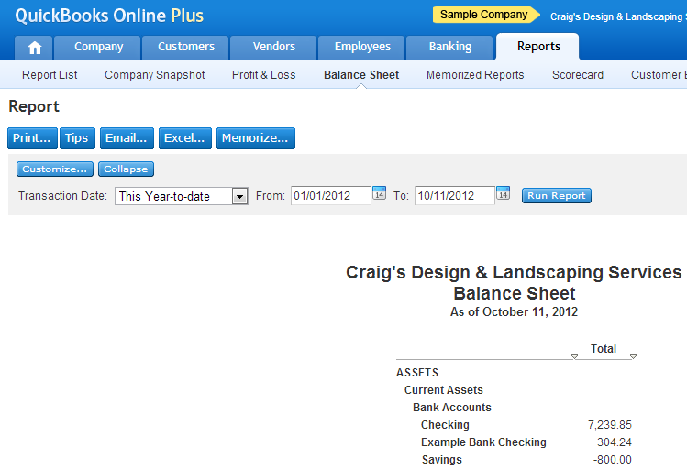

For more additional information beyond this default display, see later in this lesson.

## Changing How A Report Looks When Printed

### Turn on the Text Wrapping Preference for Reports

You can control whether or not text wraps automatically in report columns. Turning on text wrapping can improve how a report appears on the screen or the printed page.

* On the screen, text wrapping helps minimize having to scroll horizontally
* On the printed page, text wrapping helps prevent cutting off the columns on the right side of the page

You can set the default behavior for text wrapping in reports using Preferences. Each user in your company can have individual settings for this preference.

To turn on text wrapping for reports:

1. Open Preferences (or, from the Company menu, choose Preferences).
2. Click the Reports section; then click Display/Print Settings.
3. Select the Turn on text wrapping in report columns checkbox.

Click Save.

### Change Browser Printing Options

Browser printing options control page orientation and margins:

1. From your browser's File menu, choose Page Setup.
2. Make your changes.
3. Click OK.

### Change the Way Column Titles Print

Your browser has a setting that controls if it prints background colors and images, or ignores them.

QuickBooks Online Plus uses background colors for headings, so by controlling how your browser prints background colors, you can control the way QuickBooks Online Plus prints headings.

Try printing both ways to see which you prefer.

1. From your browser's Tools menu, choose Internet Options.
2. Click the Advanced tab.
3. Scroll to the Printing section.

Check or clear Print background colors and images.

You can also:

* Adjust the column width and have the columns print the way they show up on the screen.
* Export it to Microsoft Excel. In Excel, you can control all the formatting (fonts, headers and footers, columns, spacing).

## Printing Wide Reports

If some of the columns in your report don't print, try the following:

|  |  |
| --- | --- |
| * Preview the appearance of a printed report * Turn on text wrapping for reports * Resize columns in a report * Remove unneeded columns * Make the margins smaller * Change the orientation to landscape | * Print on legal-size paper * Scale the page by a percentage. Check your Printer Setup properties to see if your printer driver supports scaling. * Export the report to Excel: In a spreadsheet, you have more control over report formatting. |

## Email Reports

Emailing reports is simple. Here are the steps:

1. Create the report you want to send.
2. Click Email... the Email Report window opens.
3. Fill out the fields. Here are some tips:

* From: This is auto-populated with the email address associated with your login name. If it's the wrong email, click Incorrect? and follow the instructions.
* To: Enter the recipients full email address. If there is more than one recipient, separate the addresses with commas or semi-colons.
* Subject: The default subject is the name of the report. You can change the subject.

1. Click Send. The report is sent as text in the body of the email and as an html attachment.

## Customizing the Content of a Report

It's easy to customize QuickBooks Online reports, so you can quickly develop report formats tailored to your unique business. Once you customize a report, you can have QuickBooks Online memorize it so that you can run it any time you wish. Customize QuickBooks Online reports in minutes from the Customize Report window.

To change what a report shows:

* There are two ways to open the Customize Report window
* In the Report List, click the wrench button next to the name of the report.
* Open the report, and then click Customize at the top of the report.
* To Change the settings in the Customize Report window and then click Run Report.

For example, by default, each report shows data as of today's date. To limit the report to a different set of dates, choose a Transaction Date range above the report or in the Customize Report window.

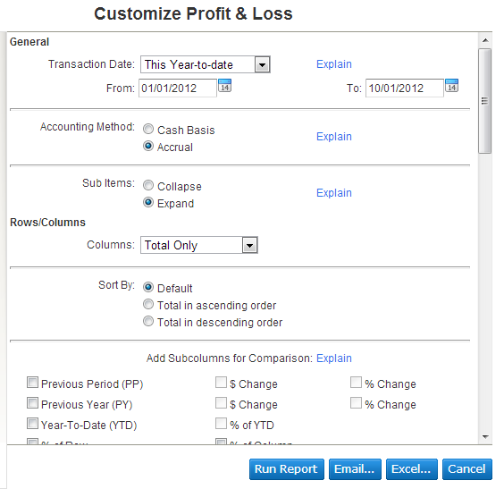

The Customize Report window contains many settings that help you limit the report so that it shows only what you want to see. To further customize, export the report to Excel. In Excel, you can control all the formatting (fonts, headers and footers, columns, spacing).

Note: The options available for customizing reports depend on the features that are turned on in QuickBooks Online. For example, you cannot customize by class if class tracking isn’t turned on.

# Lesson 2: Company Reports

## What is a Company Report?

Simply: it is financial statement indicating a company’s health. Reading a report is fairly easy. If you can read what ingredients are in a package of soup or baseball stats from last night’s baseball game from the morning paper, you can learn to read basic financial reports.

Remember Cuba Gooding Junior’s immortal line from the movie Jerry Maguire, “Show me the money!” Reports show you the money. They show you where a company’s money came from, where it went, and where it is now.

There are four main financial statements.

* Balance Sheet: shows what a company owns and what it owes at a fixed point in time
* Profit & Loss statement: shows how much money a company made and spent over a period of time
* Cash flow statement: shows the exchange of money between a company and the outside world over a period of time
* Statements of shareholders’ equity (you, your partner or investor—i.e. Bank—are shareholders): shows changes in the interests of the company’s shareholders over time

Let’s look at each of the first two financial statements in more detail.

### Balance Sheet

“What is my business worth?” This report provides a financial snapshot of your company. It lists the balances for each asset, liability, and equity account as of a specific date. It also calculates what your business is worth (the equity) by subtracting what your company owes (liabilities) from everything it owns (assets).

* Assets are things that a company owns that have value. This typically means they can either be sold or used by the company to make products or provide services that can be sold. Assets include physical property, such as plants, trucks, equipment and inventory. It also includes things that can’t be touched but nevertheless exist and have value, such as trademarks and patents. And cash itself is an asset. So are investments a company makes.
* Liabilities are amounts of money that a company owes to others. This can include all kinds of obligations, like money borrowed from a bank to launch a new product, rent for use of a building, money owed to suppliers for materials, payroll a company owes to its employees, environmental cleanup costs, or taxes owed to the government. Liabilities also include obligations to provide goods or services to customers in the future.

Balance Sheet Report

1. On the Reports tab, click Balance Sheet.
2. Notice the list of assets and below them, the list of liabilities.

### Profit & Loss

“How much money did I make and spend?” This report is also called an income statement. It summarizes your income and expenses for each income or expense account on your chart of accounts, so you can tell if you're operating at a profit or a loss. The important thing to remember about an income statement is that it represents a period of time. This contrasts with the balance sheet, which represents a single moment in time.

To understand how Profit & Loss reports are set up, think of them as a set of stairs. You start at the top with the total amount of sales and income made during the accounting period. Then you go down, one step at a time. At each step, you make a deduction for certain costs or other operating expenses associated with earning the revenue. At the bottom of the stairs, after deducting all of the expenses, you learn how much the company actually earned or lost during the accounting period. This is often called the “the bottom line.”

Moving down the stairs from the net revenue line, there are several lines that represent various kinds of operating expenses. Although these lines can be reported in various orders, the next line after net revenues typically shows the costs of the sales. This number tells you the amount of money the company spent to produce the goods or services it sold during the accounting period.

Profit & Loss Report

1. On the Reports tab, click Profit & Loss.
2. Notice the list of income and below, the list of expenses.

## Quick Company Health Reports

### Company Snapshot

The Company Snapshot report gives you a great overview of the money coming in and going out of your business, along with the ability to compare your business to others in your industry.

To access the report:

1. On the Reports tab and select Company Snapshot.
2. If prompted, install the Adobe® Flash® Player plug-in (this will require you to close all browser windows) and then try to access the report again.

When the report opens you will see the following:

* In the top-left box you will see a graphical representation of the five Income accounts with the most income for the selected period. All other accounts are lumped into a category called Other.
* The top-right box will show a pie graph of the five Expense accounts with the greatest expenses for the selected period. All other expenses are listed under the Other category.   
  Note: You can click on the Income and Expense pie charts to "drill down" to more detailed reports.
* The next set of boxes is Previous Year Income and Expense Comparison charts. These charts have been added to allow you to compare income and/or expenses from year to year. You can click on the chart itself to see detailed data used to make up the chart you see in this section.
* The bottom-left box lists all the Customers who owe you money and their current open balance amount.
* The bottom-right box shows all the Vendors you owe money to and your current open balance with them.
* In the top-right corner of each box is a Print icon. Click the icon to view the Print Preview page for the chart in that box. To print, click the Print button in the top-left corner of the Print Preview page.

Because of the unique nature of this report, you will notice the following limitations:

* No customization
* No ability to export to Excel, PowerPoint, or to copy and paste into other applications

### Scorecard

Intuit aggregates company data from thousands of small businesses who are using Intuit financial software. The data aggregation is done to be consistent with industry best practices and also in alignment with our privacy policy. The aggregated data excludes any company specific data such as address and telephone number so that any single company cannot be identified individually or by inference.

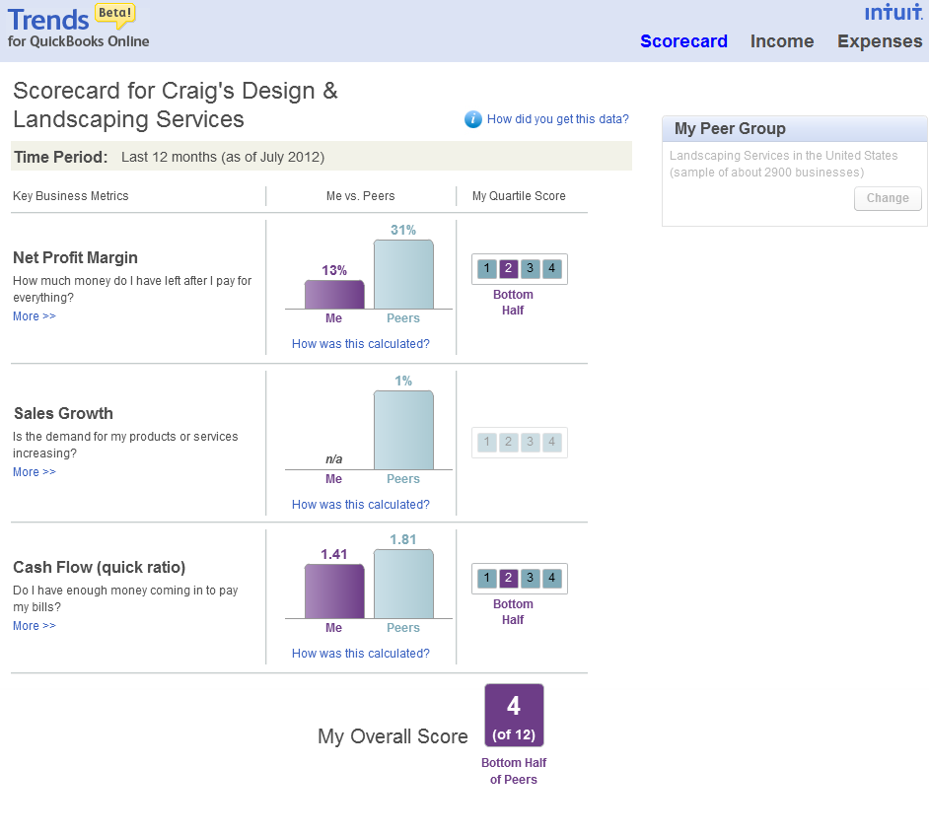

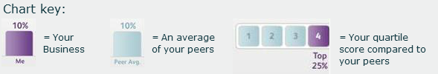

# Lesson 3: Customer Reports

## Customer Balance Detail Report

“What's the detail behind what customers owe?” The customer balance report list the customers who owe your company money and how long ago since their invoice for payment. This report shows the unpaid customer balances, grouped by customer and job. It can be very important information for you as a business owner to have, but it is useful to others as well. For example, your company’s bank may want to review your customer balance report if you are looking for a loan.

Creating a Customer Balance Detail Report

After finishing reading a magazine article about “Improving Your Business Acumen,” you have tried pulling the Customer Balance Summary and found you wanted more dates, balances and totals. You need more detail.

1. On the Reports tab, click Customer Balance Detail Report.
2. Notice the columns showing Customers, Dates, Amounts and Balances.

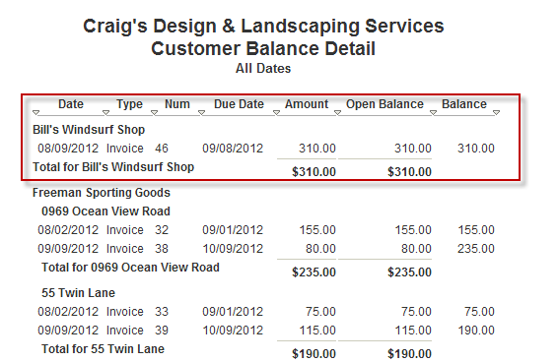

## Collections Report

“How do I collect overdue payments?” This report lists overdue invoices and unapplied credit memos grouped by customer. It includes when the invoice was due, the number of days past due, as well as the customer's phone number.

Creating a Collections Report

1. On the Reports tab, click Report List>Customers>Collections Report.
2. Notice the columns showing Customers, Dates, Past Due Amounts and Balances.

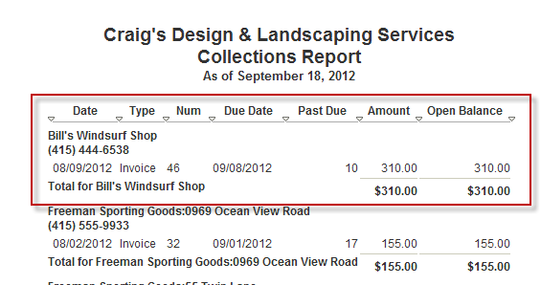

## Unbilled Charges Report

“What charges do I need to create invoices for?” This report lists transactions that have not yet appeared on an invoice.

Creating an Unbilled Charges Report

1. If you haven’t already done so, in the Preferences list, under Sales Form Entry, click Delayed Charges to go to that section of the Preferences screen. Click the box next to Delayed charges.
2. On the Customers tab, click Income List.
3. Click the Create New button and select the Customer Charge link from the dropdown menu.
4. From the Customer dropdown, select Amy’s Bird Sanctuary.
5. From the Product/Service dropdown, select Design. The description, QTY, Rate and Amount pre-fill.

Click Save.

To pull the Unbilled Charges Report, do the following:

1. On the Reports tab, click Reports List>Customers>Unbilled Charges.
2. Notice your unbilled charge for Amy’s Bird Sanctuary.

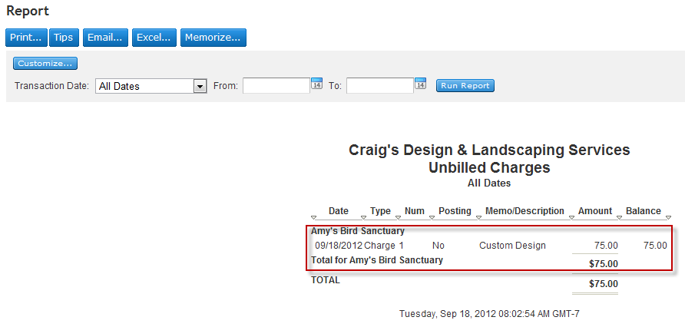

## Memorized Reports

Memorizing a report allows you to save it with its current customization settings. You can also set a schedule for sending the report (by itself or with a group of other reports) by email.

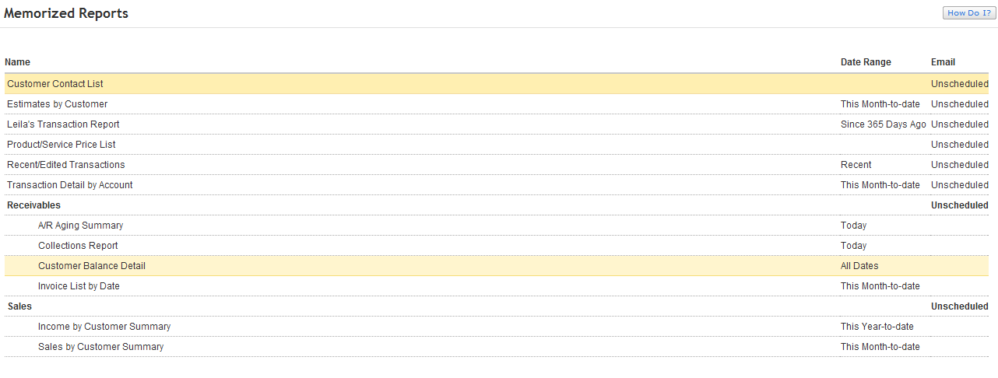

Creating Memorized Reports

Memorizing a report allows you to save it with its current customization settings.

1. Find and display the report you want to memorize. To change what's in the report, click the Customize button (wrench).

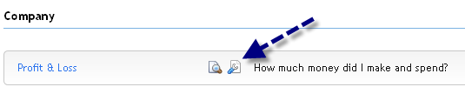

1. Once the report is customized the way you like it, click Run Report.
2. If you are satisfied with how the report looks, click the Memorize... button. Enter a descriptive name for the report in the Name of memorized report: field.

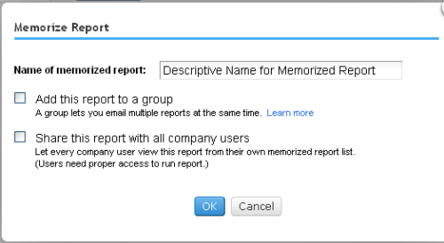

You can add this report to a group and/or give a copy to all company users.

Adding reports to a group allows you to set a common email schedule for all the reports in the group. The reports appear under the group name on your list of memorized reports. If you add a report with an email schedule to a group that also has an email schedule, the newly added report will follow the group's email schedule. In addition, you have the option of choosing if the reports are sent as Excel files. Accounting professionals appreciate the ability to automatically send reports to themselves (such as the Reconciliation Discrepancy report) or to their clients (Profit & Loss, Balance Sheet, etc.) on a regular basis.

To add a memorized report to a group:

1. In the Memorize Report window, check Add this report to a group.
2. From the list of group names, select a group, or if you want to create a new group, select Add New and enter the name of a new group.

Click OK.

The report you added uses that schedule and email information set for the group. If the group doesn't have a schedule yet, set the schedule and email information for the group.

To schedule reports for a group:

1. In the Reports tab, click Memorized Reports.
2. Select the group, and then click Edit. The Report Group Settings window opens.

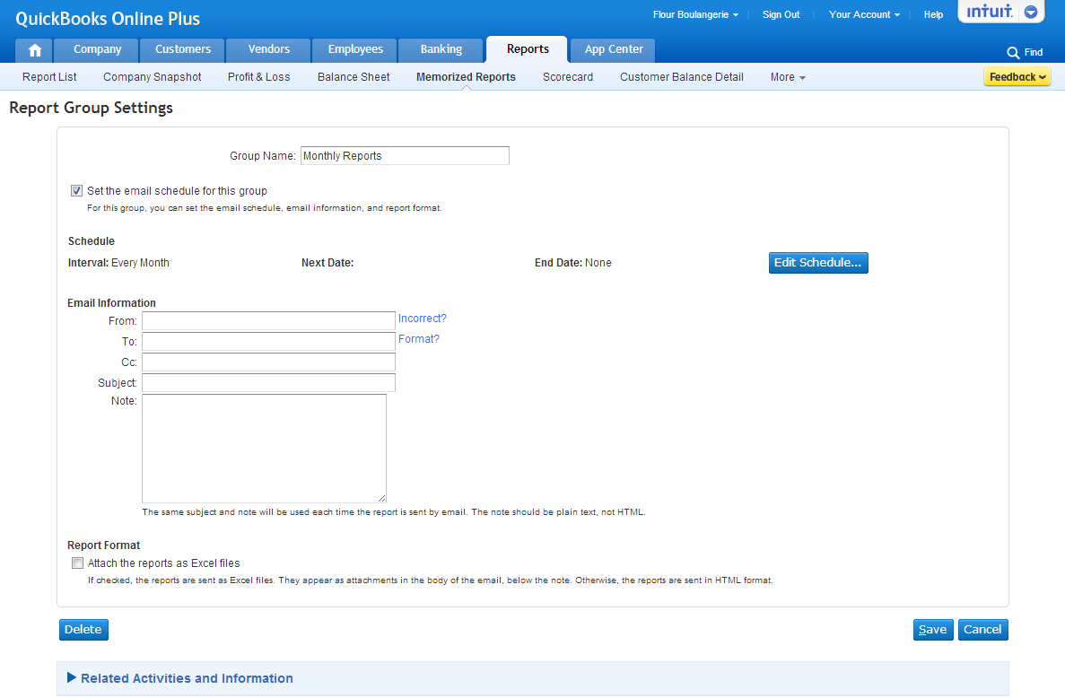

1. From here you can edit the schedule, enter email information, and select the report format.   
   Note: This is the only place from which you can set reports to send automatically and choose to attach reports as Excel files.
2. When you are finished, click Save.

### Customizing Fields, Columns and Filtering

With QuickBooks Online, it is possible to make many types of changes to fields, columns and filtering data from within each report’s Customize window.

You can create your own custom fields to include on estimates, invoices, sales receipts, refund receipts, and credit memos. Use custom fields to track additional information that QuickBooks Online Plus does not already let you track.

Name each field, and select whether it should be shown on sales forms. Select numbers in the Order column to set the left to right sequence. The fields are placed flush right at the top of forms.

After you have saved your preferences, you can go to Customize Forms to control whether customers should see the custom fields. The following reports have the option of adding custom fields:

|  |  |
| --- | --- |
| * Transaction List by Date * Customer Balance Detail * Collections Report * Transaction List by Customer * Sales by Customer Detail/Product Service/ Location/ Class Detail | * Taxable Sales Detail * Customer Balance Detail * AR Aging Detail - Estimates by Customer * Invoice List * Recent/Edited Transactions * Recent/Automatic Transactions |

Note: If you change the customization on a memorized report, you need to memorize it again to save the changes.

Add a Custom Field to Report Columns

To set up custom fields to appear on sales forms:

1. From the Company tab and click Preferences.
2. Click Sales Form Entry on the left.
3. Click Custom Fields. Note the custom field with the name of Crew #.

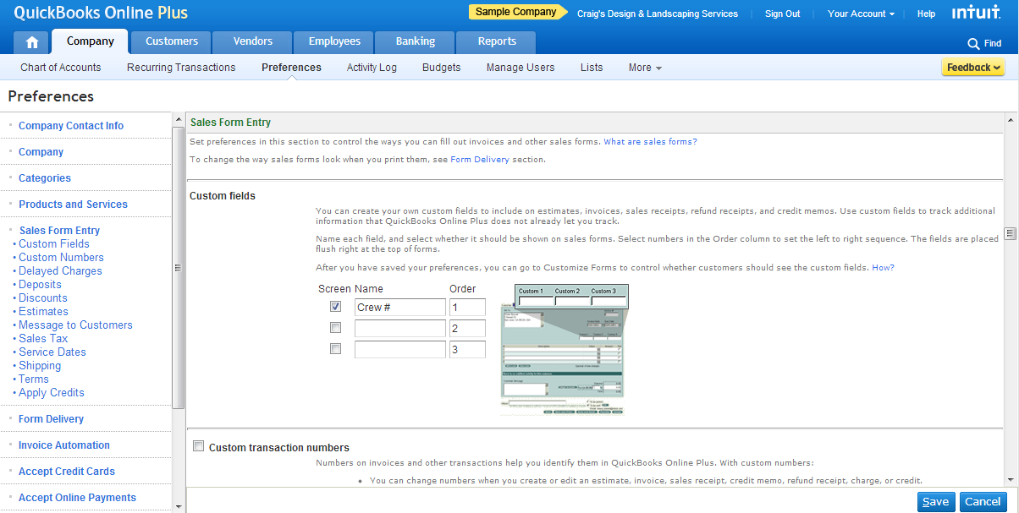

Let’s use this custom field as a column in our report.

To add the custom field as a column:

1. Go to Reports, select a Sales report, and then click Customize.
2. Go to the Rows/Columns section, and then click the Change Columns button. The Select and Reorder Column window opens.

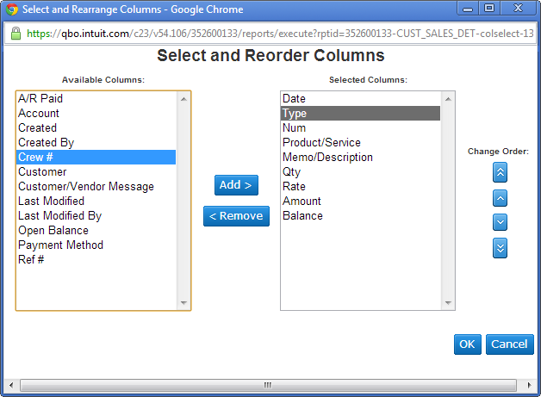

1. Select Crew# from the list of Available Columns, and then click Add>.
2. Change the order of the columns as you desire, and then click OK. The Select and Reorder Columns window closes.
3. In the Customize report window, click Run Report. The report opens with the custom Crew # field.

### Sorting and Filtering (Matching)

In addition to adding custom fields and rearranging columns, you can customize what information appears on a report. The Customize window includes options for grouping, sorting, and matching (filtering).

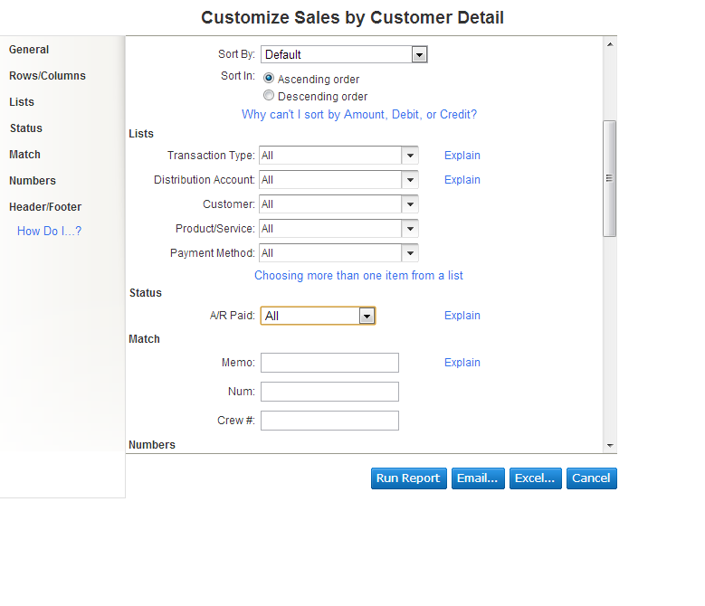

# Lesson 4: Vendor and Sales Reports

## A/P Aging Summary Report

“How much does each client owe, and how much is overdue?” This report summarizes the status of unpaid invoices and unapplied credit memos. For each customer who owes money, the report shows:

* Total invoices that were billed but unpaid in the current period
* Totals the customer hasn't paid from previous periods.

Creating an A/P Aging Summary Report

1. On the Reports tab, select Reports List. In the Vendor’s section, select A/P Aging Summary.
2. Notice the columns showing Customers, Current, Past Due Dates and Totals.

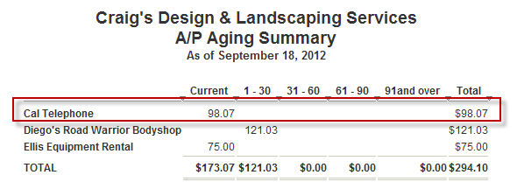

## Sales by Customer Detail Report

“What are the detailed sales by customer?” This report is a more detailed version of Sales by Customer Summary. In addition to income from each customer, this report lists the transactions that contributed to each total.

Creating a Sales by Customer Detail Report

1. On the Reports tab, select Reports List. In the Sales section, select Sales by Customer Detail.
2. Notice the columns showing Date, Product/Service, QTY, Rate and Balance.

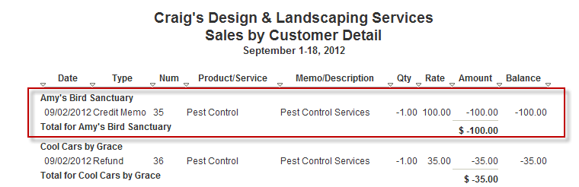

## Sales by Product/Service Detail Report

“What are the detailed sales by product or service?” This report is a more detailed version of Sales by Product/Service Summary. In addition to the unit and dollar sales for each product or service, this report lists the transactions that contributed to each total.

Creating a Sales by Product/Service Detail Report

1. On the Reports tab, select Reports List. In the Sales section, select Sales by Product/Service Detail.
2. Notice the columns showing Date, Product/Service, Customer, QTY, Rate and Balance.

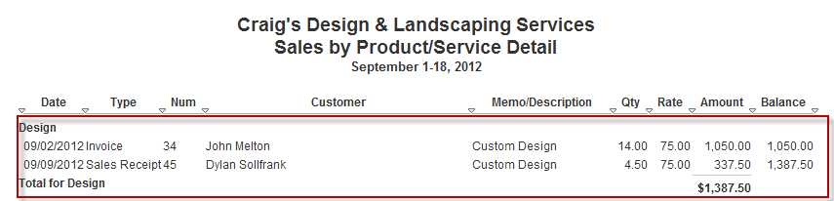

# Course Conclusion

From this course, you have explored the Company reports necessary to gauge the health, progress and needs of your company. You covered the important Customer reports that identify how much is owed you. And finally, you uncovered the Sales and Vendor reports that let you know how much you have sold to customers.