QuickBooks Online 2013 Student Guide

Course 6:  
Expanding QuickBooks Online –  
Payments, Payroll and Apps

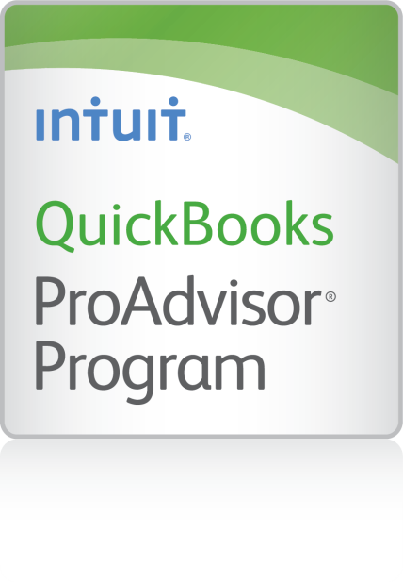

**Copyright**

© 2013 Intuit Inc. All rights reserved.

**Trademarks**

©2013 Intuit Inc. All rights reserved. Intuit, the Intuit logo, and QuickBooks, among others, are registered trademarks of Intuit Inc. Other parties’ marks are the property of their respective owners.

**Notice to Readers**

The publications distributed by Intuit Inc. are intended to assist accounting professionals in their practices by providing current and accurate information. However, no assurance is given that the information is comprehensive in its coverage or that it is suitable in dealing with a client’s particular situation. Accordingly, the information provided should not be relied upon as a substitute for independent research. Intuit Inc. does not render any accounting, legal, or other professional advice nor does it have any responsibility for updating or revising any information presented herein. Intuit Inc. cannot warrant that the material contained herein will continue to be accurate or that it is completely free of errors when published. Readers should verify statements before relying on them.

Table of Contents

About the Author for Lesson 2 4

About the Author for Lesson 3 5

Course Overview 6

Expanding QuickBooks Online 6

Objectives 6

Training at a Glance 7

Background Information 7

QBO Plus Test Drive 8

Lesson 1: Payment Solutions 9

Benefits to You 9

Benefits to Your Customers 9

QuickBooks Online Merchant Service Account 10

Features and Benefits 10

How to Sign up for QuickBooks Online Merchant Account Services 11

Processing Credit Cards in QuickBooks Online 13

Setting up Recurring Payments 14

Using GoPayment 15

How GoPayment Works 16

Finding and Integrating GoPayment Transactions 17

Electronic Check Processing 18

The Intuit Payment Network 19

Key Benefits 19

The Customer Perspective 20

How to Sign Up for the Intuit Payment Network 21

Accessing the Intuit Payment Network from QuickBooks Online 21

Accepting Online Payments 22

For More Information 22

Lesson 2: Online Payroll 23

Overview of QuickBooks Online Payroll 23

Getting Started 24

Adding QuickBooks Online Payroll 24

Selecting Payroll Preferences 25

The Set up Payroll Interview 26

The To Do List 30

Processing Payroll 31

Running Your First Payroll 31

Step One: Create Paychecks 32

Step Two: Approve Paychecks 33

Step Three: Print Paychecks 34

Changing Payroll Settings 38

The Payroll Setup Screen 38

The Employee List 41

The Report List 43

Free 30-day Trial 44

After the Free Trial 44

Direct Deposit 44

QuickBooks Online Features and Benefits 45

Additional Payroll Service Options 46

Mobile Payroll App 46

Intuit Full Service Payroll 47

When Intuit Payroll (QBOP & IFSP) is Not the Best Fit 50

Lesson 3: Apps to Expand QuickBooks Online 51

Connected 51

The App Center in QuickBooks Online 51

How to Find, Purchase, and Access Apps 52

How to Purchase 52

How to Access Apps after Purchase 53

Popular Apps 53

Method CRM 53

Transaction Pro Importer 54

SalesForce 54

Mavenlink.com 54

ZenCash 55

SOS Inventory.com 55

Bill.com 55

Avalara 56

Course Conclusion 57

Appendix – Payroll Set Up Checklist 58

Payroll Setup Checklist 58

# About the Author for Lesson 2



#### Laura Redmond

Redmond Accounting Inc.

Laura is founder of Redmond Accounting Inc based in Menlo Park, CA deep in the country's tech-capital Silicon Valley. The firm provides web-based accounting solutions and controller services that are collaborative and mobile in nature to give growing companies the freedom to access their business intelligence from anywhere. As a former Financial Controller and IT Manager, Laura's strength lies in creating efficient, feature-rich accounting processes harnessing today's technology. Laura and staff are Certified QuickBooks ProAdvisors. The firm uses QuickBooks Online as the central component to their client solutions, adding a mix of appropriate Apps from the Intuit Marketplace to provide clients with time & cost saving methods for running their businesses. Laura's twenty years of accounting experience include multi-department management, strong organizational methods and system administration. The development of a proprietary workflow practice manager and commitment to true SaaS based solutions adds to the firm's success. Laura is certified by the AIPB and an Advanced Certified Method application developer.

# About the Author for Lesson 3



#### Stacy Kildal, CPB

Kildal Services LLC

Stacy Kildal is owner/operator of Kildal Services LLC, located in Waterford Michigan—an accounting and technology consulting company that specializes in all things QuickBooks. As an Advanced QuickBooks ProAdvisor, she also supports QuickBooks clients all over the country, offering payroll, bookkeeping and training. In 2012, Stacy had the distinct honor of being selected as one of CPA Practice Advisor’s Most Powerful Women In Accounting.

She regularly teaches QuickBooks workshops through the local county planning and economic development department, along with community college and continuing education classes for various school districts. Stacy is one of the three hosts for the Radio Free QuickBooks weekly online radio show, and writes regular blogs for the [Sleeter Group’s QuickBooks and Beyond](http://www.sleeter.com/blog/category/expertscorner/onlinesolutions/) as well as [AccountingWEB.com](http://www.accountingweb.com/blog/pajama-work-quickbooks-technology-cloud)

As a member of the esteemed Intuit Trainer/Writer Network, Stacy has presented many live seminars and webinars. Her attendees enjoy the passion she exhibits for her work and can easily relate to the many real life examples she uses during these presentations. She has also been frequently featured on Intuit’s [Accountant Blog](http://blog.accountants.intuit.com/author/stacyikildal/), Community "Ask the Expert" forums, at various Intuit Academy To Go podcasts, and has hosted a number of Intuit Small Business Online Town Hall sessions. She is a big fan of working mobile and has been recognized by Intuit as being an expert on QuickBooks Online, having written Intuit’s original courses for the US, Singapore and Canadian versions.

Kildal Services LLC provides consulting, speaking and writing services to clients (including other accounting professionals) nationwide.

.

# Course Overview

## Expanding QuickBooks Online

## Objectives

Upon completion of this course, you will be able to do the following:

* Describe the QuickBooks Merchant Account service within QuickBooks Online
* Describe how to integrate and accept payments using GoPayment
* Identify functionality of the Intuit Payment Network
* Understand which online payroll offering is best for your needs
* Set up QuickBooks Online Payroll
* Process QuickBooks Online Payroll
* Differentiate the features of QuickBooks Online Payroll vs. Intuit Full Service Payroll
* Describe how Apps expand the functionality of QuickBooks Online

## Training at a Glance

Use this as a guide to select specific training topics.

|  |  |  |
| --- | --- | --- |
| Lessons | Topics | Description |
| 1. 1: Payment Solutions | * QuickBooks Online Merchant Account Service * Using GoPayment * The Intuit Payment Network | This lesson will help you locate features, functions and pricing information for QuickBooks Online Merchant Account Service, GoPayment, and the Intuit Payment Network. |
| 1. Lesson 2: Online Payroll | * Overview of QuickBooks Online Payroll * Getting Started   Adding QuickBooks Online Payroll  Selecting Payroll Preferences  The Set Up Payroll Interview  The To Do List  Processing Payroll  Running Your First Payroll  Step One: Create Checks  Step Two: Approve Paychecks  Step Three: Print Paychecks  Changing Payroll Settings  The Payroll Setup Screen  The Employee List  The Reports List   * Additional Payroll Options   Mobile Apps  Intuit Full Service Payroll  When Intuit Payroll solutions (QBOP & IFSP) are not the best fit | This lesson will cover the steps to get started with QuickBooks Online Payroll (QBOP). You will explore the QBOP interface and discover how to process paychecks, make tax deposits and file payroll forms. This lesson will also help you differentiate among the additional online payroll service options available. |
| 1. Lesson 3: Apps | * The App Center in QuickBooks Online * How to Find, Purchase, and Access Apps * Popular Apps | This lesson introduces you to the App Center in QuickBooks Online and how to purchase and access purchased Apps from inside your QuickBooks Online company file. It also overviews popular Apps and their utility. |

## Background Information

Intuit Payment Solutions helps minimize unnecessary transaction work for both you and your customers. Intuit Payment Solutions add power to payment options through QuickBooks Online - where you already do your accounting.

Some customers like to pay by credit card so that they can accumulate miles or bonus points with the card issuer. Other customers like to pay by bank account, either because they don't have or don't want to use unsecured credit. Merchant Service is a tool that allows you to accommodate your customer’s payment preferences.

QuickBooks Merchant Service offerings are dynamic because they offer multiple options to complete a payment transaction. From GoPayment on your iPhone (for those who are on site providing services or products), to Merchant Account Services (as a link to pay emailed invoices associated with QuickBooks billing solutions), to key-entered options within a browser (to process payments for credit card or ACH debit transactions). These options put the power in your hands to get paid in a manner that works best for both you and your customer

## QBO Plus Test Drive

Lessons in the Activities Handbooks include hands-on exercises in a QuickBooks Online Plus “test drive”. The test drive uses a sample company file called Craig’s Design & Landscaping Services. It can be accessed through the following link:

<https://qbo.intuit.com/redir/testdrive>

You don’t have to create an account or sign in; just complete the security validation and click Continue. This test drive is designed for you to explore and try out new things without worrying that you will break something or make a mistake. It is not designed to retain any changes you make. Once you close the QBO Plus test drive, it is completely refreshed, so please remember to allow sufficient time to complete each activity. But don’t worry if you have to close the test drive before you are finished! You can always begin again.

Note: The test drive uses the QuickBooks Online Plus plan. It contains some features that are not available in QuickBooks Online Simple Start or Essentials. In addition, some features, such as the Apps Center tab and in-product Help are not enabled at this time. However, this is subject to change.

# Lesson 1: Payment Solutions

## Benefits to You

* Get paid faster
* Saves time processing payments
* Minimizes trips to the bank
* Maximizes time doing billable work

## Benefits to Your Customers

* Protection: Transactions by credit card are insured both ways
* Saves time: No need to receive a bill, queue it for payment, and then issue payment
* Convenience: Multiple forms of payment available

## QuickBooks Online Merchant Service Account

A Merchant Service Account is an agreement between a merchant and their merchant account service provider that allows customers to pay by credit card. In this relationship, the financial institution agrees to pay for credit card purchases in exchange for the ability to collect on the debt owed by their customer.

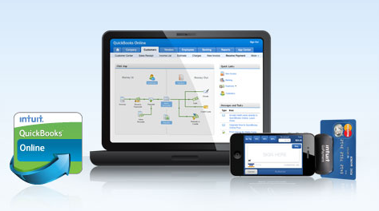

QuickBooks Merchant Account Service allows you to process all major credit card transactions directly into QuickBooks Online. Payment information is automatically updated so you never have to enter data twice.

### Features and Benefits

* Credit card processing that allows you to accept credit card payments directly into QuickBooks Online
* Automatic set up of recurring sales receipts and credit card payments
* Transaction information saves automatically to your company file
* Includes GoPayment for swiped transactions
* No additional software or hardware required
* No cancellation fees and no long-term commitments
* Free mobile card reader that accepts credit cards on a mobile phone or device
* Free live customer service 24/7, 365 days a year

### How to Sign up for QuickBooks Online Merchant Account Services

Follow the steps below to sign up for Merchant Service to QuickBooks Online:

1. Sign in to QuickBooks Online.
2. Choose Company > Preferences > Accept Credit Cards.
3. On the left column under Accept Credit Cards, click Learn More...
4. 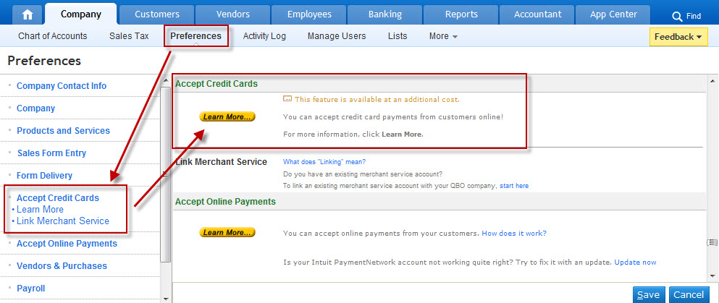Click **Activate Now**.

Follo**w the steps** to activate your new account.

Note: A merchant account can only be linked to one company at a time, so if you link your merchant account to QuickBooks Online, you will not be able to accept credit cards in a previously linked QuickBooks company. If your account is not linked to a QuickBooks company (that is, if you're using GoPayment) this does not apply.

After you have been approved for your merchant account with QuickBooks Merchant Service, there is a short preference set-up procedure.

Below are the steps to set your preferences:

1. Choose Company > Preferences.
2. On the side menu, click Accept Credit Cards.
3. For the question, “Which bank account should be used for depositing transactions processed by the QuickBooks Online Merchant Service”, under Account, select the bank account you'd like your credit card payments to deposit to. (We recommend choosing Undeposited Funds, which allows you to group deposits to match the way funds are deposited into your bank.)
4. For the question, “Which bank account should be used for error transactions processed by the QuickBooks Online Merchant Service”, under Account, select the account where you'd like to track transactions that failed due to a processing error. When the error is fixed, the transactions will be moved back to the regular Account for deposits. By default, the system will list Credit Card Receivables.
5. Select your desired option for how to view Payment status:

* Yes, always show me credit card status, even if it is approved
* No, show me status only after an AVS (Address Verification Service) mismatch or a processing error

1. Click Finish.

### Processing Credit Cards in QuickBooks Online

To receive a customer payment in QuickBooks Online, go to Customers > Sales Receipt. Select your customer from the dropdown menu and enter their credit card information. Then, click OK.

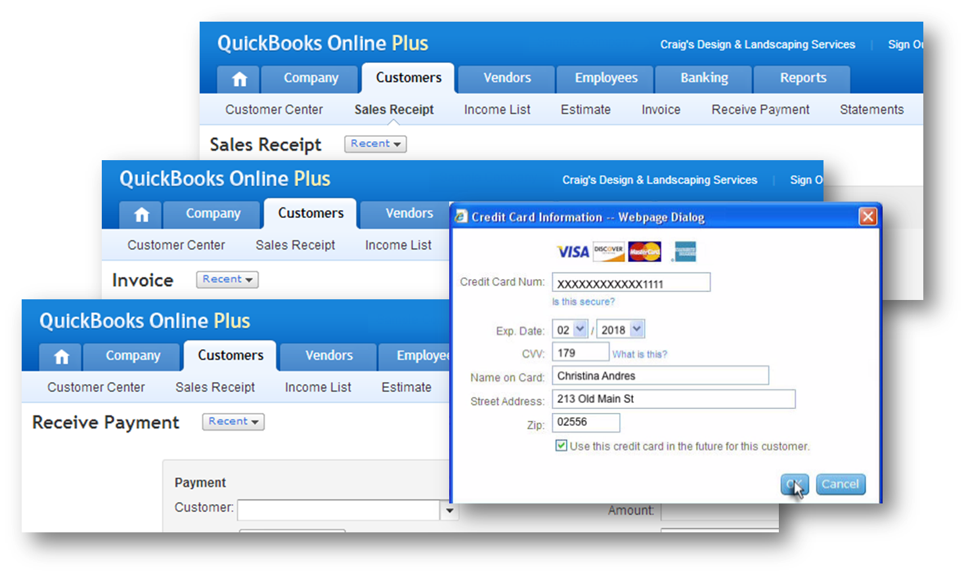

### Setting up Recurring Payments

To set up a recurring monthly charge, create a Recurring Sales Receipt. Visa and MasterCard guidelines require you to obtain written authorization from your customer prior to setting up a recurring credit card billing. (If you need assistance procuring this form, go to the QuickBooks Online Help menu and search “How do I get the credit card authorization form?”)

Complete the following steps to create a recurring sales receipt:

1. Go to the Company tab and click Recurring Transactions.
2. On the bottom right click New.
3. For Transaction Type: select Sales Receipt.
4. Enter a Template Name to identify what the template is for (this name is not included on the transaction).
5. Choose the Template Type: Scheduled.
6. Click Edit Schedule and set the schedule for frequency to charge your customer.
7. Click OK.
8. Select your customer from the Customer: drop down menu and enter their billing information inside the form.
9. Under Payment Information: for the Pmt Method: select the credit card type.
10. Click Edit to enter the customer’s credit card information and click OK.
11. Under Delivery Information, select To Be Sent (the customer will receive an email each time their card is charged).

Note: If you use the Days in advance to create option when setting up a sales receipt for a recurring charge, the charge will process on the date the transaction is created, not on the transaction date. For example, a sales receipt that recurs on the 15th of each month, if created 10 days in advance, will process the credit card charge on the 5th of each month. If you wish to charge your customer just once or manually, use the Sales Receipt feature found in the Customer menu.

## Using GoPayment

GoPayment allows you to get paid anytime and anywhere that you have cellular reception. Its flexibility gives you the ability to process credit cards through your mobile device. This service is bundled with a Merchant Service Account. It is also available separately as a stand-alone, pay-as-you-go payment solution. (This works for customers who do not need to invoice through QuickBooks Online.)

Any business that has people in the field such as pool service technicians, electricians, personal trainers, inspectors and appraisers would benefit by using GoPayment. Key benefits include:

* Collect payments while face-to-face with clients
* Get paid prior to performing services or releasing your product
* Accept payments via any mobile device
* Import transactions from your Intuit Merchant Service Center account
* Cash flow is put on the fast track instead of waiting 30, 60 or even 90 days for your client to pay your invoice
* No contracts, no minimum fees, no cancellation fees and no setup fees
* Free card reader

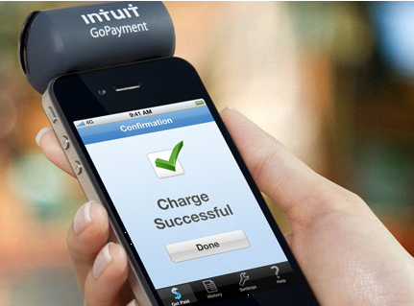

### How GoPayment Works

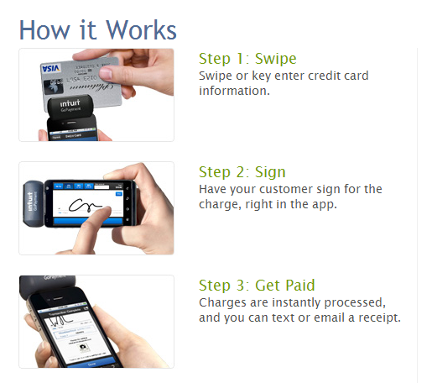

Note: After accepting payments on your mobile device, record these transactions in your QuickBooks Online company file by adding the payment as a Sales Receipt or, by receiving payment to an existing Invoice.

### Finding and Integrating GoPayment Transactions

Follow the steps below to record GoPayment transactions:

1. Choose Customers > GoPayment. (Your company may use a different term for customers, such as Clients.)
2. From the GoPayment Transactions to Record page, click the payment you want to record.
3. Choose how to record the payment: Receive Payment or Sales Receipt.
4. Select your customer from the drop-down menu. If the customer is not in this list, go back into QuickBooks Online and add the customer first. Note: There is no Add New choice from the GoPayment page.
5. Amend the memo as necessary. (We recommend not removing the term GoPayment from the memo field because transactions will not display on the GoPayment Transaction List report for future viewing.)

Click Save & Next to continue recording payments.

If using Receive Payment, find your recorded GoPayment transactions and match them to invoices:

1. Choose Reports > Report List.
2. On the left sidebar, click Sales.
3. Click GoPayment Transaction List.
4. Adjust the report dates if necessary to locate older GoPayment transactions.
5. Open the Receive Payment you created from Customers > GoPayment earlier.
6. Select the correct invoice from the invoices and outstanding transactions section.

Click Save.

Note: If you skip this step, your customer invoice will still show as open, even though you have received payment.

If you do not match or add all of your GoPayment transactions in one sitting, they can be accessed the next time you open the GoPayment menu. You can also find these payments in the Customer Center where you can match payments to the appropriate customer invoice. You will want to adjust the Show drop-down option to Payments and select any payments displayed in the Unapplied column.

Follow the steps below if you are using Sales Receipt and need to specify the Product/Service in QuickBooks Online:

1. Choose Reports > Report List.
2. On the left sidebar, click Sales.
3. Click GoPayment Transaction List.
4. Adjust the report dates if necessary to view older GoPayment transactions.
5. Find and open the Sales Receipt created from Customers > GoPayment.

Click the Product/Service drop-down menu and select the Product/Service to record it under.

Note: When you make this adjustment, you will lose the amount and other data from the transaction. You can still view all of your GoPayment transactions from the Merchant Service Center at <https://merchantcenter.intuit.com> or, from History in the GoPayment application on your device. To deposit payments to your bank account, choose Banking > Deposits.

## Electronic Check Processing

The Intuit Online Check Terminal makes getting paid by check easy and affordable for any business. Key benefits include the following:

* Process check payments from any computer with an internet connection
* Minimize trips to the bank to deposit checks
* No need to purchase a terminal or additional software

Note: You can convert a paper check by having your customer sign an authorization form and void the check.

## The Intuit Payment Network

The Intuit Payment Network (IPN) is an online service to request and send electronic payments between customers and vendors. With IPN, you can request customer payment by ACH debit and have your customer approve it. Your customer can also initiate payment without your advance request. Also, as an IPN user, you have the ability to accept bank payments without having to obtain your customer’s bank information. Your customer can pay you directly through the emailed invoice.

### Key Benefits

* ACH-based, electronic invoicing and payment service
* Most payments deposited directly into your bank the next day
* Multiple options for getting paid
* Insert a payment link into the QuickBooks Online invoice
* Send a payment request from the Intuit Payment Network website
* Automatically syncs with QuickBooks Online
* Payments can be received by credit card (different rates from IPN or Merchant Service)

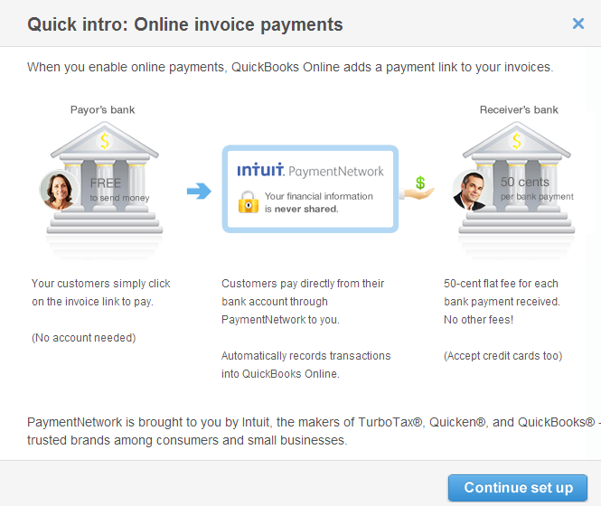

Locate the Intuit Payment Network Overview

1. In your QuickBooks Online company file, go to Company > Preferences.
2. Click Accept Online Payments.
3. Click the link titled How does it work?
4. Review the information from the Quick Intro window.

### The Customer Perspective

The steps below show the customer experience using the Intuit Payment Network.

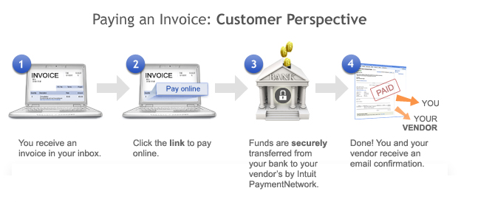

## How to Sign Up for the Intuit Payment Network

### Accessing the Intuit Payment Network from QuickBooks Online

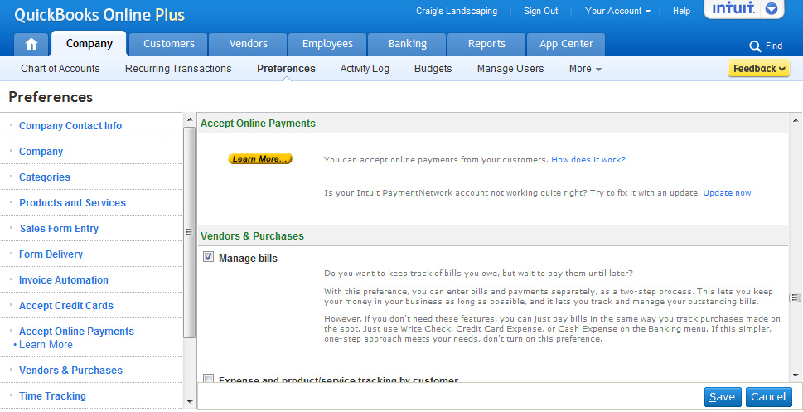

**1**

**2**

## Accepting Online Payments

|  |  |
| --- | --- |
| When you email your customer an invoice, you can include an option that lets them submit payment online. It's fast, easy, and free for your customers. Note that the payment recipient is charged a $.50 fee for each transaction. Below is an overview of how online payments work: | |
| Step 1 In QuickBooks Online, select the Let customer pay online checkbox and email the invoice to your customer. | https://cdn.qbo.intuit.com/c36/v53.122/images/ipn-step1.png |
| Step 2 Inside the email, your customer clicks the Pay Online link. | https://cdn.qbo.intuit.com/c36/v53.122/images/ipn-step2.png |
| Step 3 Your customer pays the invoice. | https://cdn.qbo.intuit.com/c36/v53.122/images/ipn-step4.png |
| Step 4 Money is transferred to your bank account and automatically recorded in QuickBooks Online. | https://cdn.qbo.intuit.com/c36/v53.122/images/ipn-step5.png |

## For More Information

* Intuit Payment Network: <https://ipn.intuit.com/>

# Lesson 2: Online Payroll

#### Authored by Laura Redmond

## Overview of QuickBooks Online Payroll

QuickBooks Online Payroll (QBOP) is found inside the QuickBooks Online company account on the Employee tab. This option is best suited for small businesses processing their own payroll. Features that make this payroll service superior to its competition include the following:

* Anytime, anywhere access
* Unlimited payroll runs
* Pay employees by direct deposit or print checks
* Online employee portal
* Federal and state tax payments and quarterly and annual filings, federal and state payroll tax forms automatically filled in and submitted electronically, including year-end W2 forms (Signature-ready forms are provided for states where E-file is not available)
* US-based live expert support by phone and chat
* Seamless integration with QuickBooks Online and online employee timesheets
* No need to install payroll updates
* Multi-state option
* Optional add-ons, including workers comp pay-as-you-go and Intuit 401(k) solutions

There are two levels of service:

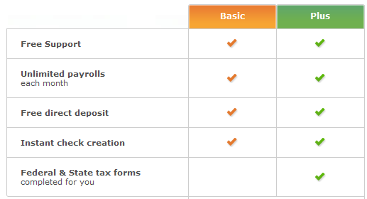

## Getting Started

### Adding QuickBooks Online Payroll

Navigate to the Employees Tab > Employee List. Click Turn on Payroll.

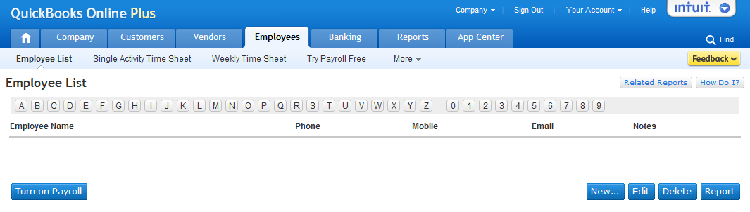

### Selecting Payroll Preferences

Once you turn on Payroll inside QuickBooks Online, select the first option to file payroll taxes yourself using tax forms completed by QBOP. The second option is to have Intuit payroll experts handle payroll tax filings (called Intuit Full Service Payroll) that are not maintained inside the QuickBooks Online company account. You will find more information about Intuit Full Service Payroll (IFSP) later in this lesson.

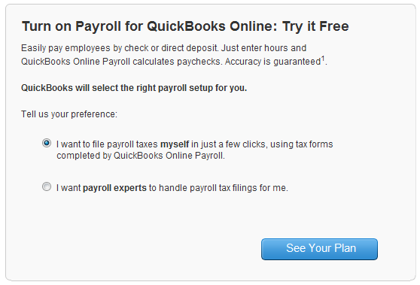

### The Set up Payroll Interview

1. The About your business section allows you to enter general business information and to select the payroll options that meet your needs:

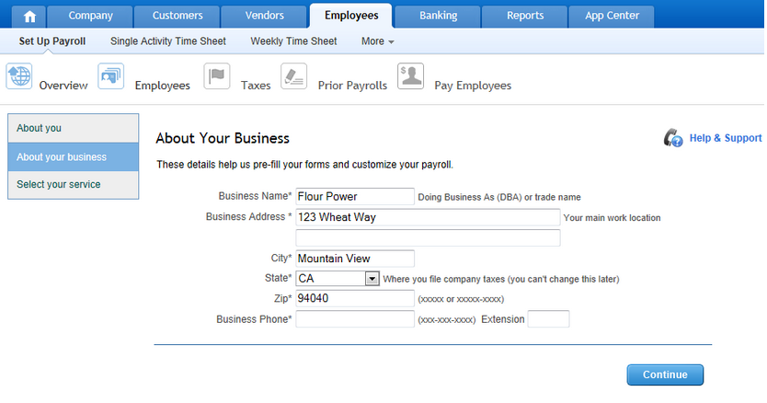

1. Click Start and enter employee names, tax withholdings, pay schedules and pay rates.

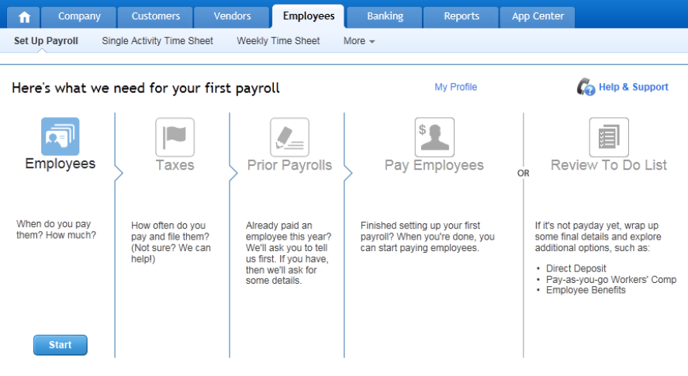

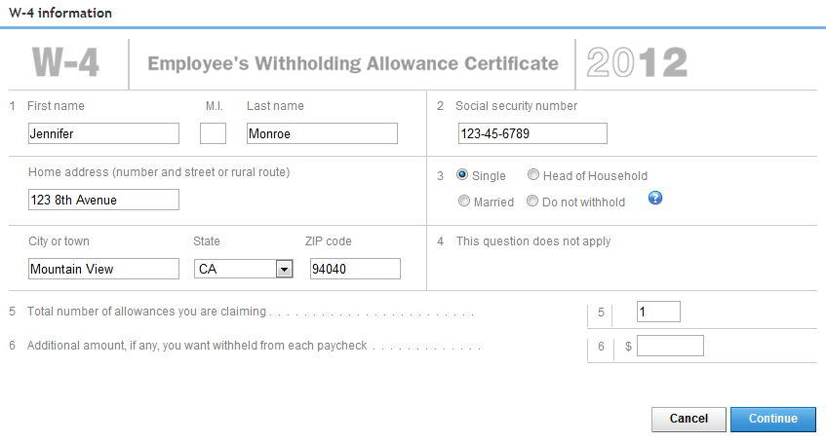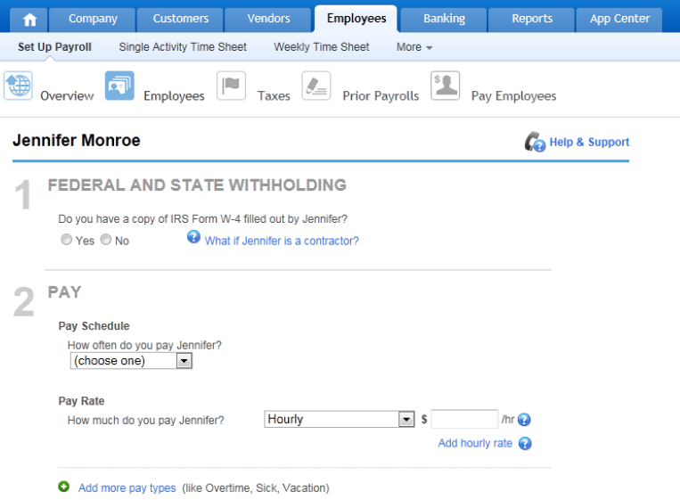

1. Enter your payroll tax information: Federal and state identification numbers, filing frequencies, payroll tax deposit schedules and rates (such as state unemployment rates).

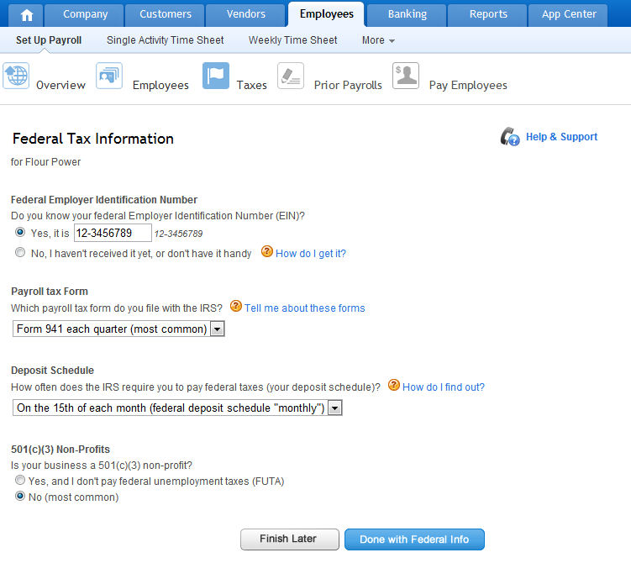

1. For historical year-to-date accuracy, enter prior payroll information. All data must reconcile for the purposes of verification. You will be prompted to enter the following information:

* Total amounts paid to employees
* Total amounts paid in current quarter
* Payroll liabilities
* FUTA taxes by quarter (if applicable)

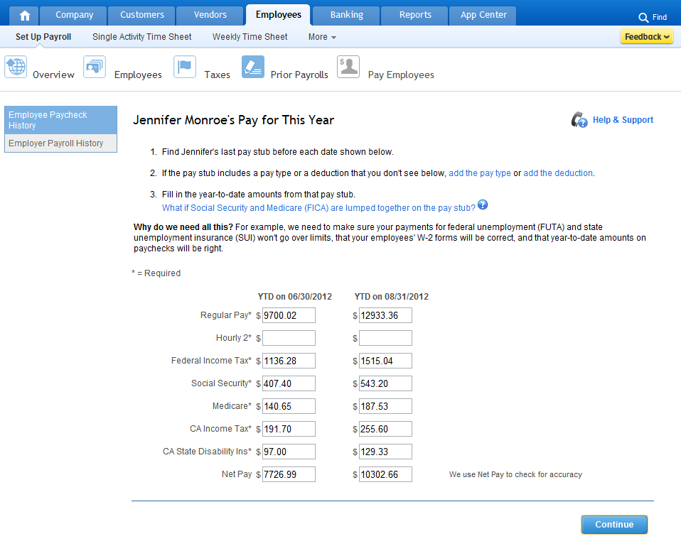

Note: See the Appendix for a complete Payroll Setup Checklist. This list details the information you will need when setting up QuickBooks Online Payroll.

### The To Do List

QuickBooks Online Payroll will remind you of important activities, such as when payroll taxes and payroll forms are due. Be sure to check this tab regularly. When you set up a new payroll account, the following tasks will be suggested on your To Do list:

* Set up accounting preferences: Define which accounts and classes you’d like your paychecks and tax payments to go to. Use QBOP’s recommended preferences, or enter your custom options.
* Set up Direct Deposit: Enter your company’s bank routing and account number, and the routing and account numbers for each employee you’d like to pay electronically.
* Enter prior tax payments: Reconcile your taxes owed and taxes paid for payrolls you ran outside of QBOP this year. Enter historical tax payments to account for payments already made.
* Set up Electronic Services: File and pay taxes electronically.

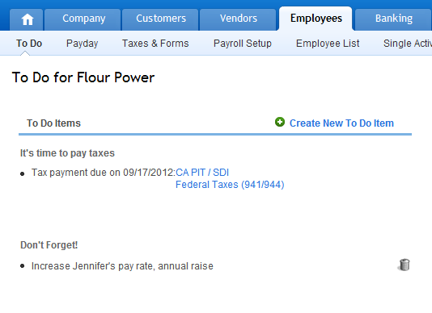

**You can customize your own To Do items.**

## Processing Payroll

### Running Your First Payroll

To run your first payroll, click the Pay Employees button on the Setup screen. If it’s not payday yet, click the Review List button and complete the tasks on your To Do list.

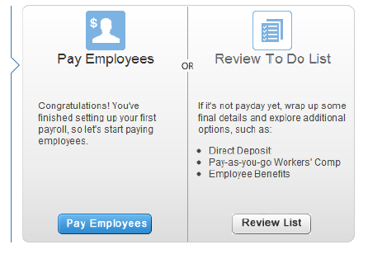

### Step One: Create Paychecks

Follow the steps below to begin paying employees:

1. Go to Employees > Payday.
2. If you have multiple pay schedules, select the one you want to pay now.
3. Select a Check Type: Regular Checks is the default and is used most often; you can also run checks for bonuses, Commissions, or fringe benefit adjustments. Click Go to set the screen for the proper input based on the type of check selected.
4. Verify the date of the pay period and the payment.
5. Enter the hours or amounts. The salary and rate information is populated from the information you provided when initially setting up the employee. If you want to make changes for this payroll period only, click the Check Details icon on the same row as the employee.
6. Click Create Paychecks.

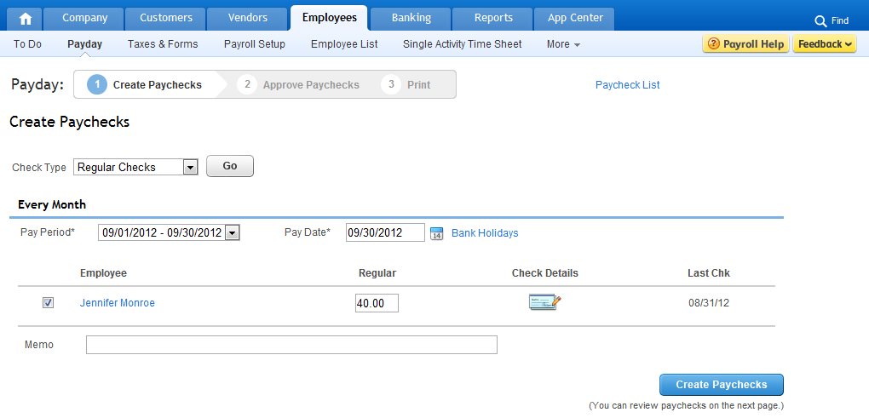

Note: Direct deposit paychecks must be processed by 5pm PST two banking days before the pay date. Funds will be withdrawn from the Company’s bank account one day before the pay date. Employees will receive funds electronically in their bank account on the pay date.

### Step Two: Approve Paychecks

1. Review your list of paychecks.
2. Click Details on a row to view all details regarding gross pay, tax withholdings, employer payroll tax, deductions, garnishments, vacation accrual. On the detail screen, you are given the option to delete a check or approve it. Click Approve Paychecks to return to the Approve Paychecks list.
3. Click Edit on a row to view all details and make changes. From the Approve Paychecks list, you also have the option to Undo all paychecks and start over.
4. Once all paychecks are ready to pay and you have confirmed that the total of the Net Pay column is available in the bank account, click Approve Paychecks. You will be taken to the list of checks for this pay period with options to print.

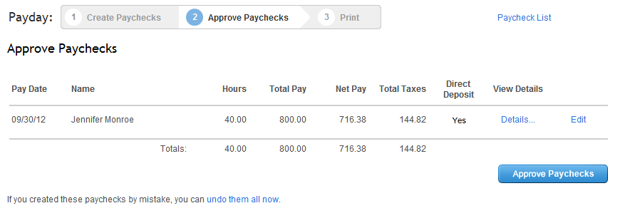

### Step Three: Print Paychecks

1. On your first payroll, you will be prompted to set your printing preferences. You may also want to print paycheck stubs on plain paper to include with hand-written paychecks or for employees with direct deposit. You can save the PDF to email or archive.
2. Assign check numbers and then View & Print your checks. A PDF of the check will display on your screen for printing.

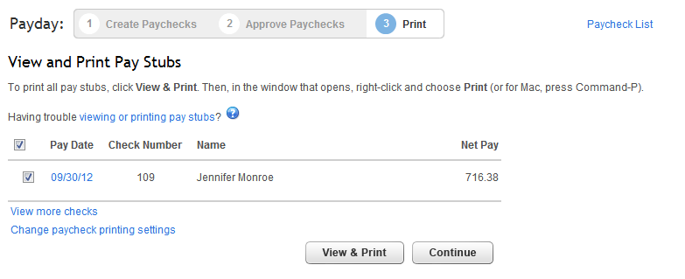

1. If you have given an employee access to the Employee site (in the Employee List settings), click Send Email to notify your employees that they have been paid. Employees can log in to their own portal to view paycheck details and history. The web address for the Employee portal is [www.paycheckrecords.com](http://www.paycheckrecords.com).
2. When you are done with payroll, you can view reports. If you currently have taxes due, pay them now by clicking the hyperlinked notification Pay taxes now.

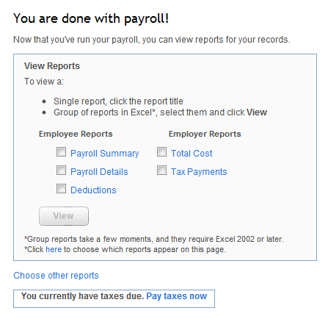

#### The Paycheck List Screen

To review a list of all paychecks, click Paycheck List. From here you can delete, view and print, modify check numbers, and send email notifications.



#### The Taxes & Forms Screen

Use the Taxes & Forms screen to pay taxes, edit tax setup, view tax liabilities and payments, and enter prior tax history.

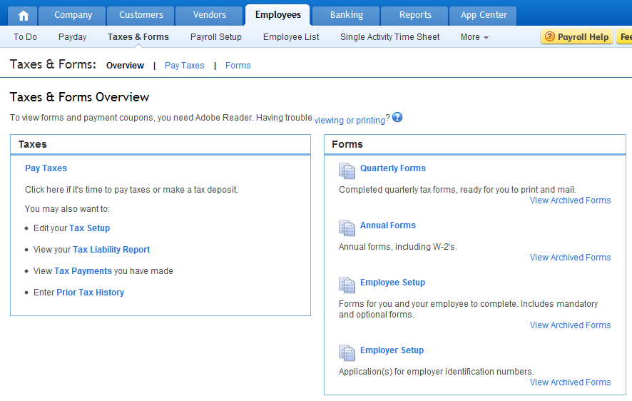

On the Pay Taxes screen, you will see the section called Tax Payments Due Now if there are any. If not, you will only see the Tax Payments Due Later section. If there are tax payments currently due, there will be a notification displayed on your To Do screen and on the final screen when you process paychecks. For each tax payment due now, click Create Payment.

Select the payment date and click Approve. If electronic services are activated, the Pay Electronically checkbox will be selected and your tax payment will be submitted electronically. Otherwise, the To Be Printed checkbox will be selected.

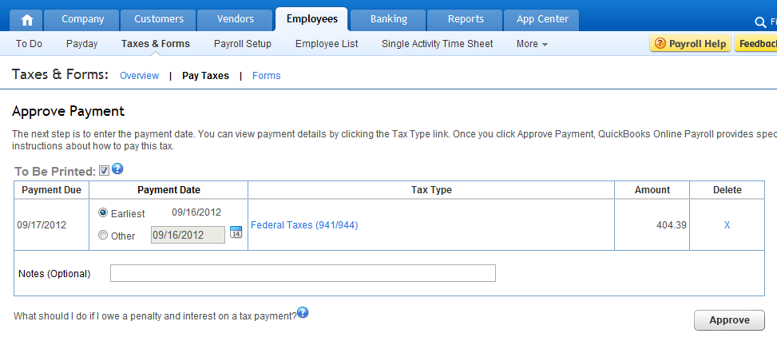

You will be shown instructions on making tax payments specific to federal or state guidelines. Print the payment worksheet/coupon and payment check for mailing, or visit the tax agency’s electronic website to make a payment.

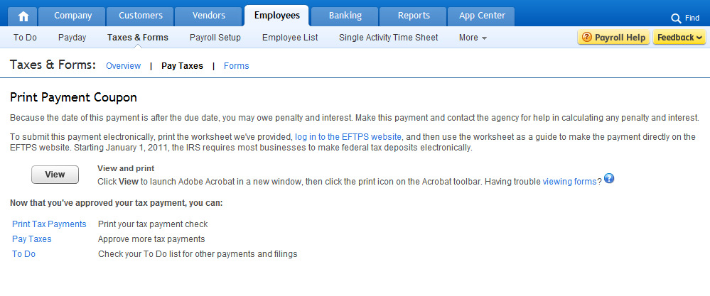

From the Taxes and Forms screen, you can also submit current and archived quarterly and annual payroll forms and employee and employer setup forms. Click the name of the form you want and view a PDF of the form, verify all calculated taxes were paid and balance due is zero, and then submit electronically or print to mail. (When these taxes become due, a reminder will display on the To Do screen.)

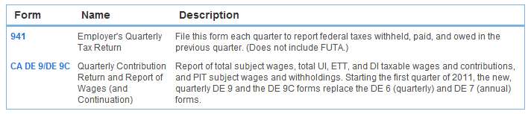

## Changing Payroll Settings

To modify payroll settings, navigate to the Payroll Setup screen on the Employees tab. You can update pay schedules, paid time off, deductions, contributions and direct deposit. Workers’ Compensation premiums can automatically be calculated. The Setup screen is organized into three main categories: Payroll & Services, Company & Account, and Employees. Below are descriptions of some of the settings found under each category.

### The Payroll Setup Screen

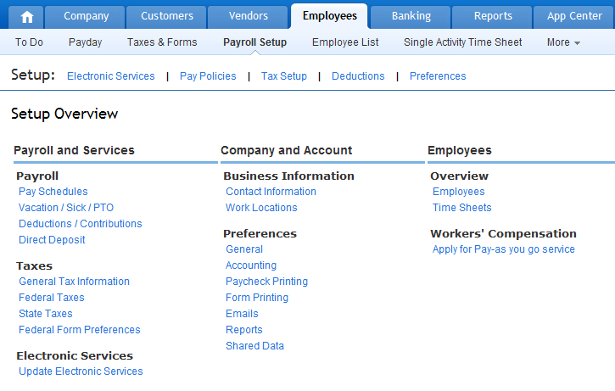

#### Vacation/Sick / PTO

Under the Payroll & Services header, go to Payroll > Vacation / Sick / PTO to enter category, description and hours accrued.

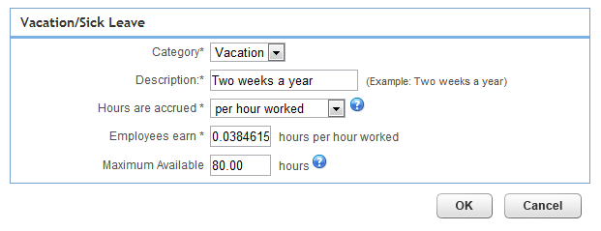

#### General Tax Information

Go to Taxes > General Tax Information to modify federal tax, state tax, and federal form preferences.

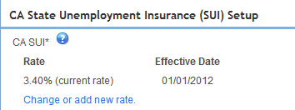

#### Update Electronic Services

Go to Electronic Services > Update Electronic Services to add your company’s bank account information, and, sign and submit enrollment forms.

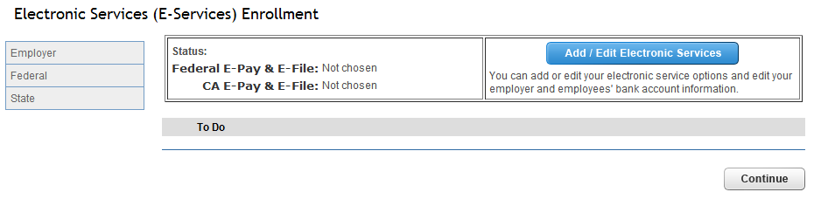

#### General Preferences

To update preferences for the Pay Types you want to include as columns on the Create Paychecks page and, to select the steps you want to complete each time you approve paychecks go to Preferences > General under the Company & Account header.

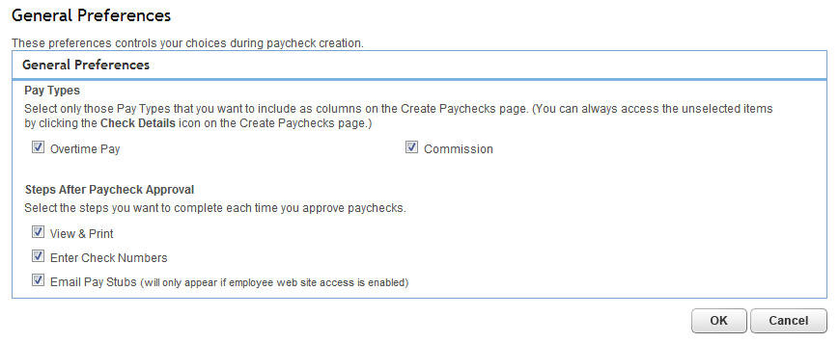

#### Time Sheets

To update timesheet preferences, go to Overview > Time Sheets under the Employees header. Here you can allow unlimited Time Sheet-only access to staff so that time entered on their timesheet displays to the Create Paychecks screen.

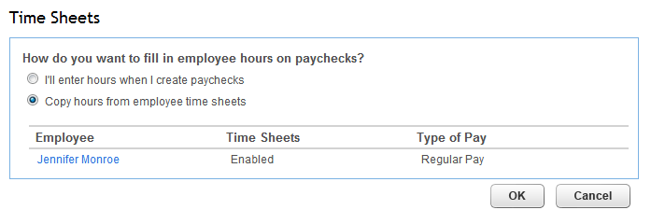

### The Employee List

From the Employee List screen, you can add and update employee information. Click the employee’s name to modify their record.

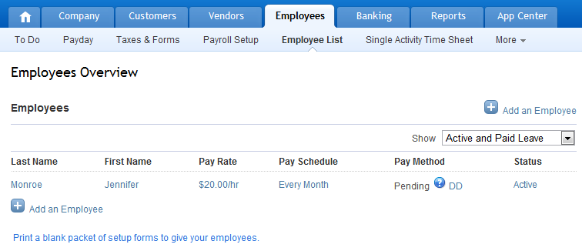

Each employee record is separated into sections: Basics, Employment, Pay, Taxes & Exemptions, Deductions & Contributions, Vacation & Sick Pay, Employee Site Access, Time Tracking, and Notes.

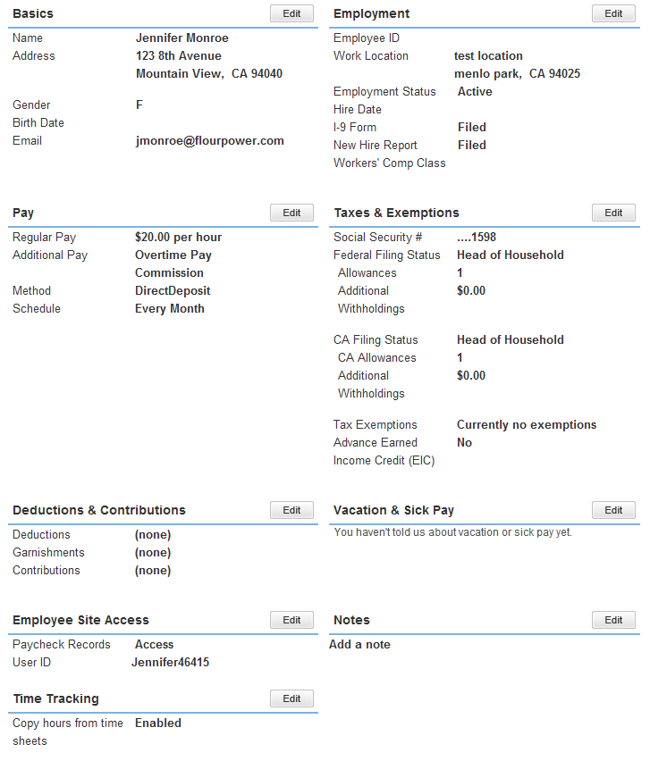

### The Report List

To access payroll Reports, go to Reports > Report List. From the left menu, click Payroll. You can filter by employee, date, work location, or deduction type (depending on the type of report).

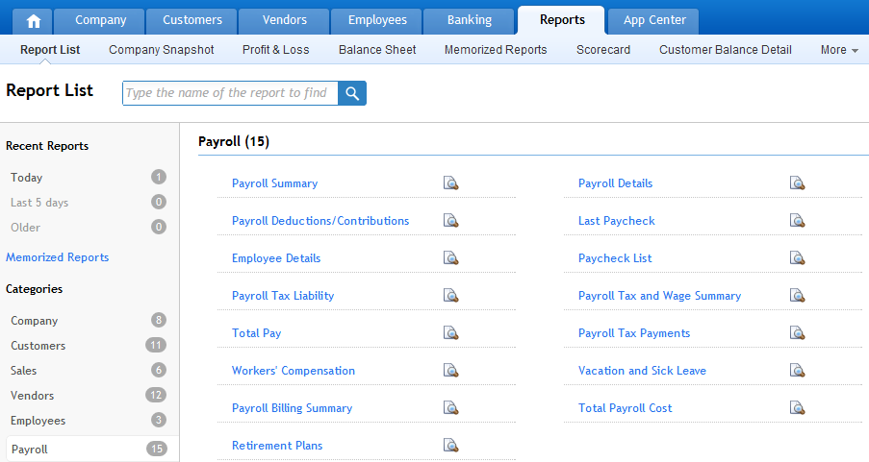

#### Vacation & Sick Leave

To view the vacation history for an employee, run the Vacation & Sick Leave report. This summary report leads to the Details report: Click the vacation balance on an employee to view details of the accrual of that balance. From the Details report, the far column on the right will show the Type of vacation accrual. For any with the type Paycheck, click the hyperlinked paycheck date to view the paycheck details responsible for that individual (or particular) accrual.

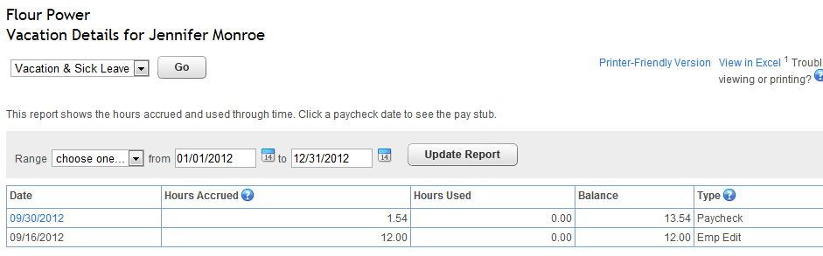

### Free 30-day Trial

All new Payroll customers can opt for a 30-day free trial. However, the time the trial starts is different for bundled customers vs. add-on customers:

* For QuickBooks Online + Payroll bundlers: 30-day trial starts at the time of sign up
* For Payroll customers who add-on from in-product: 30-day trial starts after Payroll set up is complete and the customer approves and runs their first payroll

### After the Free Trial

* Regular pricing will apply after the 30-day trial, less any applicable discounts

### Direct Deposit

In QuickBooks Online Payroll, Direct Deposit is free.

Note: QuickBooks Online does not support Direct Deposit for contractors.

### QuickBooks Online Features and Benefits

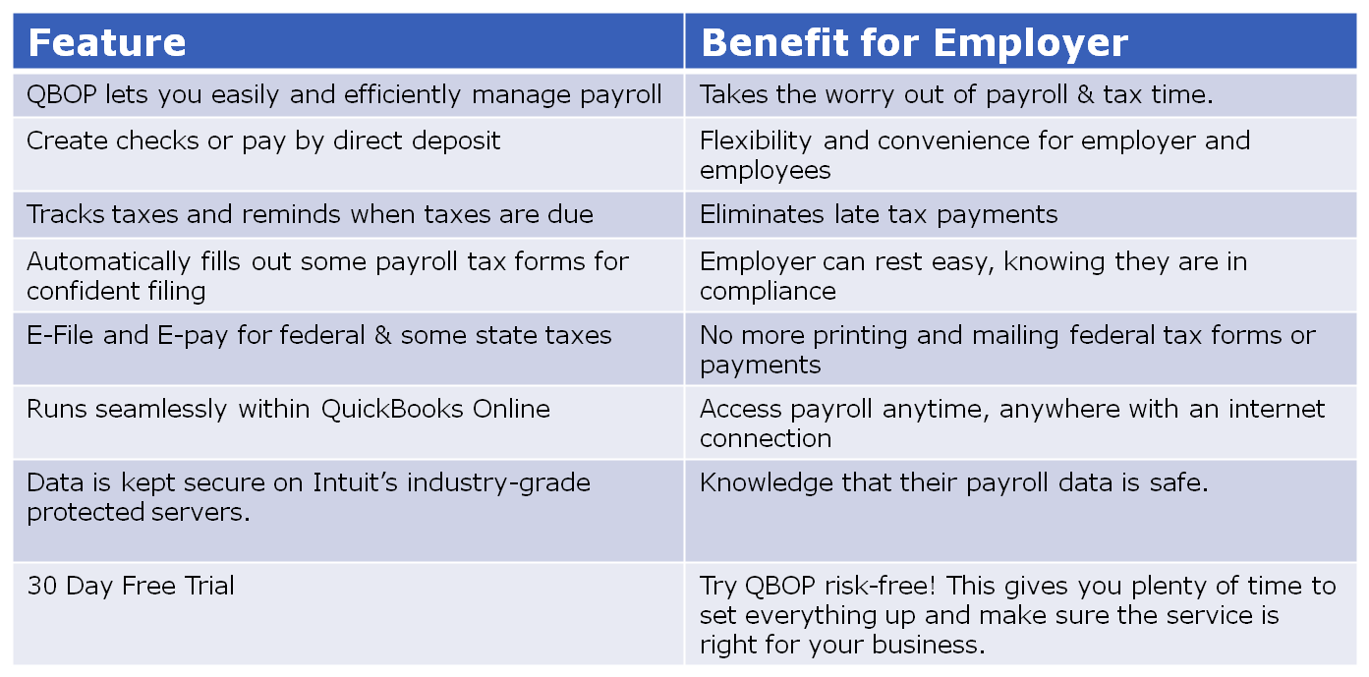

## Additional Payroll Service Options

### Mobile Payroll App

QBOP customers can run payroll from their mobile devices using the IOP mobile app which is available for both iOS and Android. iOS users can pay and file their payroll forms electronically (for selected states). QuickBooks Online Payroll mobile app allows you to:

* Pay employees with direct deposit or check
* Pay taxes and file forms from iPhone or Android phones
* Preview paychecks before approving
* View employee info and reports of your last run payroll

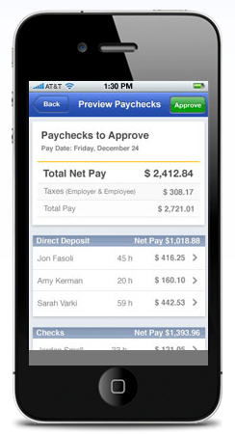

### Intuit Full Service Payroll

Intuit Full Service Payroll (IFSP) is an outsourced payroll service that handles all paychecks and payroll taxes via a separate online website.

* Intuit verifies employee social security numbers with federal agencies, sets up your direct deposit account for the company and employees, and works with your prior payroll service provider to transfer your information
* You select the employees you want to pay and enter their hours. Total pay and hours are instantly calculated. To prevent errors, IFSP immediately notifies you if you enter hours that are significantly different from the prior pay period.

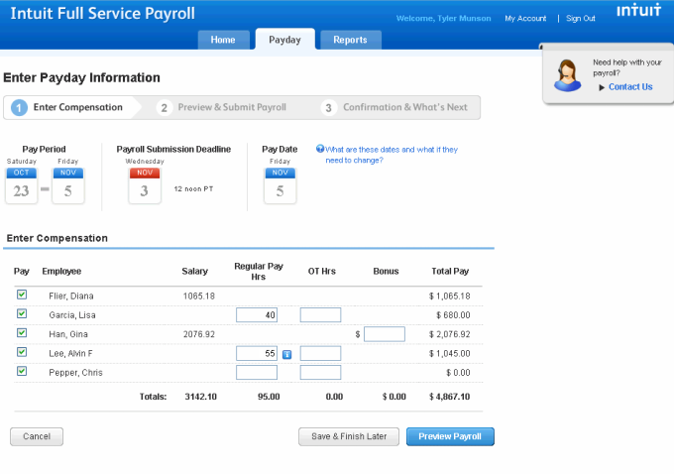

With IFSP, you can preview your payroll prior to submitting it to ensure accuracy. You can also compare this payroll to a prior payroll period.

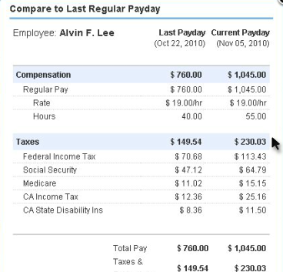

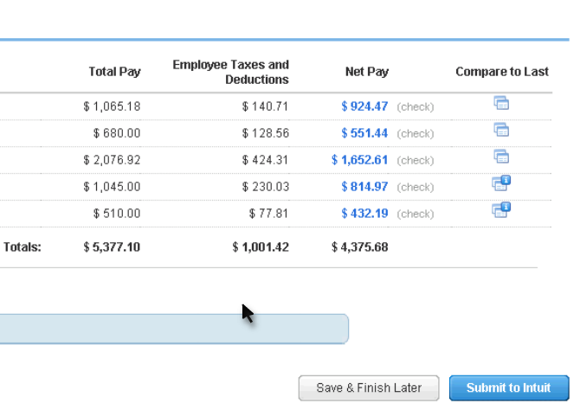

IFSP can process your payroll weekly, bi-weekly, semi-monthly or monthly. IFSP notifies you about upcoming tax payments, files and pays your taxes, and lets you keep the money you pay to tax agencies until the payment is actually due. IFSP creates and distributes your W2 forms at the end of the year. You can also pay contractors via direct deposit and prepare and submit 1099-MISC electronically. With IFSP, there are no tax penalties - guaranteed. In addition, your paycheck data can be exported directly to QuickBooks Online (click Export to QuickBooks after you run payroll.)

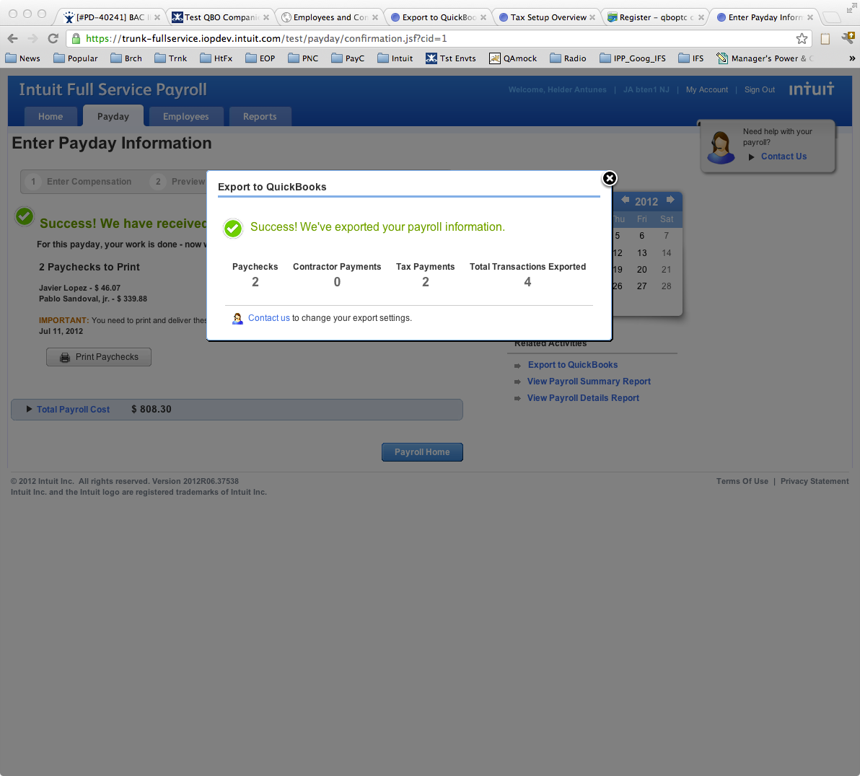

IFSP paychecks are exported to QuickBooks Online as type check and can be viewed in account registers and reports.

Note: For the most up-to-date information regarding IFSP services click the following link: http://payroll.intuit.com/payroll_services/fullservice_payroll.jsp

### When Intuit Payroll (QBOP & IFSP) is Not the Best Fit

* 3rd Party Sick Pay – disability paid to employees via a private insurance company
* TERFA / Allocated Tips / Tips to Minimum
* Amended tax returns
* Certified or Union Payroll calculation
* 3rd Party checks to garnishment agencies, insurance companies, etc
* After the Fact Payroll
* Cannot have more than one bank account for different electronic services
* Form 943 for agricultural businesses

# Lesson 3: Apps to Expand QuickBooks Online

#### Authored by Stacy Kildal, CPB

## Connected

While QuickBooks Online focuses on solving all core accounting functions, there are many other related tasks that 3rd party applications can solve for small businesses. Connecting to these applications (the cloud) has several benefits:

* The cloud enables an unparalleled ability to connect these applications so that data is shared.
* There is a single source of truth – not just for Accounting – but across applications.
* Instead of re-entering data – and potentially creating errors – your data flows seamlessly between applications, so you never re-enter it.

### The App Center in QuickBooks Online

To access the latest featured Apps that integrate with QuickBooks Online, go to the App Center tab.

Note: Unfortunately, the test drive company does not currently have access to the App Center. This feature is found in trial and subscribed QuickBooks Online accounts.

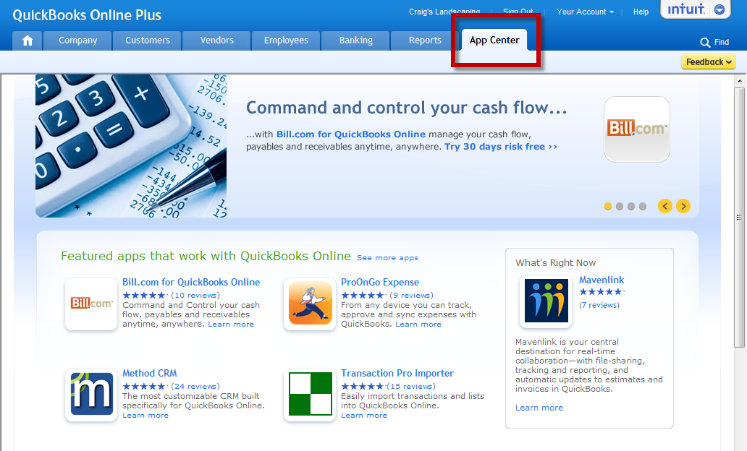

## How to Find, Purchase, and Access Apps

### How to Purchase

Each featured App has a free trial with the option to subscribe after 30 days. Click the Authorize button to sync an App with QuickBooks Online. To connect your new App to QuickBooks Online, complete a brief registration page.

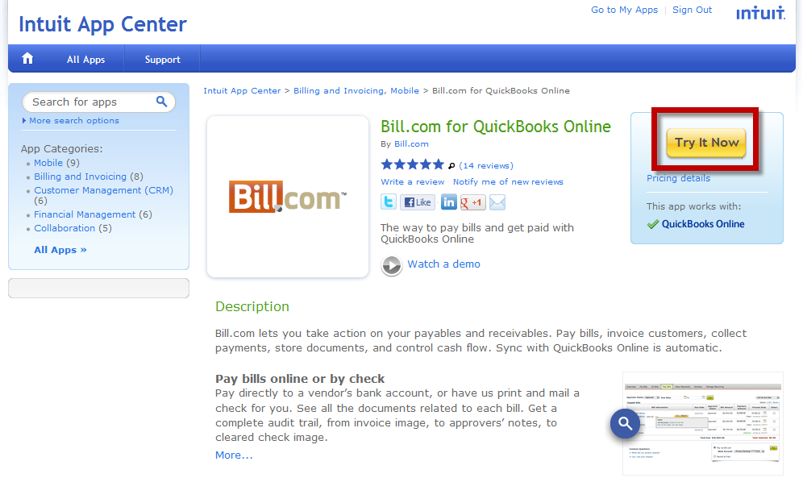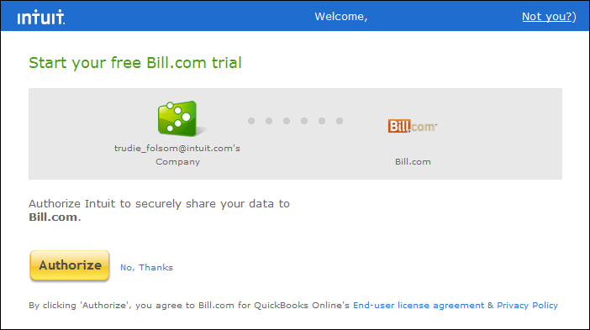

### How to Access Apps after Purchase

To access each of your Apps, click the Intuit logo dropdown arrow in the top right corner of your Company file.

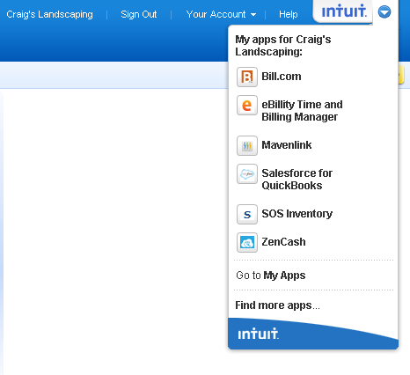

## Popular Apps

### Method CRM

Create web-forms to collect leads from your website, create and sync invoices, payments and estimates with QuickBooks Online, and build self-service portals for customers and partners to view orders, place requests and make payments.

* Method has near-zero setup time and the highest level of bi-directional synchronization possible.
* All your customers, vendors, employees, items, and other QuickBooks Online lists are accessible from a web browser.
* You can view, add and edit virtually every QuickBooks Online transaction, including estimates, invoices, payments, vendor bills.

<http://appcenter.intuit.com/method-crm>

### Transaction Pro Importer

Use this App to do convert from non-QB desktop to QuickBooks Online. Accountants and small business owners utilize this tool to import transactions from any other program that will export to spreadsheet format.

* Import Lists or Transactions into QuickBooks Online
* Great for conversion from non-QuickBooks software
* Useful for importing Webstore or EBay/Paypal transactions

<http://appcenter.intuit.com/TransactionProImporter>

### SalesForce

This Application was built specifically to integrate with QuickBooks Online. Users can view customer history/balance and create Activities/Opportunities within their email. Its features include:

* Track Leads
* Allow sales teams to create Estimates and Invoices
* Integration with Google Calendar and Outlook

<http://appcenter.intuit.com/salesforcecrm>

### Mavenlink.com

This App provides Budget to Actual reporting and is a robust project/team management program. Its features include:

* Project management/team collaboration
* Syncs with QuickBooks Online and Google Docs
* Provides email updates and scheduling
* Invite clients to participate

<http://appcenter.intuit.com/mavenlink>

### ZenCash

This App allows you to create customizable timelines for managing receivables and Collections. Its features include:

* Sync with QuickBooks/QuickBooks Online
* Automatically mail thank you notes when invoices are generated and/or paid
* Arrange for a ZenCash AR specialist to call about past due invoices
* Legal collections

<http://appcenter.intuit.com/zencash>

### SOS Inventory.com

This App has advanced inventory functionality for assemblies, sales orders, tracking work in process, receiving low inventory alerts and tiered pricing plans. Its features include:

* Track inventory assemblies
* Track work in progress
* Create sales orders and convert them to QuickBooks Online invoices
* Value inventory using LIFO method
* Receive automated email or SMS alerts when inventory gets low

<http://sosinventory.com/>

### Bill.com

Bill.com lets you take action on your payables and receivables. Pay bills, invoice customers, collect payments, store documents, and control cash flow. Automatically sync with QuickBooks for Windows and QuickBooks Online. Its features include:

* See a picture of your future cash flow
* Pay Bills online or by check
* Automate customer payments

<http://appcenter.intuit.com/bill.comforquickbooksonline>

### Avalara

Avalara offers sales tax integration. Its features include:

* Calculates sales tax (both rates and taxability rules)
* Fully completed returns
* Multiple sales tax rates
* Integrates with GoPayment

<http://www.avalara.com/>

Note: This popular App is not yet added to the App Center. However, stay tuned, engineers are working to add it soon.

View App demos

1. Go to [http://appcenter.intuit.com](http://appcenter.intuit.com/)
2. From the Learn More links, select three or four of the featured Apps and view their demonstration videos.

# Course Conclusion

This course introduced you to the features, functionality and pricing information for Merchant Account Service within QuickBooks Online. You also viewed how to integrate and accept payments using GoPayment and the Intuit Payment Network. In addition, you learned about QuickBooks Online Payroll options, setup and payroll processing. Finally, you explored the App Center in QuickBooks Online and learned about the Apps that can help you expand the functionality of your QuickBooks Online program.

# Appendix – Payroll Set Up Checklist

## Payroll Setup Checklist

START HERE: You'll need the following information to set up Intuit QuickBooks Payroll. You can find the information in your own records, from your accountant, or from federal and state agencies.

#### 1. Company Information

◻ Company bank account: For direct deposit or electronic tax payments.

#### 2. Compensation and Benefits

◻ Types of employee benefits: Such as hourly wages, salaries, bonuses, commissions, and tips.

◻ Types of employee compensation: Such as health and dental insurance, 401(k), retirement plans, vacation/sick leave, or Flexible Spending Account (FSA).

◻ Other additions and deductions: Such as cash advances, mileage and travel reimbursements, union dues, and wage garnishments.

#### 3. Employees

◻ Completed Form W-4 for each employee. (Tip: If not available, enter "single" and "0" allowances; you can change these values later.)

◻ Pay rate: Hourly, salary, commission, etc.

◻ Paycheck deductions: Employee contributions to health insurance, retirement plans, or garnishments (child/spousal support).

◻ Sick/vacation hours balance: if applicable.

◻ Hire and termination dates.

#### 4. Direct Deposit

◻ Direct Deposit: Employees' bank account and routing numbers for direct deposits to their bank accounts (additional fees apply).

#### 5. Tax Information

◻ Federal Employer Identification Number (FEIN) and state agency ID numbers: You'll need unique ID numbers from the IRS and state agencies to file and pay taxes. Contact the agencies to apply for these ID numbers (see [www.payroll.com/compliance](http://www.payroll.com/compliance)).

◻ Filing requirement and deposit schedule for payroll taxes: Requirements for when to file and deposit payroll taxes vary. Companies that owe more payroll tax typically pay and file more frequently. See [www.payroll.com/compliance](http://www.payroll.com/compliance) or contact the IRS and your state agency to determine your requirements.

◻ Electronic Federal Tax Payment System (EFTPS) enrollment: It's mandatory to submit federal tax deposit payments electronically. You can enroll in EFTPS at [www.eftps.gov/eftps](http://www.eftps.gov/eftps).

◻ Other tax information: Such as state assessment, surcharge, administrative or training tax rates, and local or other taxes, if applicable.

#### 6. Prior Payrolls

NOTE: If you've already paid employees this calendar year, we need to know the amounts to accurately calculate new paychecks and complete your tax forms.

◻ For the current quarter: Payroll details from each paycheck.

◻ For each prior quarter of this calendar year: Summary by employee and summary for all employees (total company payroll).

#### 7. Liability Information

◻ For the current quarter: Copies of all payroll liability checks.

◻ For each prior quarter of this year: Summary of payroll liability payments.