QuickBooks 2013 Instructor Guide

##### cid:1494632F-E8AD-4F81-8A68-A9CB9DF38BCF Instructor Handouts

Table of Contents

Handout 1: Balance Sheet Accounts B-2

Handout 2: Accounts Created Automatically B-3

Handout 3: Registers Associated with Quickbooks Windows B-5

Handout 4: Quickbooks Item Types B-6

Handout 5: Inventory Workflow B-7

Handout 6: Group vs. Inventory Assembly Items B-8

Handout 7: Sales Tax B-9

Handout 8: Employer Payroll Responsibilities B-10

Handout 9: Payroll Item Types B-11

Handout 10: List of Payroll Expenses and Liabilities B-12

# Handout 1: Balance Sheet Accounts

The following table describes the use of each of the balance sheet account types available in QuickBooks.

|  |  |
| --- | --- |
| This Account Type | Tracks |
| Bank | Checking, savings, and money market accounts. Add one bank account for every account your company has at a bank or other financial institution. (You should also use this account type to track petty cash.) |
| Accounts receivable (A/R) | Transactions related to the customers who owe you money, including invoices, payments, deposits of payments, refunds, and credit memos. Most companies have only one A/R account. |
| Other current asset | Assets likely to be converted to cash or used up within one year, such as notes receivable due within a year, prepaid expenses, and security deposits. |
| Fixed asset | Long-term notes receivable and depreciable assets your company owns that aren’t likely to be converted into cash within a year, such as equipment or furniture. |
| Accounts payable (A/P) | Transactions related to the vendors to whom you owe money, including your company’s outstanding bills, bill payments, and any credit you have with vendors. |
| Credit card | Credit card purchases, bills, payments, and credits. |
| Current liability | Liabilities scheduled to be paid within one year, such as sales tax, payroll taxes, accrued or deferred salaries, and short-term loans. |
| Long-term liability | Liabilities such as loans or mortgages scheduled to be paid over periods longer than one year. |
| Equity | Owner’s equity, including capital investment, drawings, and retained earnings. |

# Handout 2: Accounts Created Automatically

The following is a list of the accounts that QuickBooks creates automatically.

* Accounts Receivable. QuickBooks creates this account during the EasyStep Interview, or the first time you create an invoice.
* Inventory Asset. When the first inventory item is created in a company data file, QuickBooks creates the Inventory Asset account.
* Undeposited Funds. QuickBooks adds this account to the chart of accounts the first time you record a payment from an invoice or a sales receipt. QuickBooks uses this account to hold money you’ve collected until you deposit it in a bank account.
* Accounts Payable. QuickBooks creates this account during the EasyStep Interview, or the first time you enter a bill.
* Payroll Liabilities. QuickBooks adds this account to the chart of accounts automatically when you turn on the payroll feature in a company file. QuickBooks initially maps all payroll items that create liabilities to this account.
* Sales Tax Payable. QuickBooks creates this account when you turn on the sales tax feature.
* Opening Bal Equity. This account is created the first time you enter the opening balance for a balance sheet account. Every time you add a new account with an opening balance, QuickBooks records the second half of the entry in the Opening Bal Equity account. This means that total equity is the net balance of the assets minus the liabilities entered into QuickBooks. Once you’ve entered all of the accounts and balances, you may use a journal entry to allocate Opening Balance Equity to the proper equity accounts. Then make the account inactive to help ensure it is not used any more.
* Retained Earnings. This account is unique because there is no register associated with it. Each time you run a balance sheet, you assign the date of the report. QuickBooks then calculates the net income from all transactions from the earliest date in the company file to the end of the fiscal year prior to the current year. QuickBooks displays the results as retained earnings. Because of this feature, you don’t need to make the traditional closing entries at the end of the year.
* Uncategorized Income. QuickBooks creates this account the first time you enter an opening balance for a customer.

Note: Instead of entering an opening balance for customers, you should enter the actual open invoices (with the same dates and items). This ensures accurate aging reports. After entering all open transactions and beginning balances, enter adjustments as necessary to ensure balances match the opening balance sheet balances.

* COGS. When the inventory feature is turned on and the first inventory item is created in a company file, QuickBooks creates a Cost of Good Sold (COGS) account.
* Payroll Expenses. This account is created when you turn on payroll in a company data file. All payroll expense items are initially mapped to this account.
* Uncategorized Expenses. QuickBooks creates this account the first time you enter an opening balance for a vendor.

Note: Instead of entering an opening balance for vendors, you should enter the actual open bills (with the same dates, accounts or items). This ensures accurate aging reports. After entering all open transactions and beginning balances, enter adjustments as necessary to ensure balances match the opening balance sheet balances.

* Reconciliation Discrepancies. QuickBooks creates this expense account when you enter an adjustment to reconcile small accounting discrepancies. QuickBooks uses this account to track all reconciliation differences.
* Purchase Orders. QuickBooks creates this account the first time you create a purchase order. This is a non-posting account that does not affect your balance sheet or income statement.

# Handout 3: Registers Associated with Quickbooks Windows

You can open the register associated with a window by choosing Use Register from the Edit menu when the window is displayed.

|  |  |
| --- | --- |
| While you have this window displayed… | You can display the register for this account… |
| Create Invoices | Accounts Receivable |
| Enter Bills | Accounts Payable |
| Write Checks | The account you have displayed in the Bank Account field on the check form. |
| Receive Payments | Accounts Receivable |
| Make Deposits | The account you have displayed in the Deposit To field, or Undeposited Funds if that option is selected. |
| Enter Sales Receipts | The account you have displayed in the Deposit To field. |
| Create Credit Memos/Refunds | Accounts Receivable |
| Enter Credit Card Charges | The account you have displayed in the Credit Card field. |

You can also open the register for any balance sheet account (except Retained Earnings) by double-clicking the account name in the chart of accounts.

# Handout 4: Quickbooks Item Types

## Items for Things You Buy and Sell

|  |  |
| --- | --- |
| Type | Use to Enter |
| Service | Services you charge for or services you purchase.  EXAMPLES: Professional fees, labor |
| Inventory Part | Items you purchase, track as inventory, and then resell.  EXAMPLES: Electrical outlets, t-shirts |
| Inventory Assembly (Premier) | Items you produce or buy, track as inventory, and then resell.  EXAMPLES: Pre-assembled door kits, custom bicycles |
| Non-Inventory Part | Items you sell but do not purchase; items you purchase but do not resell; items you purchase and resell, but do not track as inventory.  EXAMPLES: Custom-made slipcovers, pizza, office supplies |
| Other Charge | Other charges on a sale or purchase.  EXAMPLES: Shipping charges, delivery charges |
| Group | A group of individual items already on the item list.  EXAMPLES: A group of services and lab fees for office visits, a group of services and food items provided by a caterer |

Items That Calculate

|  |  |
| --- | --- |
| Type | Use to |
| Subtotal | Calculate a subtotal before calculating a discount or charge that covers several items. |
| Discount | Calculate an amount to be subtracted from the total. (To discount several items, use a subtotal item before the discount item.) |
| Payment | Record a payment received at the time of invoicing so that the amount owed on the invoice is reduced. |
| Sales tax | Calculate a single sales tax for a sale. |
| Sales Tax Group | Calculate two or more sales taxes grouped together and applied to the same sale. |

# Handout 5: Inventory Workflow

The following graphic provides an overview of how to track inventory information in QuickBooks.

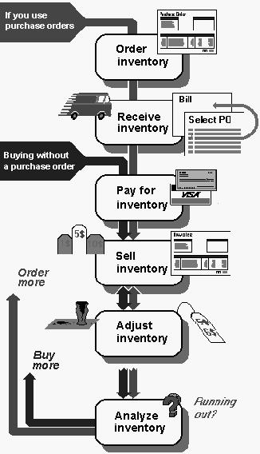

# Handout 6: Group vs. Inventory Assembly Items

The following table compares group and assembly items to help you decide which item type is appropriate for a given situation.

|  |  |
| --- | --- |
| Group item | Inventory assembly item |
| Can include combinations of different item types, such as inventory and service items | Can contain only inventory parts or other inventory assembly items To combine a service item with an assembly item, create a group and include both the assembly item and the service item in the group. |
| Allows you to print individual items contained in the group on sales forms | Prints only the assembly name, not component part names, on sales forms |
| No reports available specifically for groups | Will appear after inventory part items on standard inventory reports; pending build report will list builds in the pending state |
| Quantity on hand of each item included in the group is adjusted in inventory at the time of sale | Quantity on hand of component items is adjusted in inventory when the assembly is built |

Note: Inventory assembly items are only available in QuickBooks Premier Editions.

# Handout 7: Sales Tax

The following graphic provides an overview of how to track sales tax information in QuickBooks.

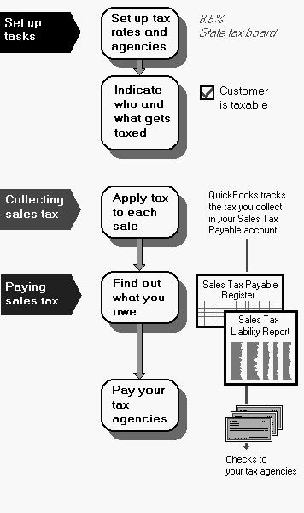

# Handout 8: Employer Payroll Responsibilities

The following is a list of payroll activities for which the employer is responsible.

* Calculate gross pay for employees
* Calculate federal withholding
* Calculate state withholding
* Calculate FICA
* Calculate Medicare
* Calculate federal unemployment
* Calculate state unemployment
* Add any other deductions
* Withhold taxes and deductions from employee’s paycheck
* Write a check for the net pay to the employee
* Submit tax reports and pay taxes to the government
* Pay any other withheld deductions

# Handout 9: Payroll Item Types

A payroll item is anything that affects the amount on a paycheck. QuickBooks has six types of payroll items.

The following table provides the name and description of each payroll item type.

|  |  |  |
| --- | --- | --- |
| Type | Description | Examples |
| Compensation | Hourly wage, salary, bonus | Straight time, salary, overtime, Sales commission, piece rate, tips, awards |
| Insurance benefits | Deductions for medical insurance and other insurance | Health, dental, and vision insurance, group term life insurance, health savings account |
| Retirement benefits | Deductions for retirement plans | 401(k), Simple IRA, 403(b), 408(k)(6) SEP |
| Paid time off | Employee time off | Vacation, sick, PTO |
| Miscellaneous | Additions and deductions | Cash advance, mileage reimbursement, wage garnishment, union dues |
| Custom | State taxes and other taxes | State tax, local tax, job training tax |

# Handout 10: List of Payroll Expenses and Liabilities

## Payroll Expenses

* Employee’s gross pay
* Employer payroll taxes
* - Social Security (FICA)
* - Federal Unemployment Insurance (FUTA)
* - Medicare
* - State Unemployment Insurance (SUI)—if paid by employer
* - State Disability (SDI)—if paid by employer

## Payroll Liabilities

* Taxes you’ve withheld from paychecks for the following
* Social Security (FICA)
* Federal Unemployment Insurance (FUTA)
* Medicare
* State Unemployment Insurance (SUI)
* State Disability (SDI)
* State income tax
* Federal income tax