QuickBooks 2013 Instructor Guide

##### Instructor Guide

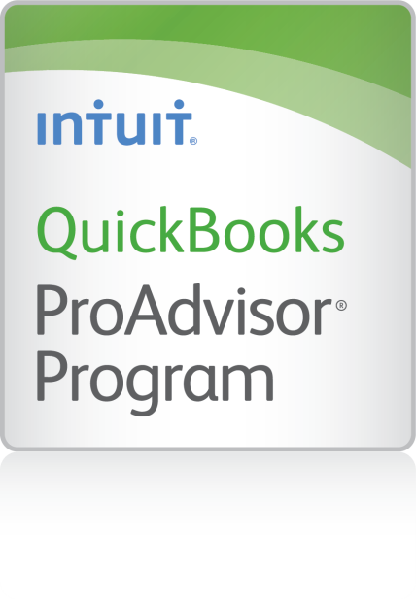

Table of Contents

Training Objectives 2

Supporting Materials 3

Instructor Preparation 4

Getting Started with The Training 4

Tips for Success 5

Check In With the Audience 5

Include a “Parking Lot” 5

Provide a Value Sheet for Notes 6

Provide Positive Reinforcement 6

Timing is Everything 6

The Laptop Screen Trick-Hands On Tip 6

# Training Objectives

It is important to identify the training objectives to determine which lessons to include. Although there are sixteen lessons included in the training materials, you should select the lessons appropriate to meet the training objectives. The materials are available in formats that allow you to customize them to meet your needs.

For example, if you are conducting an Introduction to QuickBooks seminar, you may only cover about half of the lessons (as indicated with an * below). You may have separate seminars or training sessions on payroll, inventory, or other topics.

Alternatively, if you are providing training for a client to their employees, if they have inventory and payroll that may be included for employees as appropriate.

The sixteen lessons include:

1. Getting Started
2. Setting up QuickBooks **\***
3. Working with Lists **\***
4. Working with Bank Accounts **\***
5. Using Other Accounts in QuickBooks
6. Entering Sales Information **\***
7. Receiving Payments and Making Deposits **\***
8. Entering and Paying Bills **\***
9. Analyzing Financial Data **\***
10. Setting up Inventory
11. Tracking and Paying Sales Tax **\***
12. Doing Payroll with QuickBooks
13. Estimating and Progress Invoicing
14. Tracking Time
15. Customizing Forms and Writing QuickBooks Letters
16. Working with Multiple Currencies

The lessons marked with an **\*** cover the essentials for a basic Introduction to QuickBooks seminar. Depending on the training objectives, participants and time, you may add additional lessons.

**TIP**: Upload the handouts and sample data file to a folder in Dropbox, SugarSync or another file sharing service. Then you can share it with people to download the materials.

# Supporting Materials

* **PowerPoint file**: Customize with your contact information and edit for lessons to be covered during the training.
* **Student Handouts for each Lesson**: Select the lessons to include for the training. Use them as your guide as you present the material.
* **Instructor Demo (Appendix A):** A demonstration meant to be presented by the instructor with the class observing. It gives an introduction to the major QuickBooks features, and demonstrates how QuickBooks automates day-to-day bookkeeping.

This demonstration would be especially helpful if you are doing a presentation to provide an overview of QuickBooks (perhaps to a luncheon or group meeting). The demo includes:

* Entering Sales
  + Creating an Invoice
  + Filling in the Details
  + Viewing the Customer’s Register
  + Receiving a Customer Payment
  + Making a Deposit
* Entering and Paying Bills
  + Entering a Bill
  + Using QuickBooks to Remind You When to Pay
  + Paying Bills
  + Handling Purchases You Pay for on the Spot
* Managing Inventory
  + Ordering Inventory
  + Receiving Inventory Items
  + Receiving Bills after Receiving Items
  + Selling Items
  + Generating Inventory Reports
* Creating Reports and Graphs
* **Instructor Handouts** (Appendix B) include:
  + Handout 1: Balance Sheet Accounts
  + Handout 2: Accounts Created Automatically
  + Handout 3: Registers Associated with Quickbooks Windows
  + Handout 4: Quickbooks Item Types
  + Handout 5: Inventory Workflow
  + Handout 6: Group vs. Inventory Assembly Items
  + Handout 7: Sales Tax
  + Handout 8: Employer Payroll Responsibilities
  + Handout 9: Payroll Item Types
  + Handout 10: List of Payroll Expenses and Liabilities
* **Sample Data File** (qblesson.qbb): The Rock Castle Construction file to be used with the training materials. Restore the file at the beginning of training (which provides a great opportunity to discuss backup files and file types).

# Instructor Preparation

1. Install QuickBooks on your computer’s hard disk.
2. Copy the qblesson.qbb file from the QuickBooks in the Classroom CD-ROM onto your computer’s hard disk.

Review the instructor demonstration available in Appendix A and the lessons to be covered to make sure you’re familiar with the material.

# Getting Started with The Training

* Start with learning objectives
  + Set expectations
* Be sure to include introductions
  + Introduce yourself and your qualifications – Don’t overdo it. Keep in mind that as the instructor, you are deemed credible and knowledgeable. Be careful not to appear to be marketing or selling yourself. Do a good job presenting the material and provide attendees with your business card for ‘follow up questions’ they may have forgotten to ask during the training.
  + Have participants introduce themselves – Spend a little time inquiring about your students’ backgrounds—whether they own a business or are the bookkeeper for a small business and the type of business or industry. Also, try to determine whether any of them have experience with accounting or QuickBooks. This information can help you gear the course towards your students’ particular needs.
  + Consider an ice-breaker question if needed – about something safe like sports, weather or another safe topic.
* Housekeeping
  + Provide schedule with expected break times
  + Let everyone know where to find the restrooms
  + Remind participants to silence cell phones

# Tips for Success

* Bring in tips and tricks for all levels
* Include “Did You Know?” statements
* Grab their attention
* Move around the room
* Focus on different people at different times
* Find a “key phrase” and get everyone to repeat it
* “Wow – I didn’t know that!”
* “I can do it!”

## Check In With the Audience

* Ask someone to clarify a point
* “Can you think of a situation where you can use a zero-dollar check?”
* Never ask:
* “You all know what a zero-dollar check is, don’t you?”
* “Anyone who doesn’t know what a zero-dollar check is?”

## Include a “Parking Lot”

* Use flip chart or bring poster
* Any unanswered question is written on parking lot
* Especially if you know it’s covered later
* Keeps the flow going and keeps you in control
* Don’t get off topic!
* DWI-MO – “Deal with it and Move On”

## Provide a Value Sheet for Notes

* Remind them to use this for the “ah-ha moments”
* Include your contact information

## Provide Positive Reinforcement

* Positive reinforcement keeps the participants involved
* Even if they answer a question wrong, thank them for trying
* If there are more than 10 people in your audience, restate all questions
* Use props
* Such as the Staples: “That was easy” button

## Timing is Everything

* Watch your timing
* Practice at home
* Mark timing in your notes
* Check in with the participants
* Ask if the pace is ok
* Check for understanding throughout the session

## The Laptop Screen Trick-Hands On Tip

* Acknowledge that “hands-on” is more difficult
* “It’s difficult to know what to look at – your own computer screen, the notes, the presenter?”
* Keep people focused
* Set up a process:
  + Lower your laptop screen (or watch up here) while I show you
  + “Let’s all do this together”
  + Open your screen to do the exercise
  + Lower the screen when you are done