QuickBooks 2013 Student Guide

##### cid:1494632F-E8AD-4F81-8A68-A9CB9DF38BCF Tracking and Paying Sales Tax

Table of Contents

Lesson Objectives 11-2

Overview of Sales Tax in QuickBooks 11-3

Setting Up your Tax Rates and Agencies 11-4

Grouping Single Taxes Together 11-5

Identifying Your Most Common Tax 11-6

Indicating Who and What Gets Taxed 11-7

Applying Tax to Each Sale 11-9

Determining What You Owe 11-10

Paying Your Tax Agencies 11-13

Tracking and Paying Sales Tax — Review Questions 11-14

Review Activities 11-15

Answers to Review Questions 11-16

# Lesson Objectives

* To get an overview of sales tax in QuickBooks (the steps involved in tracking, collecting, and paying it)
* To see how to set up QuickBooks to track sales tax
* To see how to apply sales tax to a sale
* To learn how to determine a business’s sales tax liability
* To write a QuickBooks check to the appropriate tax agency for sales tax liability

Notes

# Overview of Sales Tax in QuickBooks

To use QuickBooks to track and pay your sales tax:

* Set up your tax rates and agencies
* Indicate who and what gets taxed
* Apply tax to each sale
* Find out what you owe
* Pay your tax agencies

Notes

# Setting Up your Tax Rates and Agencies

Some businesses need to apply more than one sales tax to their sales; for example, they may collect a state sales tax as well as several county sales taxes. You need to create a separate sales tax item for each tax whose amount you must report (not necessarily for each tax you collect—some states want you to report state sales tax and county sales tax as separate items, while others let you report them as one item).

Even if you’re paying more than one type of tax, you usually want your customers to see one overall tax amount, not separate taxes for the state and county. You’ll learn how to do that in this lesson.

To add a sales tax item:

1. From the Lists menu, choose Item List.
2. Click the Item menu button, and then choose New.
3. In the Type field, choose Sales Tax Item.
4. In the Sales Tax Name field, type Bayshore.
5. In the Description field, type Bayshore City.
6. In the Tax Rate (%) field, type 1.
7. In the Tax Agency field, type Bayshore Tax Agency.

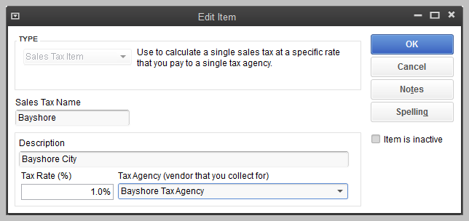

1. Click OK.
2. Click Quick Add.
3. Click OK.

If QuickBooks prompts you to add “Bayshore” to the dictionary, click Add.

Notes

# Grouping Single Taxes Together

Even if you collect a combination of sales taxes (for example, city tax and county tax) that you report separately, you probably don’t want to confuse customers by showing separate taxes on your invoices or sales forms. QuickBooks lets you group some or all of your tax items so that customers see a single tax amount on your invoices and sales receipts. Instead of a sales tax item, you’ll be creating a sales tax group.

To create a sales tax group:

1. With the Item List displayed, click the Item menu button, and then choose New.
2. In the Type field, choose Sales Tax Group.
3. In the Group Name/Number field, type Bayshore Group.
4. In the Description field, type Sales Tax, Bayshore.
5. Click in the Tax Item column, and then choose Bayshore.
6. Click on the second line in the Tax Item column, and then choose San Tomas.

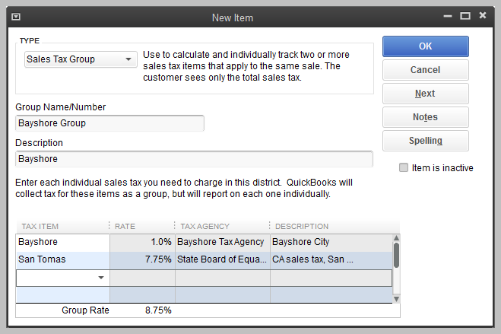

Click OK.

Notes

# Identifying Your Most Common Tax

If you want QuickBooks to apply sales tax to your invoices and sales receipts, you have to tell it which sales tax item or group is the one you use most often. Once you do that, QuickBooks applies that sales tax when you fill out an invoice or a sales receipt. (You can choose a different sales tax from the sales form if you don’t want the default tax.)

To set up a default sales tax:

1. From the Edit menu, choose Preferences.
2. In the Preferences window, click the Sales Tax icon in the left panel, and then click the Company Preferences tab.

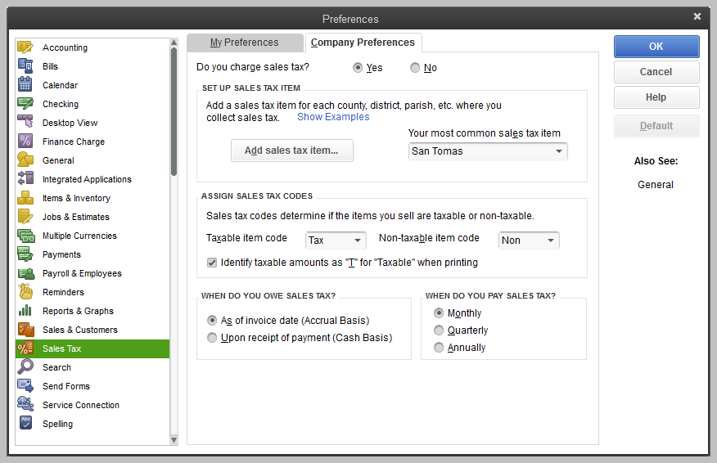

1. In the Most common sales tax field, make sure San Tomas is selected.

Click OK.

Notes

# Indicating Who and What Gets Taxed

The next step in setting up sales tax is to indicate who and what gets taxed. You have to tell QuickBooks whether or not a customer is taxable and assign a default tax item or tax group to that customer.

You must also distinguish between taxable and non-taxable items on the Item list. When you add an item to the Item list, there’s a place in the window where you can indicate whether you charge tax for the item. QuickBooks remembers this information, and shows whether or not an item is taxable when you enter the item on a sales form.

To indicate a taxable item:

1. In the Item list, select Doorknobs Std (under Hardware).
2. Click the Item menu button, and then choose Edit Item.

The code in the Tax Code field is a taxable code, which tells you that this item is taxable. When you choose the item to be included on a sales form, QuickBooks knows that the item is taxable and automatically applies the default sales tax (San Tomas sales tax with a rate of 7.75%).

1. Click OK to close the Edit Item window.

Close the Item list.

Notes

In the same way that you can specify that an item in the Item list is taxable, you can indicate whether or not a particular customer is taxable or non-taxable in that customer’s record.

To see an existing customer record:

1. Click Customers on the icon bar.
2. Select Jimenez, Cristina.
3. Click Edit Customer.
4. Click the Sales Tax Settings tab.

The tax code selected indicates that transactions with this customer are subject to sales tax. Because it is the default sales tax, the San Tomas tax item is assigned automatically. However, this customer is located in Bayshore, which has just instituted its city sales tax, so change the tax item to Bayshore Group.

1. In the Tax Item field, choose Bayshore Group.

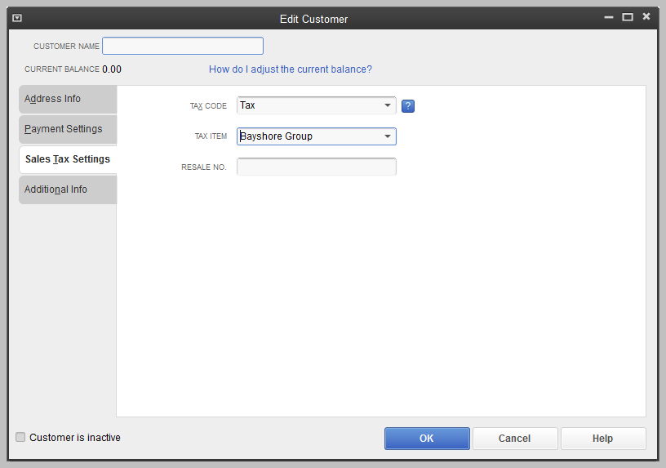

1. Click OK.

Close the Customer Center.

Notes

# Applying Tax to Each Sale

If you’ve set up a default sales tax, assigned taxes to your customers, and marked taxable items you sell as taxable, QuickBooks automatically calculates and applies the tax when you make a sale.

To apply tax to a sale:

1. On the Home page, click Create Invoices.
2. In the Customer:Job field, choose Jimenez, Cristina:Utility Shed. (Select both the customer and the job.)
3. In the Template field, select Custom Invoice from the drop-down list.
4. Click in the Item column and select Doorknobs Std.
5. In the Quantity column, type 4, and then press Tab.

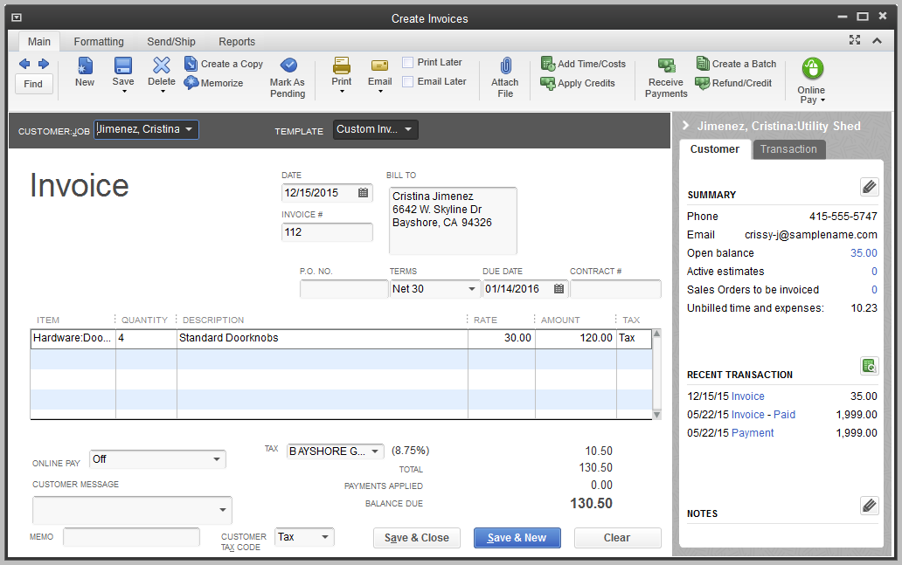

Click Save & Close.

Notes

# Determining What You Owe

If you’re required to collect sales tax from customers, you also have to make periodic payments of the sales tax you’ve collected. QuickBooks gives you three ways to determine the amount of your sales tax liability: the Sales Tax Liability report, the Sales Tax Payable register, and the Pay Sales Tax window.

To create the sales tax liability report:

1. From the Reports menu, choose Vendors & Payables, and then choose Sales Tax Liability.
2. In the Dates field, choose This Month-to-date from the drop-down list.

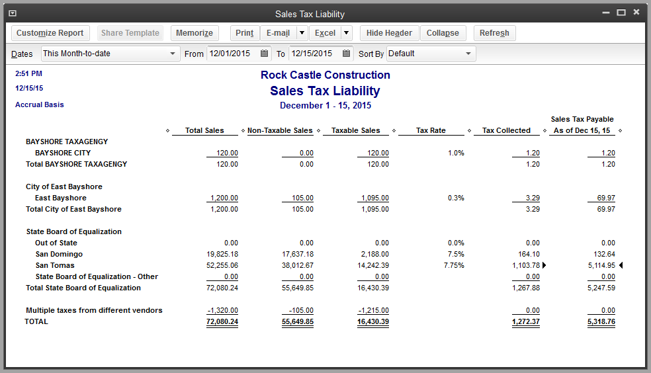

The sales tax liability report shows the total taxable sales as of a date you choose, total non-taxable sales, and the amount of sales tax you owe each tax agency. QuickBooks displays the sales tax liability report on an accrual basis (unless you changed the default setting in the Sales Tax Preferences window). The report shows exactly how much sales tax you collected.

1. Close the sales tax liability report.

If QuickBooks asks if you want to memorize the report, click No.

Notes

If you’d like to see where your sales tax revenue is coming from, you can run the Sales Tax Revenue Summary report, which shows you the sources of all taxable and non-taxable sales transactions, broken down by individual sales tax codes.

To run the sales tax revenue summary report:

1. From the Reports menu, choose Vendors & Payables, and then choose Sales Tax Revenue Summary from the submenu.

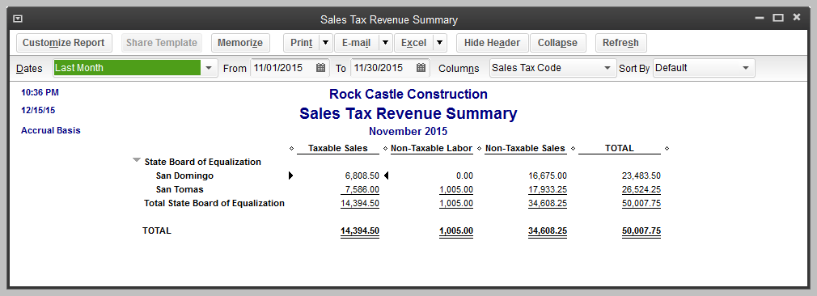

Close the report.

Each time you write an invoice or sales receipt that includes sales tax, QuickBooks enters the information in the sales tax payable register. QuickBooks keeps track of transactions for all tax vendors in the same Sales Tax Payable account.

To see the sales tax payable register:

1. From the Company menu, choose Chart of Accounts.
2. Click Sales Tax Payable once to select it.
3. Click the Activities menu button and select Use Register.

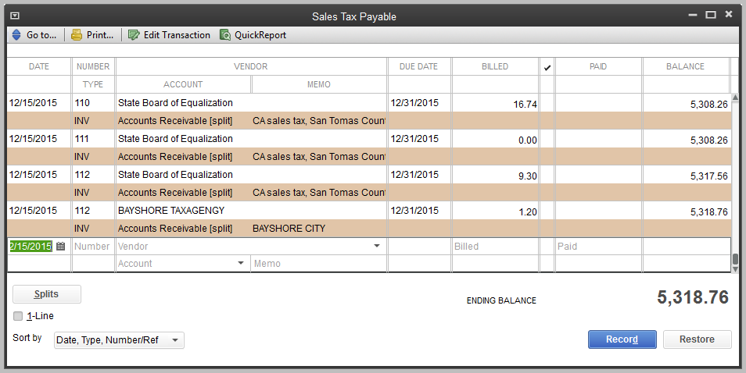

Each entry in the register is a single tax transaction. Taxes you record on invoices and sales receipts appear as increases, and payments you make to tax agencies appear as decreases. The ending balance of the register is your current tax liability. Notice how some transactions have the same invoice number. When you record two tax rates on the same invoice or cash sale, the register shows a separate transaction for each tax agency. (This is because you have to make separate payments to individual tax agencies.)

1. Close the register.

Close the chart of accounts.

Notes

# Paying Your Tax Agencies

When it's time to pay sales tax, you use the Pay Sales Tax window to write a check to your tax agency or agencies. Suppose Rock Castle Construction is ready to make a sales tax payment.

To make a sales tax payment:

1. On the Home page, click Manage Sales Tax.
2. In the Manage Sales Tax window, click the Pay Sales Tax button.
3. In the Show sales tax due through field, type 12/15/15, and then press Tab.

QuickBooks displays tax agencies and the amounts you owe.

1. To mark them for payment, click the Pay All Tax button (you may see amounts that are different from those shown in the image below).
2. Select the To be printed checkbox.

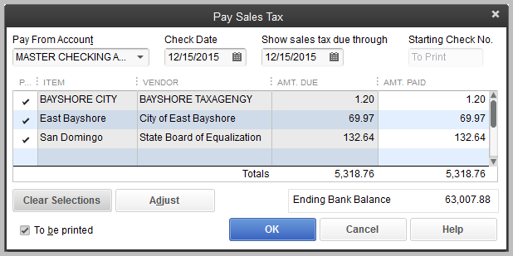

1. Click OK.

Close the Manage Sales Tax window.

Notes

# Tracking and Paying Sales Tax — Review Questions

1. Which of the following statements is false?
2. You can set up both taxable and non-taxable items
3. You can associate different sales tax rates with different customers
4. QuickBooks automatically sets up your sales tax rates based on the city and state you enter in the Company Information window.

All of the above

Use a ____________________________________________________________________ item to combine multiple sales tax items into one amount on sales forms.

1. Which of the following can you use to determine your sales tax liability?
2. Sales Tax Payable account register
3. Pay Sales Tax window
4. Sales tax liability report

All of the above

1. To correctly affect sales tax liability, you should make payments to tax collecting agencies from which QuickBooks window?
2. Write Checks
3. Pay Sales Tax
4. Either a or b

None of the above

1. In what part of the program do you assign sales tax codes and items to customers?
2. In the Sales Tax Code list
3. On the Customer tab of the New or Edit Item window
4. On the Additional Info tab of each customer’s record in the Edit Customer window

None of the above

# Review Activities

1. Create an invoice for Pretell Real Estate’s 155 Wilks Blvd. job, for 10 interior wood doors and 2 exterior wood doors.

After you record the invoice, open the sales tax payable register to see how QuickBooks has recorded the tax due from the invoice.

# Answers to Review Questions

1. Which of the following statements is false?
2. You can set up both taxable and non-taxable items
3. You can associate different sales tax rates with different customers
4. QuickBooks automatically sets up your sales tax rates based on the city and state you enter in the Company Information window.

All of the above

Use a sales tax group item to combine multiple sales tax items into one amount on sales forms.

1. Which of the following can you use to determine your sales tax liability?
2. Sales Tax Payable account register
3. Pay Sales Tax window
4. Sales tax liability report

All of the above

1. To correctly affect sales tax liability, you should make payments to tax collecting agencies from which QuickBooks window?
2. Write Checks
3. Pay Sales Tax
4. Either a or b

None of the above

1. In what part of the program do you assign sales tax codes and items to customers?
2. In the Sales Tax Code list
3. On the Customer tab of the New or Edit Item window
4. On the Additional Info tab of each customer’s record in the Edit Customer window
5. None of the above