Quicken Mac 2007 Reviewer’s Guide



Welcome to Quicken® Mac 2007.

Quicken Mac 2007 is a comprehensive personal finance software for the Mac platform designed for — and by — Mac users. Quicken Mac 2007 makes managing your finances easy and offers many features exclusive only to Mac users.

Enhancements of this year’s product come in the following critical areas:
401(k) Updates - Quicken connects and synchronizes with your 401(k) accounts and provides you with better insight into your investment decisions.

Paycheck Detailing - Quicken allows you or your spouse to enter in all of the information from your paychecks. In turn, this helps to track balances and contributions appropriately which makes tax time and open enrollment decisions much easier.

Confirm Balance and Holdings – Quicken helps you keep your financial institution information consistent by linking your local Quicken data file to the account balance and information stored by your financial institution.

QuickEntry Dashboard Widget - You can now quickly enter the basic transaction details via a new QuickEntry Widget. Information entered will appear appropriately coded the next time you open Quicken.

“I am really impressed with the new features in Quicken 2007. The Paycheck
feature is very handy and will make it much easier to help keep track of all my
paycheck details.

The QuickEntry widget is fantastic! It allows me to enter some quick transactions without leaving my other applications or starting up the full Quicken App. Thanks for the work on this
and the other improvements that make Quicken 2007 the best version to date.”
Paul Goodrich, Pleasanton, CA

401k and Investment Updates

Quicken Mac 2007 will now allow you to track your investments and provides you with more insight into your entire portfolio at a glance. With new alerts and information on potential tax related effects, you can now make up-to-date, educated decisions on whether to trade, buy or sell your investments.
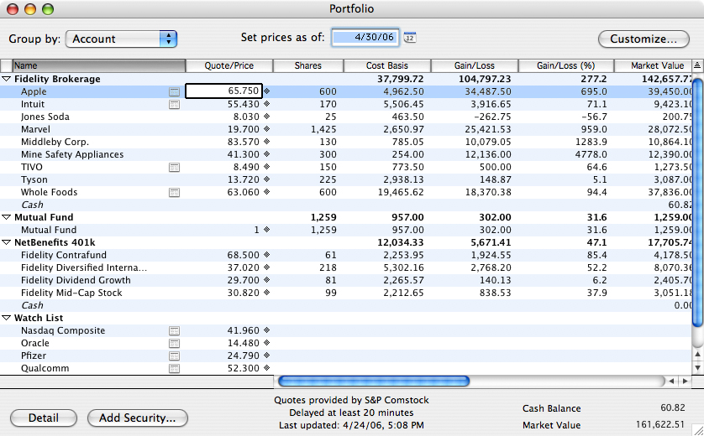
Mac users can now track various 401k investments in a single window.

“Quicken for the Mac continues to be the premier personal and home business
financial management package for the Macintosh.”
David Sternlight, Los Angeles, CA

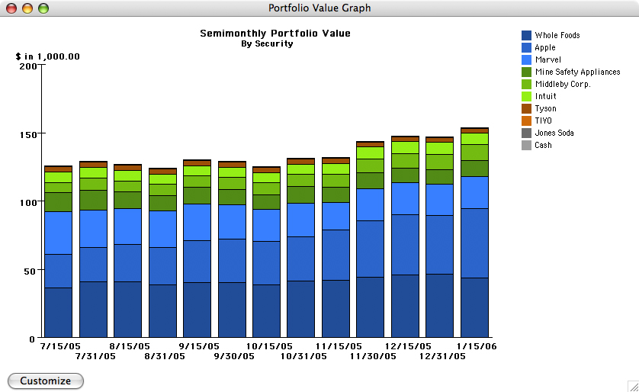
The visual Portfolio Value Graph gives you a quick view of how your portfolio is performing over time.

Paycheck Detailing

Quicken Mac 2007 will allow you to input and track all of the pertinent information contained in your family’s paychecks in a simple to use interface. Armed with this additional information, you can better track account balances and investment contributions which will empower you to make smarter tax decisions and open enrollment choices.

Better understand the categories listed on your paycheck and make more educated decisions with Paycheck Detailing.
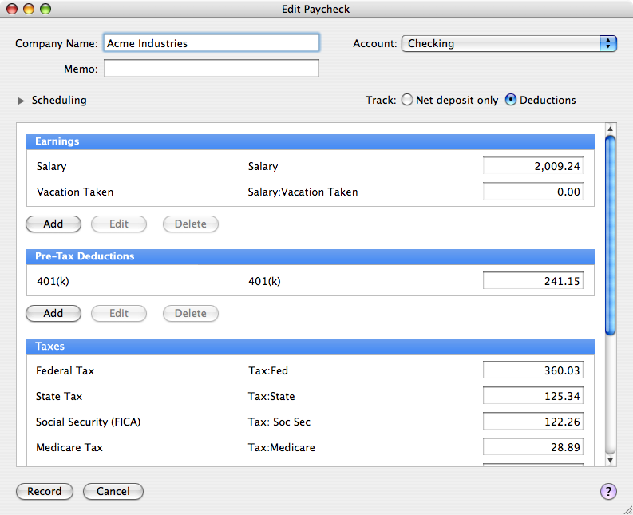

Balance and Holdings

Quicken has the ability to link the information in your local Quicken data file to the account balance and information stored by your financial institution. Quicken Mac 2007 can quickly uncover discrepancies and help you to resolve the differences. .

Quicken Mac 2007 helps you make sure your financial institution information stays in sync.

QuickEntry Dashboard Widget

One of the most visually exciting features for 2007 is the QuickEntry Dashboard widget – exclusive to Mac users. This feature allows you to quickly enter information into Quicken using a simple and straightforward interface element that is popular on the Macintosh platform: a custom, desktop widget.

Quickly enter the basic details of the expenditure in the simple, desktop-based QuickEntry widget and then move on to your next task. The next time you open Quicken, the expenditure details will be automatically entered and reflected in the register.

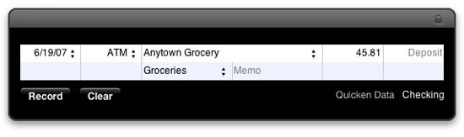
Users can use the QuickEntry Dashboard widget to quickly input expenditure details without even opening Quicken.

“The widget is terrific and a great help as I keep track of grocery bills. I don't even have to open the application to enter a single transaction.”
David DelMonte, Washington, DC

Quicken Mac 2007 System Requirements

A Macintosh. Quicken is supported on Intel-based Mac computers with Rosetta.
Mac OS v10.3.9, Mac OS v10.4.6 "Tiger" or later; the QuickEntry Dashboard widget requires Mac OS v10.4.6 or later.
256 MB RAM
Internet access required for all online features, including online account access and online payment

Product Features New or Improved in Quicken Mac 2007
Name
Track your spending
Easier online account setup* | X
Balance your checkbook | X
Create customized reports and graphs | X
Pay bills online* | X
Get alerts for upcoming bills | X
Download bank and credit card data* | X
Add due dates to your iCal calendar | X
Synchronize with Pocket Quicken® on Palm OS® | X
NEW! Dashboard widget for easy spending entry and tracking | X
Backup your data to online .Mac account* | X
Plan and Save
Monitor your total net worth | X
Create and manage your budget | X
NEW! Comprehensive paycheck management | X
NEW! Download and track 401(k) accounts* | X
Find ways to reduce debt | X
Plan for a new home, college or retirement | X
Forecast your cash flow | X
Simplify Taxes
Transfer data to TurboTax® | X
Find hidden tax deductions | X
Plan tax-cutting strategies | X
Find ways to minimize capital gains taxes | X
Track tax related expenses | X
Manage Investments
NEW! Set up investment accounts easily | X
Analyze your portfolio | X
NEW! Download security quotes and more* | X
Chart multiple securities on one screen | X
Export your portfolio to the Web* | X
Compare the Morningstar Rating™ on mutual funds* | X

* Online features require Internet access and are subject to change. Services vary among participating financial institutions or other parties and may be subject to application approval, additional terms, conditions and fees.

